|  |  |  |
| --- | --- | --- |
|  |  | Phillis Wheatley High School  4801 Providence St. Houston, TX 77047  713-671-3900  Follow us on Twitter @welovewheatley  https://www.houstonisd.org/wheatley |
|  |  |  |
| Phillis Wheatley High School  Providence St. Houston, TX 77047  713-671-3900  Follow us on Twitter @welovewheatley |  | **Welcome back to school!**  Greetings Wildcat Family!  As we transition back to campus for in-person instruction, we have developed guidelines to ensure the safety and wellness of all stakeholders are prioritized. Please review the guidelines we have placed into action to address any challenges or questions regarding our return to campus. Remain confident that we will continue to assess the conditions and keep our guidelines flexible if changes are warranted. If additional changes, or adjustments, are needed, we will notify all stakeholders via social media, the campus website, and virtual updates.  [**Please Check out our Return to Campus Plan**](https://www.houstonisd.org/cms/lib2/TX01001591/Centricity/Domain/1879/Return%20to%20Campus%20Plan.pdf)  [**Modelo de instrucción virtua**](https://www.houstonisd.org/cms/lib2/TX01001591/Centricity/Domain/1879/Return%20to%20Campus%20Plan.pdf) |
|  |  |  |
|  |  | Tech Corner |

**HISD HELP DESK 713.892.7378**

|  |  |
| --- | --- |
|  |  |
| **Upcoming Events**  TACRAO Virtual College Fair- **October 12-16**  NACAC College Fair- **October 17** |  |
|  |
|  |

**College Center**

Wheatley’s College Center is devoted to serve 9th through 12th grade students with various opportunities and exposure to post-secondary education. Opportunities that are provided to students include college visits, classroom presentations, college and career fairs, industry visits and more. We collaborate with internal and external departments throughout the district and assist students with financial aid, college applications, summer opportunities and career explorations. The college center staff aims to work together to make sure students successfully graduate high school and have the skills they need to achieve greatness in the future.

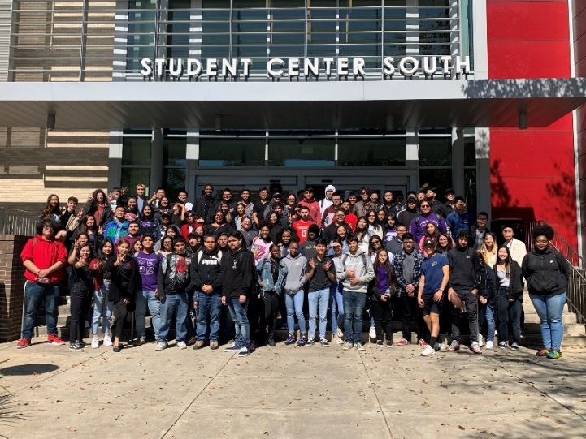

Students attended a technology workshop at the University of Houston, February 2020

**Scholarships**

First Community Credit Union Scholarship- **October 19**

American Academy Scholarship- **October 21**

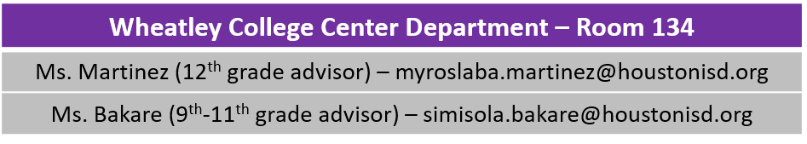



**Wraparound Services is an HISD program which houses Resource Specialists who connects scholar’s and their families to organizations and services to within the community.**

* **Food Distributions** • **Utility and Rental Assistance** • **Health Care**
* **Employment Opportunities** • **Snap Benefits** • **And much more!**

# Ways to contact your Wraparound Specialists

 **NOTE: A Student Assistance Form (SAF) can be completed and submit by Administration, Teachers, Staff and Parents.**

Complete and submit a SAF from your: Laptop. or Cellphone

Click, Type, Copy or Paste the link below.

**Student Assistance Form:** [www.tinyurl.com/hisdsaf](http://www.tinyurl.com/hisdsaf) *.*

*Please be certain to clearly describe the need.*

*Stay informed on all new resources throughout the community by joining:*

<https://www.remind.com/join/hd46be>

**Call: Ms. Spruiell at 713-691-3900**



**Join Her**

[**e**](https://bit.ly/3jsMzpK)

Phillis Wheatley High School – Volunteers in Public Schools (VIPS) recruits alumni, parents and community partners to donate their time, resources, and knowledge in support of the district’s primary goal to increase student achievement. Volunteers can contribute in areas such as mentoring, tutoring, fundraising, career education, enrichment programs, extracurricular and community service activities, and office and classroom assistance. After [registering online](https://www.houstonisd.org/vipslogin) and undergoing the annual background check, volunteers can work in any HISD school for the school year. All schools can track volunteer hours donated to the school district by establishing an online VIPS account.

To ensure we exceed our goals for the upcoming school year – renew your VIPS status going to [www.houstonisd.org/VIPS](http://www.houstonisd.org/VIPS). Contact Ms. Melodee Thomas if you have any questions or concern.

**Wheatley Campus News!**

Phillis Wheatley is currently accepting application for Mr. & Miss Wheatley Royal Court.

The purpose of Mr. & Miss Wheatley is to represent the student body of Wheatley High School by exemplifying the spirit and highest standards of the school. Mr. & Miss Wheatley will be expected to represent Wheatley High School in various school and community functions. The purpose of the royal court is to bring the student body together.

The Royal Court application can be found on the following sites:

Phillis Wheatley High School website: **houstonisd.org/wheatley**

Twitter: **@WeLoveWheatley**

Looking for High School Leaders!

We are accepting Class Officers applications:

Phillis Wheatley High School website: **houstonisd.org/wheatley**

Twitter: **@WeLoveWheatley** Wheatley New Cheer & Dance Teams!

Cheer Try-outs! October 26, 2020 Learning Commons @ 4:30

Senior Game Day Celebration!

Wheatley HS vs Worthing HS Football Game

November 7, 2020 (Saturday) @ 2:00 pm

**JROTC**

PSAT/ SAT Testing Day!

SAT - Seniors October 27, 2020 – 8:00 am

PSAT – Juniors October 29, 2020 – 8:00 am

Athletics

* **Football Tickets are limited each week to 5 (to be sold) per Participant.  Tickets left over will be available to be sold to the Wheatley Family/Staff.**
* **The same ticket information apply to the Wheatley Volleyball Team.**

**Basketball Season is Here!!**

* **All who are interested in playing please contact the following:**

**Girls Basketball- Coach Carr**

**Boys Basketball- Coach Reynolds**

Boys Basketball- Coach Reynolds