**Logs Test Week 15**

**Question 1:**

Write the reciprocal of 3 + 5i, in the form a + bi and evaluate ab2 =

**Question 2:**

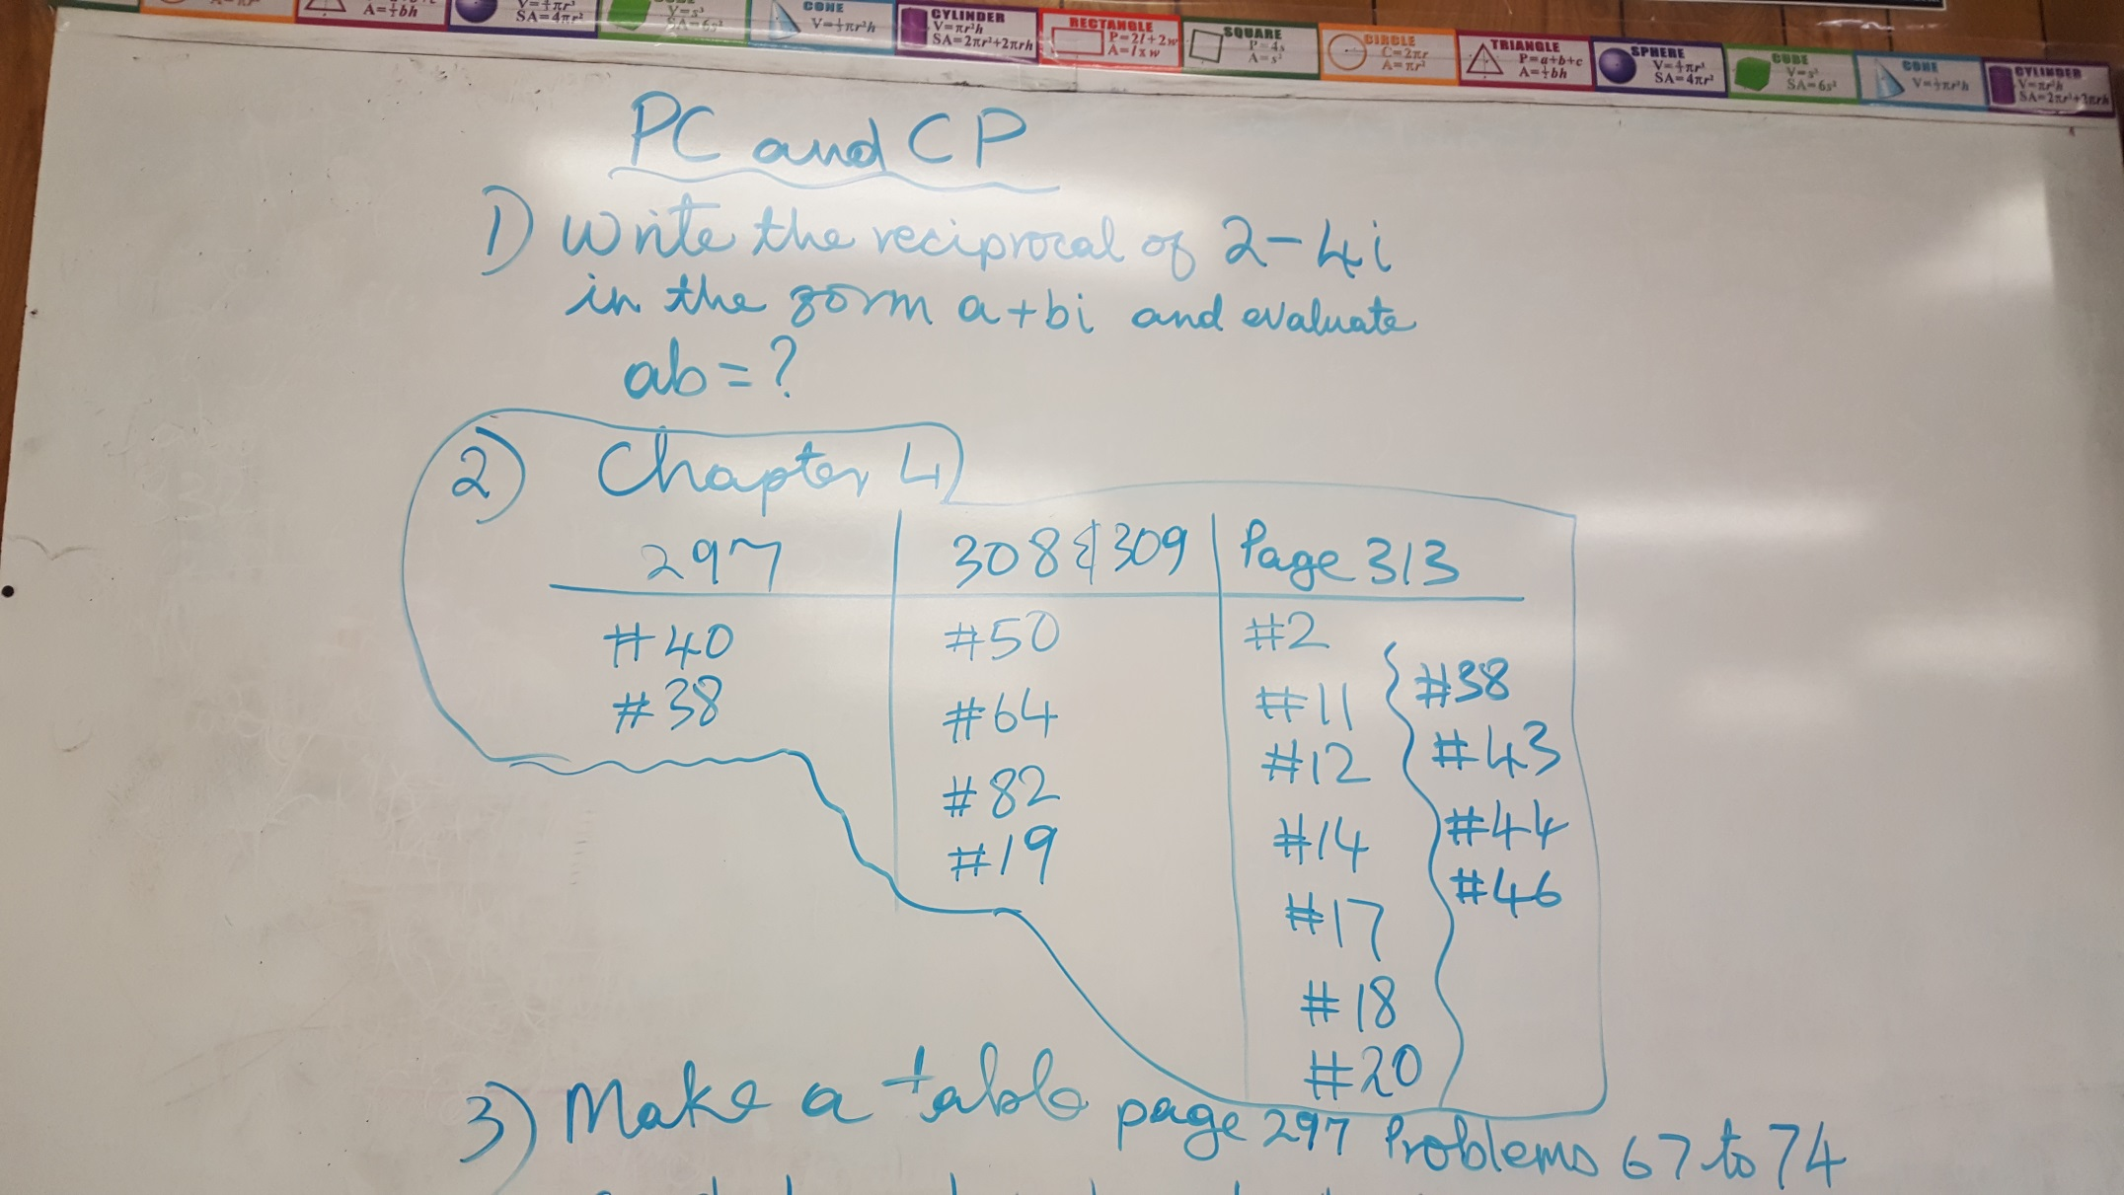

**Question 3:**

