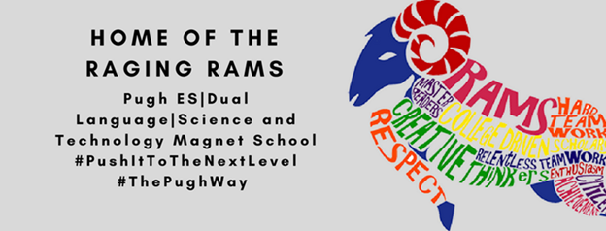
SDMC Agenda
Monday, January 31, 2022
Agenda items:

ESSER funding
- Magnet Awareness
- Gardening Club
- Special Education "Sensory Objects"
- Flexible Seating
- Cones for Safety
STEM Lab Position
STEAM Magnet
Opening of 3rd PreK and Kindergarten classes

