**File Shares:** Your file shares will be moved to managed servers at the Hattie Mae White data center.

1. First Click Your Start orb and Type \\FSPROD04\ and hit enter or click the link.

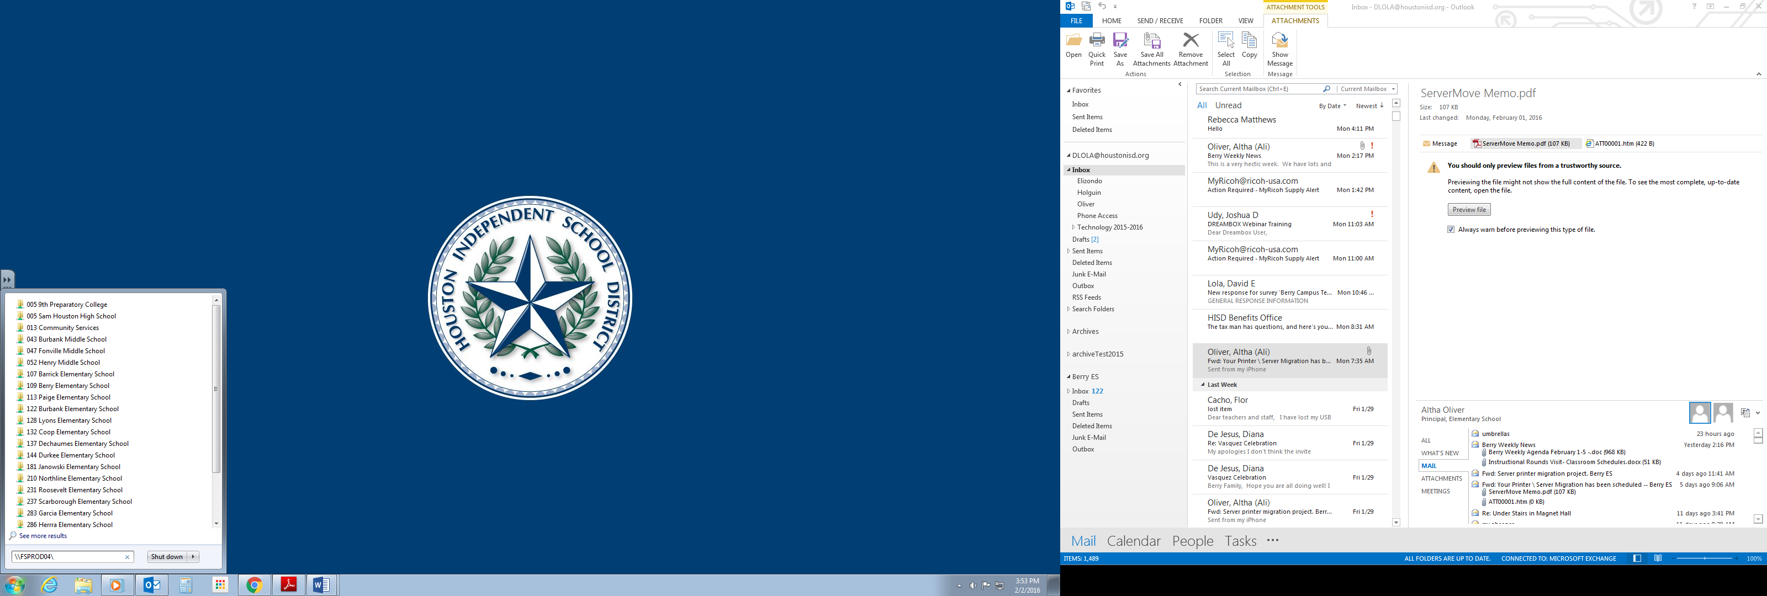

1. You should now see a list of file shares. Select our campus file share ***109 Berry Elementary School*** and click on it.

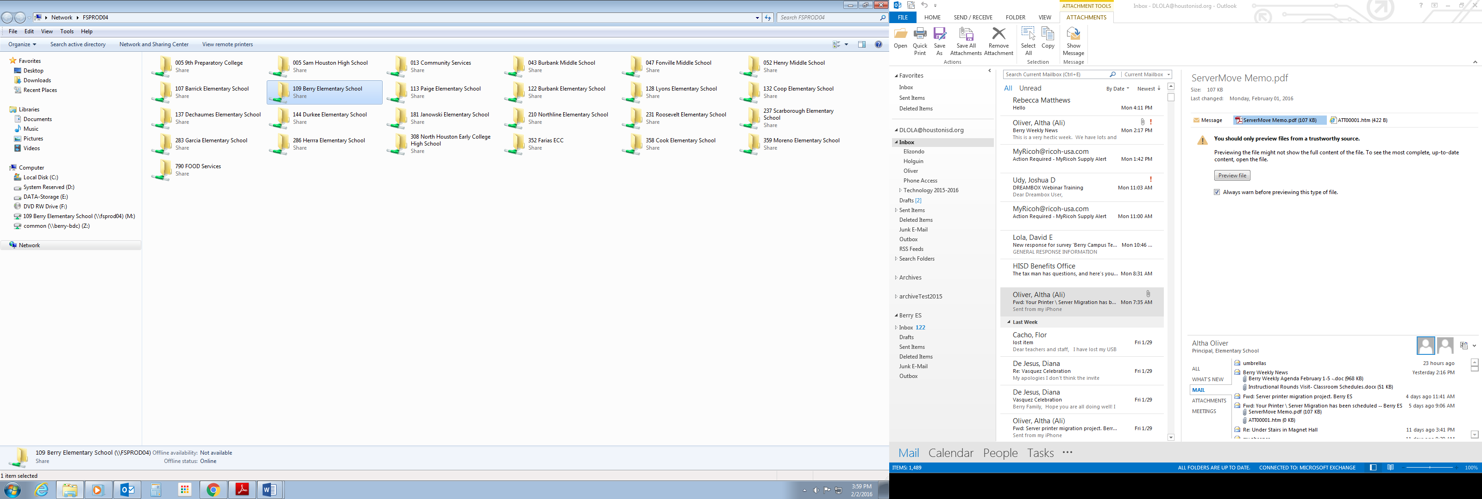

1. Next you will click on the batch file listed at the bottom of the list (***REMAP DRIVES***). This will map the file share drive to your computer. When successful you will see the drive listed under computer.

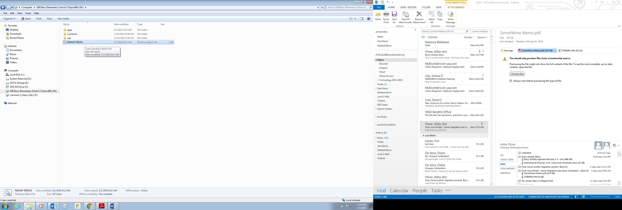

**That’s it you’re done. You did it!!!** 