**Math/Science Choice Board(Choose 5 out of seven activities: Project a Must!!)**

|  |  |  |
| --- | --- | --- |
| **Activity 1: Frequency Table** | **Activity 4: Life Cycles (Science)** | **Activity 5: Imagine Math**    **Work on Imagine Math** |
| **Activity 2: Dot Plots** | **SEL: Play the Floor is Lava**   | **Activity 6: Producers (Science)** |
| **Activity 3: Dot Plots with Decimals** | **Weekly Project:**  **Types of Consumers**   | **Activity 7: Jumping Jacks with Math Facts**   |

**Activity One: Frequency Table**

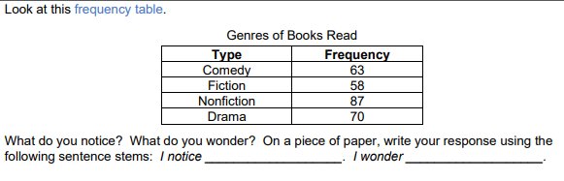

A frequency table represents data using tally marks and/or numerical counts. We use frequency tables to organize and represent collected data from a survey. What’s a survey? A survey is when someone asks a question and records the answers. What could have been the question for this frequency table? Write your answer. Look at the frequency table again. Then, answer the questions that follow the frequency table. The frequency table above shows the genres of books read by the fourth-grade students at Reed Elementary.

• How many fourth-grade students read only comedy books?

• How many fourth-grade students read comedy or drama books?

• How many more students prefer comedy and drama than non-fiction as their favorite genre?

• How many fourth-grade students participated in the survey? Hint: add all the frequencies

On your paper, explain how you know your answer to the third question is correct using the following sentence stem:

I know that _______ students prefer comedy and drama than non-fiction as their favorite genre because _____________________.

**Activity 2: Problem Solving with Dot Plots**

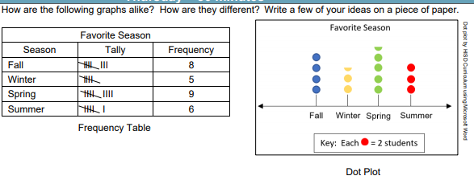

As we have been working on frequency tables this week, we know that a frequency table represents how many times something happens. We can represent this same data in a dot plot. A dot plot uses dots to represent how many times something happens, but can look different. We can change the value that each dot represents by creating a key. This let’s us know how much each dot represents. In our dot plot, the key tells us that one dot equals 2 students. If a whole dot represents 2 students what would a half dot represent? It would represent half of 2, which would represent 1 student. Look at the following dot plot:

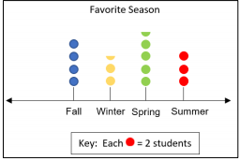

Answer the following questions about the dot plot on a piece of paper:

• How many total students were surveyed?

• How many students prefer winter or spring?

• How many students prefer winter or spring than summer?

• How many more students would need to vote for summer so that it has 2 times as many votes as fall?

Write an additional question that you can solve using the information in this frequency table. Then, explain how you would solve the problem.

**Activity 3: Problem Solving Dot Plots with Decimals**

Read the problem and look at the frequency table below: You conducted a survey of the students in your class to determine their shoe size. Then you listed students’ responses in the frequency table below:

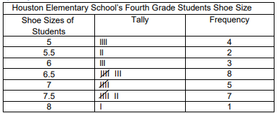

Based on the table, how many students have a shoe size of 7? Solution: When I look at the frequency table, I see five tally marks and a frequency of 5, so that means that 5 students have shoe size of 7. Represent the data in the frequency table above using the dot plot below. Then, answer the questions below.

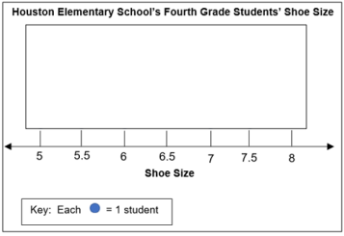

**Answer the following questions.**

• How many total students were surveyed?

• How many students have a shoe that is size 7.5?

• How many students have a shoe size that is 8?

• How many students have a shoe size smaller than 7.5?

• How many students have a shoe size of 5.5 and 7.5?

• How many students have a shoe size of 5 and 8?

• How many more students have a shoe size of 5.5 and 7.5 than a shoe size of 5 and 8?

**Activity 4: Life Cycle (Science)**

**Objective:** Explore and illustrate the life cycles of plants and animals, such as beetles, lima beans, crickets, and radishes.

**Think About It:** What are some changes we observe as organisms grow? What are some changes that happen to us as we grow? If you can, discuss this question and share your thinking with someone in your home.

**Do It:**

**What you need:**

• Pencil

• Science notebook/paper

• Markers/colored pencils

**What to do**:

• Illustrate the life cycle of a beetle.

• Label each stage of the life cycle.

• Illustrate the life cycle of a lima bean.

• Label each stage of the life cycle.

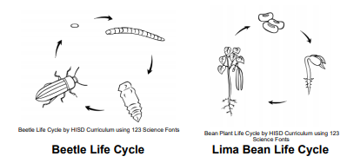

Beetle stages: egg, larva, pupa, adult

Lima Bean stages: seed, young plant, adult plant

**Understand It:**

Changes in physical characteristics of animals and plants can be evidence of growth. Animals and plants grow in different stages which may have similarities or differences between other animals in different life stages. Do life cycle illustrations include all off the stages the organism undergoes?

**Apply It**

Journal Entry: Describe each life cycle that you drew. Describe how each organism changes from the beginning to the end of their cycle.

**SEL Activity:**

Play the floor is lava Decide which furniture is ok to jump on and considered safe. Set a timer and the first person yells, “The floor is lava.” All other players must get to the “safe” spot before the time runs out.

**Activity 5: Imagine Math**

Complete at least 2 lessons on Imagine Math

**Activity 6: Producers (Science)**

**Objective:** Describe the role of producers in a food chain.

**Think About It!** What do all producers have in common? If you can, discuss this question and share your thinking with someone in your home.

**Do It!**

**What you need:**

• Pencil

• Science Notebook / Paper

• Colored pencils / Markers

**What to do:**

• Go on a scavenger hunt outside to find different producers.

• Identify 5 different producers.

• Draw pictures of the producers you found.

**Understand it!**

An organism that uses sunlight to make its own food for energy through photosynthesis is a producer. Most producers need sunlight, water, and carbon dioxide to make their own food. How many producers did you find? Do they all have the same thing in common?

**Apply It!**

Journal Entry: Explain how producers get their energy in your journal. Draw a diagram below your entry to support your explanation

**Activity 7: Jumping Jacks with Math Facts**

Do 12 Jumping Jacks.

Pick a number and do your multiplication facts.

For example:

1x1=1

1x2= 2, So I would do my 1 facts all the way to 12

**DO NOT USE 1 FACTS!!**

**Have someone record/video you doing your jumping jacks, and upload your video.**

**!Weekly Project: Types of Consumers:!**

You are to do research on the following consumers, which are: herbivores, carnivores, and omnivores. Then you are to create a book with the following:

Cover Page: On the cover page- Your name (ie. Miss Brigham); Title (ie: My Consumers Book); and a Picture

Page 1: Herbivore; Definition of Herbivore; A type of herbivore (ie: cows and deers); and a Picture of the herbivore that you chose (ie: cows or deers)

Page 2: Carnivore; Definition of Carnivore; A type of herbivore (ie:tigers and snakes); and a Picture of the carnivore that you chose (ie: tigers and snakes)

Page 3: Omnivore; Definition of Omnivore; A type of omnivore (ie:humans and bears); and a Picture of the omnivore that you chose (ie: humans and bears)

**Understand It!**

Animals that eat or consume plants and other animals are called consumers. Consumers depend on producers and other consumers to obtain their energy.

There are 3 types of consumers:

• Herbivore – consumes only producers

• Carnivore – consumes only consumers

• Omnivore – consumes producers and consumers.