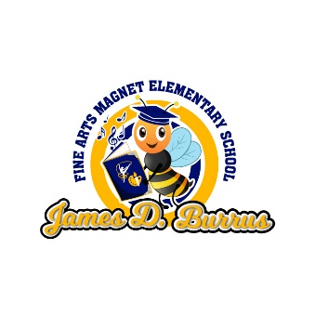
James D. Burrus Fine Arts Magnet Elementary School
SDMC Meeting Minutes
December 7, 2021
The meeting was called to order at 3:30 p.m.
Mrs. Williams welcomed all members and paused to make a special introduction of the newly acquired business partner, Joni VanReenan from IEducate. She continued the meeting by beginning to provide details on the status of HB4545 interventions/tutorials for 4th and 5th grade students. The campus has created systems within the daily schedule and afterschool tutorial time to provide additional intervention to meet the requirements of the HB4545.
The next agenda item was alerting members of Camp Spark, the holiday intervention days scheduled for December 17 – 18, 2021. Burrus elected to make these days available for students to attend to receive targeted intervention and skill building at the beginning of the winter break.
Field investigations are currently underway to determine how campus field trips will be scheduled for the upcoming spring semester. Currently, only select academic and athletic field trips are allowed with the appropriate approval.
Burrus is actively seeking to build on student attendance and ensuring students are present to participate in daily instruction. To continue to promote this initiative, the campus will be hosting “Attendance Jams” for students who have exhibited consistent positive attendance records with an opportunity to win a figit toy. For those students who have excessive absences, they will be administered attendance contracts with their parent/guardian recommended to come to campus for an attendance meeting. All other nonacademic support will be forwarded to and addressed by the new campus Wraparound Service Specialist, Ms. Duplechain.
Mrs. Williams emphasized the desire to increase parent involvement and engagement at the campus. The school as several events scheduled in the coming weeks where parents are highly encouraged to be in attendance and seek to contribute to each event which are geared towards building student learning capacity. During the month of December Burrus will host S.T.E.A.M. Night; students are asked to contribute an art submission or performance to be displayed at the event slated for later in the month. As an additional avenue to boost parent engagement, members we reminded of the 2017 Gold FACE distinction; Burrus will be hosting trainings for parents to help build a more family friendly school and to reach and exceed the distinction earned in the previous academic year.
The last item of business was to discuss the upcoming support the campus is slated to receive in the month of January. In school tutorials will be supported by IEducate, where College readiness Mentors will provide redirection and small group tutoring during the academic school day.
Mrs. Williams opened the floor for any feedback or comments. With all SDMC member in agreeance, the meet was adjourned at 3:53 p.m.

