**Math/Science Choice Board(Choose 5 out of seven activities: Project a Must!!)**

|  |  |  |
| --- | --- | --- |
| **Activity 1: Calculate Profit in a Real-World Situation** | **Activity 4: Gravity (Science)**    Objective: Design a descriptive investigation to explore the effect of gravity on an object | **Activity 5: Imagine Math**    **Work on Imagine Math** |
| **Activity 2: Calculate Profit in a Real-World Situation** | **SEL: Do a "Deck of Cards" workout!**   | **Activity 6: Weather**    Objective: Read weather maps including weather symbols and map keys. |
| **Activity 3: The Purpose of Financial Institutions**   | **Weekly Project: Chemical Reactions Turn a Penny Green**   | **Activity 7: Phases of the Moon**   |

**Activity One: Calculate Profit in a Real-World Situation**

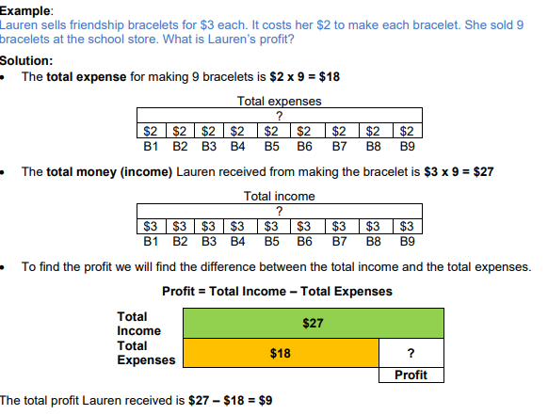

**Practice: Solve and write your solution using the sentence stems below:**

1. Nathan sold lemonade in front of his house. The cost of preparing the lemonade was $7.45. The money he received from the sale of the lemonade was $37.50. What was Nathan’s profit?

2. Randy sold pencils decorated with a fancy eraser. Randy’s expenses were $23.75 for supplies. She sold 35 pencils for $1.00 each. What was Randy’s profit? 3. John operates a candy store business. John’s expenses for his candy store are chocolate $76.59, jellybeans $54.23, taffy $17, and lollipops $37.54. Last week, John made $875 in candy sales. What was John’s profit for the week?

• The total expenses are _______________ because _______________________.

• The total income is ________________ because _________________________.

• The total profit is __________________ because _________________________.

**Activity 2: Calculate Profit in a Real-World Situation**

**Practice:**

1. Heather bought an old wooden bookcase. She repaired it and put a new coat of stain on it. When it was finished, she sold it to a neighbor. Heather made the following list to help her calculate her profit. How much profit did Heather make? Write answer using a complete sentence.

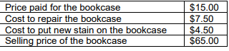

• I know $_____________ represents money received (total income), and $______________ represents the cost (total expenses).

Answer:_______________________________________________________________________

1. Jason mowed 15 lawns for $25 each. He spent $16.08 on fuel for his lawn mower. What was Jason’s profit?

• I know $_____________ represents money received (total income), and $______________ represents the cost (total expenses).

Answer:_______________________________________________________________________

1. Cali purchased supplies and props for three photo shoots. She received $78 in payment for each of the three photo shoots. What was Cali’s profit?



• I know $_____________ represents money received (total income), and $______________ represents the cost (total expenses). Answer:_______________________________________________________________________

1. Kevin sold 30 burgers today for $6.50 each. The supplies to make the burgers cost Kevin $89.20. What was Kevin’s profit?

• I know $_____________ represents money received (total income), and $______________ represents the cost (total expenses). Answer:_______________________________________________________________________

**Activity 3: The Purpose of Financial Institutions**

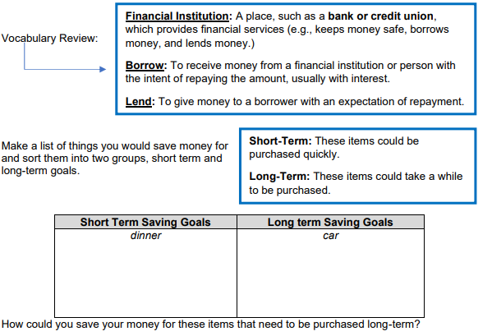

• I can save money in a _________________ to purchase my long-term items. (Piggy Bank, Bank) How could you save your money for these items that need to be purchased short-term?

• I can save money in a _________________ to purchase my short-term items. (Piggy Bank, Bank)

**Practice:**

1. Mr. and Mrs. Troutman have been saving money for several years to purchase a new home. However, they do not have enough money to purchase one yet. How can a bank help the Trautman’s to buy a new house?

2. William has $125 saved from doing extra chores and jobs around the house. His mom takes him to the bank to open a savings account. What are some advantages to keeping his money in the bank rather than at his home?

**Challenge**:

Make a T-chart labeled Advantages and Disadvantages. List the advantages and disadvantages of saving money using a financial institution versus just keeping it at home (e.g., hiding it under a bed)

**Activity 4: Gravity**

**Objective:** Design a descriptive investigation to explore the effect of gravity on an object.

**Think About It!** What force is acting on an apple falling off a tree toward the ground? If you can, discuss this question and share your thinking with someone in your home.

**Do It!**

**What you need:** • Pencil

• Science notebook/ Paper

• Small objects of various weights

**What to do:**

• With an adult’s assistance, stand on a bench or chair.

• Drop each of the objects one by one.

• Repeat the drops 3 times.

• Make observations of each drop.

• Draw a picture of your investigation.

• Which object fell the fastest? The slowest? Why?

**Understand it!**

Gravity is a force that attracts objects together. Gravity pulls objects toward the Earth.

**Apply It!**

Explain how the images demonstrate the pull of gravity on metal objects. What are some other examples of gravity?

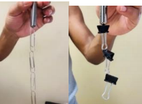

**SEL Activity: Do a "Deck of Cards" workout!**

Assign each shape a different exercise. For example, Hearts = running in place, Diamond = jumping jacks, Spades = push-ups, Clubs = sit-ups. Take turns flipping the cards and doing that number of the exercise.

**Activity 5: Imagine Math**

Complete at least 60 minutes a week on Imagine Math

**Activity 6: Weather**

**Objective:** Read weather maps including weather symbols and map keys.

**Think About It!** What are the parts of a weather map? If you can, discuss this question and explain your thinking with someone in your house.

**Do It!** 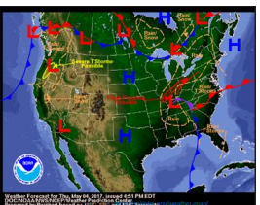

**What you need:**

• Pencil

• Science notebook/ Paper

• Weather Map

**What to do:**

• Look at the weather map shown to the right.

• Describe the symbols that are near the following states.

o Texas

o California

o Florida

**Understand it!**

To depict weather from day to day, specific weather symbols are displayed on weather maps. Symbols that are generally viewed on weather maps consist of those for a high-pressure system, low-pressure system, front (cold, warm, and stationary), jet stream, and air mass.

o Cold front - is a boundary between two air masses, one cold and the other warm, moving so that the colder air replaces the warmer air.

o Warm front - is a boundary between two air masses, one cool and the other warm, moving so that the warmer air replaces the cooler air.

o Stationary front - is a boundary between two air masses that do not move.

**Apply It!**

Create a three-flap folding model. Label one flap cold front, one flap warm front and the other flap stationary front. In your own words write a definition for each term. On the bottom flap describe the weather condition.

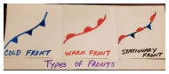

**Activity 7: Phases of the Moon**

Watch the following video on YouTube: <https://www.youtube.com/watch?v=76-HAqNKqKA>

and describe the different phases of the moon in your own words. Should be at least 4 sentences.

**Weekly Project: Chemical Reactions-Turning a Penny Green**

**What You Need:**

* Copper pennies
* [White vinegar](http://www.amazon.com/gp/product/B000RO08L0/ref=as_li_tl?ie=UTF8&camp=1789&creative=390957&creativeASIN=B000RO08L0&linkCode=as2&tag=buggyandbuddy-20)
* Dish or bowl
* [Paper towel](http://www.amazon.com/gp/product/B00I4F1W78/ref=as_li_tl?ie=UTF8&camp=1789&creative=390957&creativeASIN=B00I4F1W78&linkCode=as2&tag=buggyandbuddy-20)

**Directions:**

1. Fold a [paper towel](http://www.amazon.com/gp/product/B00I4F1W78/ref=as_li_tl?ie=UTF8&camp=1789&creative=390957&creativeASIN=B00I4F1W78&linkCode=as2&tag=buggyandbuddy-20) so that it fits inside your dish.
2. Place the **pennies** on top of the paper towel.
3. Pour [vinegar](http://www.amazon.com/gp/product/B000RO08L0/ref=as_li_tl?ie=UTF8&camp=1789&creative=390957&creativeASIN=B000RO08L0&linkCode=as2&tag=buggyandbuddy-20) over the pennies so that the paper towel is fully saturated.
4. **Observe** the pennies over the next few hours and days.

### **Tips**

Leave this experiment out for a few days, adding more vinegar as the paper towel began to dry out and flipping the pennies over occasionally. The longer we waited, the more green they became!

### **Question to Spark Curiosity & Critical Thinking**

What happened to the pennies over time? What is your theory as to why this happened?

Can you think of any other chemical reactions you’ve seen in everyday life?

**Mrs. Johnson’s Work**

Fourth Grade Math

Look at the money represented below then use the information to complete the table.

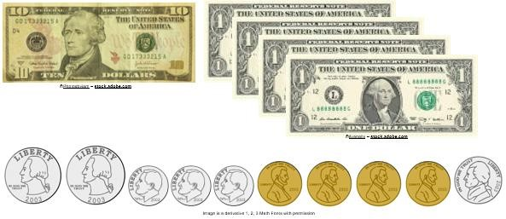

For the set of money above, draw a place value chart and place the number in the chart. Represent each digit in the place value chart. Then, complete table below.

|  |  |
| --- | --- |
| Standard Form |  |
| Expanded Form |  |
| Expanded Notation (decimals) |  |
| Expanded Notation (fractions) |  |

Amount of money: $ 8.21

Draw a place value chart and represent each digit in the place value chart. Then, complete the table below.

|  |  |
| --- | --- |
| Standard Form |  |
| Expanded Form |  |
| Expanded Notation (decimals) |  |
| Expanded Notation (fractions) |  |

Amount of money: $17.09

Draw a place value chart and represent each digit in the place value chart. Then, complete the table below.

|  |  |
| --- | --- |
| Standard Form |  |
| Expanded Form |  |
| Expanded Notation (decimals) |  |
| Expanded Notation (fractions) |  |