Isaacs Elementary

Pre-K Choice Board

|  |  |  |
| --- | --- | --- |
| Reading  LITERACY: Let’s Wash Our Hands!  • Watch Ready Rosie video Rub a Dub Counting on readyrosie.com or model washing hands with your child  Need help logging in? Contact your teacher to get your username and password.  • Write down the steps to wash hands    Picture of retelling a story with permission from Ms. Coronado  Questions for children:  1. Can you tell me what the steps are for washing your hands?  2. What happens if people do not wash their hands?  Extension: Review letter names and sounds  <https://www.youtube.com/watch?v=lhX064AiyGg>  or practice writing alphabet with your child   * Upload a picture to Seesaw of your child practicing handwashing | Math  Looking for Shapes • Look for shapes around the house • Draw the shapes you found on paper or print these • Place shapes on floor then toss a ball or rolled-up sock on top and name them    Picture of finding shapes activity with permission from Ms. Coronado  Extension: Imagine Math: Complete one lesson  <https://math.imaginelearning.com/users/sign_in> or practice rote counting with your child 1-35.   * Upload a picture of your child writing their numbers to Seesaw | Science  Toy Box Science-Collect 6-8 objects from your toy box.  Observe (look at) the toys (or objects) and think about their size.  C:\Users\P00023632\AppData\Local\Microsoft\Windows\INetCache\Content.MSO\CE3D91FE.tmp    Describe (tell) if each toy is big or small  The __________ is big because __________.  The __________ is small because __________.    Sort (group) the toys by size on the mat.  C:\Users\P00023632\AppData\Local\Microsoft\Windows\INetCache\Content.MSO\5A6D176B.tmp |
| Reading  Questions for children:  1. Which shape is in between the square and circle?  2. Can you name the shape that is above the triangle?  3. I’m thinking of a shape that has three sides, which one is it?  Extension: Review letter names and sounds or practice writing alphabet with your child  <https://www.youtube.com/watch?v=DqQtkbXLx4k&t=5s> | Math  Math Resources  • Frog Street Resource: Shape Cards pages 14-18  Extension: Imagine Math: Complete one lesson or practice rote counting with your child  <https://math.imaginelearning.com/users/sign_in>   * Upload a video to Seesaw of your child   rote counting 1-35. | S. Studies  From Here to There: Noticing Nature  Engage your preschool children’s senses and help them answer their own questions by exploring the outdoors.  What You Need: Walking shoes, Sandbox or a patch of dirt Blocks or rocks, toy cars, trucks, and plastic bowls  What You Do:  1. Take a walk around the neighborhood, and notice the  types of houses and chimneys on the street. Point out  signs that indicate location.  2. Talk about the street that you live on, such as the  number of houses, the size of the street, the trees in  the yards, etc.  3. Ask your children to describe what they see, hear, and feel.   * Upload a picture to Seesaw of your nature walk |
| Reading  Read Doctors Help by Dee Ready on <https://clever.com/> or read a book about doctors you have at home/recall a doctor’s visit  • Draw and write how doctors help people    Picture of writing activity with permission from Ms. Coronado  Questions for children:  1. What do you think might happen if we are sick and we do not go to see the doctor?  2. What can we do to stay healthy?  Extension: Review Letter Names and Sounds or practice writing alphabet with your child  <https://www.youtube.com/watch?v=KsDMOJbWt_Y> | Math  Create Patterns  • Read It’s a Pattern! By M.W. Penn on https://clever.com/ or a Math book at home  • Create a sound pattern (clap, snap, clap, snap, clap, snap)  • Create patterns with items around the house (AB, AB, AB) (ABC, ABC, ABC)    Picture of pattern activity with permission from Ms. Coronado  Questions for children:  1. What other patterns can you create?  2. Why do we have to notice patterns around us?  Extension: Imagine Math: Complete one lesson or practice rote counting with your child 1-35.  <https://math.imaginelearning.com/users/sign_in> | SEL  Gratitude Walk  Take a walk outside your home with a parent or guardian. As you are walking, say 10 things you are grateful for. You can take turns saying what you are grateful for with your parent/guardian. (Use your 10 fingers to count to 10!)  Sentence Stem: I am grateful for ___________. |
|  | | |
| Weekly Project: “My Moment in History”  A journal of your experience during COVID-19 | | |
| You are living during a historic time. Create a journal where you can write and draw about your experiences every day. To set up your journal, you can staple together several pieces of paper (or fold them in half together) or use a notebook/journal you have at home. Then decorate the outside with the title, your name, and pictures. You will create 2-3 entries for this week and a few more entries in the weeks to come. Every entry should have a picture, and at least one word of what you did that day.    Day 1: Make your journal and color the cover page.    Days 2-3: Make an entry for the day, by drawing a picture and sounding the word out and writing it.  Options:  - Your favorite activity you did that day (inside game, outside play, school work, TV you watched)  - How you felt that day  - What you ate that day  - Anything else that was important for you that day.  ** Try to make each day’s entry different** | | |  |

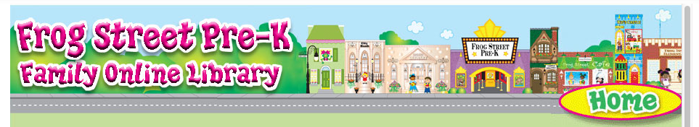

Dear Family,

We encourage you to read stories with your child. You can read the same stories your child has at school. Here is how to access to Frog Street Pre-K eBook Libraries:

[www.frogstreet.com](http://www.frogstreet.com/)

click:  Login to Portal

Email box:  type the word parent

Password box: type the word parent