# SDMC Meeting

# December 16th

1. Glows/Grows

Glows

* 1. Festive music
  2. Deck the Halls
  3. Improved student behavior
  4. Co-teacher 1st year focuses on respect and has had no behavior
  5. Honor Roll Celebrations

Grows

1. Hallways are still busy
2. Testing: We need everyone to have testing calendar when planning since it is provided at the beginning of the school year.
3. English Dept: Special education exemptions
4. Late students into 1st period.
5. ID badges
6. School Culture
   1. How are we doing as a campus with shifting the mindset of our students?
      1. Majority of our students are getting into classroom. It is a handful of students that are not following expectations.
      2. Counselors going advocacy to advocacy to be taught certain skills.
      3. Lobo TV Counselors Corner
7. Budget
   1. Budget meeting took place and occurred: $514,000 will be lost.
   2. Budget left with $1.1 million
8. Master Schedule
   1. PLC Conference times
   2. Consistent PLC times
   3. Rotating A/B schedule

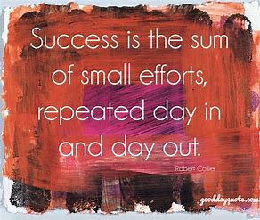

SDMC Meeting

December 16, 2023

Sign in Sheet