Isaacs Elementary
Pre- K Choice Board Lewis 05/11/2020-05/15/2020
Reading  Observing Ants!  - Place the food samples in areas where you have seen some ants  - Gather food samples (example: a piece of candy, a cracker, a cookie, a piece of fruit, an ounce of soda, etc.).  - Label each plate with the food sample it will hold  - Have your child observed which food items attract the ants  - Create a chart with the food sample name to check which food item attract the ants  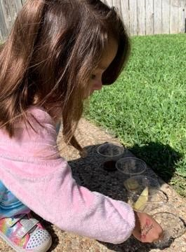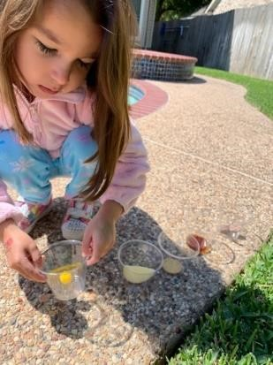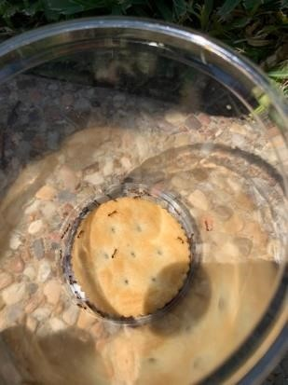  Pictures of ant activity with permission from Ms Coronado taken with iPhone  Questions for children:  - What did you notice?  - Why do you think the ants are attracted to ___?  - Which foods are the ants not attracted to? | Math  Number Hop  - Draw with chalk the numerals 0 through 9 on sidewalk, describe how you wrote the numbers (straight lines, curves, circles)  - Play with your child saying “Johnny, please hop on the number ___”  Questions for children:  - Which number did you land on?  - Can you show with your fingers what number did you land on?  - Can you sky write the number that you landed?  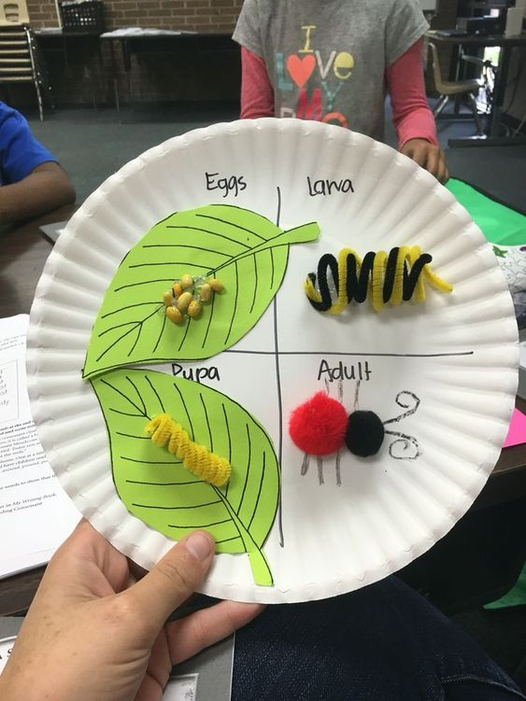  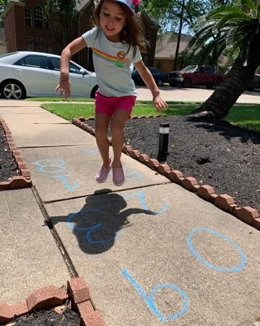  Picture of counting numbers with permission from Ms. Coronado taken with iPhone  Complete 20 minutes of Imagine Math  Upload hopping activity to Seesaw | Science  Life Cycle of an Ant  - Read a book about ants  - Explain that you are going to discuss the life cycle of an ant  - Have your child recall another life cycle we have discussed (Butterfly)  - Explain that all insects have a life cycle  - The life cycle of an ant is first the egg, then the larva, after that is the pupa, and last is the ant  - If you do not have access to the materials in the example your child may draw the life cycle and write the words independently
Reading  Math and Literacy Combined  Bug Homes  - Read a book about insects  - Observe insects to find out about where they are living, what they are doing, and how they look  - Try to observe a variety of bugs over the course of two or three days. Look under old logs, large stones or bricks, in the grass, dark/moist areas, in a tree, in the dirt, on leaves of plants  - Take photos of the bugs you see while scouting them  - On a piece of paper draw a chart that shows the bugs observed and some data about them  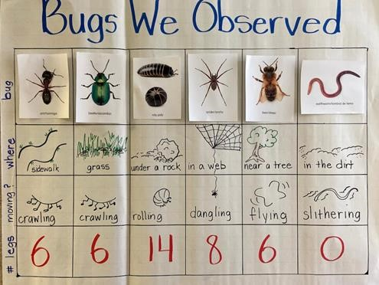  Image of bug chart description with permission from Children’s Learning Institute at UTHealth The University of Texas Health Science Center at Houston  Questions for children:  1. What is the bug’s name?  2. Do you see the bug’s legs?  3. Do you see any wings on the bug?  4. What color is the bug?  5. Are there any shapes or patterns on the bug?  6. What is the bug doing? Is it the flying, crawling, eating…?  7. Where is the bug?  Upload Bugs We Observed chart to Seesaw when complete | Math  Math and Literacy Combined  Bug Homes  - Read a book about insects  - Observe insects to find out about where they are living, what they are doing, and how they look  - Try to observe a variety of bugs over the course of two or three days. Look under old logs, large stones or bricks, in the grass, dark/moist areas, in a tree, in the dirt, on leaves of plants  - Take photos of the bugs you see while scouting them  - On a piece of paper draw a chart that shows the bugs observed and some data about them  Children’s Learning Institute at UTHealth The University of Texas Health Science Center at Houston  Questions for children:  1. What is the bug’s name?  2. Do you see the bug’s legs?  3. Do you see any wings on the bug?  4. What color is the bug?  5. Are there any shapes or patterns on the bug?  6. What is the bug doing? Is it the flying, crawling, eating…?  7. Where is the bug?  Complete 20 minutes of Imagine Math |  | Social Studies  Basic Needs  - Explain to your child that they will create a Mind Map to show the basic things that we need  - Discuss with your child the basic human needs such as food, water, clothes, a place to live. Explain to them that we need those things to stay healthy  - In the middle of your Mind Map the title should be Basic Human Needs  - In the circles branching out your child should draw a picture of the basic needs that humans have  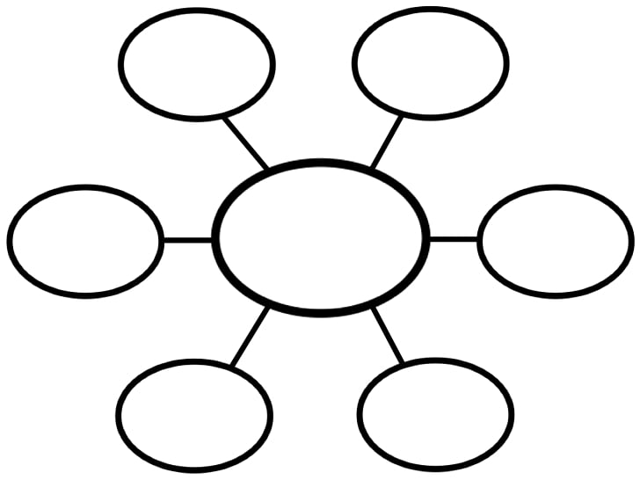  Upload to Seesaw
Reading  Bugs’ Life  - Discuss with your child, if you could be any insect, what would you like to be and tell why  - Ask your child to make up their own insect story and Illustrate it  - Ask your child to retell their story to an adult or a sibling at  Home  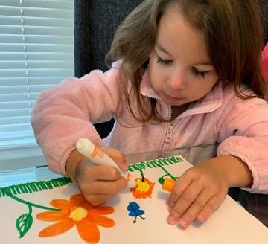  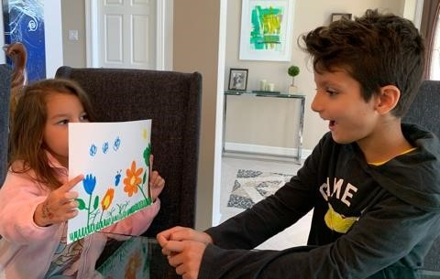  Picture of bug story with permission from Ms. Coronado taken with iPhone  Questions for children:  1. Can you name other insects that you like? | Math  Patterns Caterpillar  - Create a shape pattern caterpillar  - Help your child use different materials and objects to make a pattern shape caterpillar  - Use regular or construction paper to draw and cut shapes  - Use shapes or objects you have at home  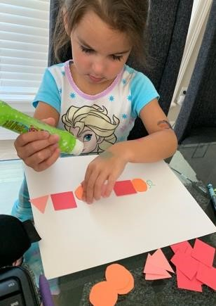  Picture of caterpillar patterns with permission from Ms. Coronado taken with iPhone  Questions for children:  1. What kind of patterns is this?  2. Can you extend the pattern?  Complete 20 minutes of Imagine Math |  | SEL  Starfish and Tornadoes  The goal: To help kids notice how much energy they’re feeling inside. When they know they have too much energy, they can either use their own calming skills or ask for help from a trusted adult.  - Make a picture of a thermometer, explain to your child what a thermometer does.  - Draw a starfish at the bottom and a tornado at the top.  - Ask if your child feels calm and peaceful like a starfish or revved up like a tornado.  - When your child is feeling over-energized, brainstorm together about ways to feel more like a starfish. For example, bouncing a ball to help release some of that energy.  - Upload to Seesaw with a video of your child discussing the calming strategies that they came up with
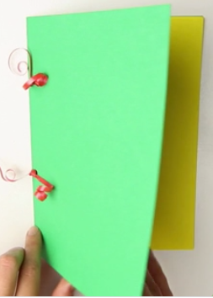
Weekly Project (ABC Journal)
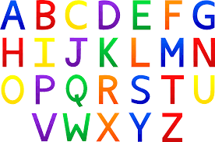

Monday- We will continue our ABC Journals from last week. Have your child to think of things that begin with the letter “L”, they can also find items around your home that begin with the letter. They should then write the letter at the top of the first page in their journal and draw and practice sounding out and labeling the items that they drew that begin with the Letter L.

Tuesday- Have your child to think of things that begin with the letter “M”, they can also find items around your home that begin with the letter. They should then write the letter at the top of the first page in their journal and draw and practice sounding out and labeling the items that they drew that begin with the Letter M.

Wednesday- Have your child to think of things that begin with the letter “N”, they can also find items around your home that begin with the letter. They should then write the letter at the top of the first page in their journal and draw and practice sounding out and labeling the items that they drew that begin with the Letter N.

Thursday- Have your child to think of things that begin with the letter “O”, they can also find items around your home that begin with the letter. They should then write the letter at the top of the first page in their journal and draw and practice sounding out and labeling the items that they drew that begin with the Letter O.

Friday- Review letters L, M, N, and O in the journal. Discuss what things you were able to find that begins with the letters, review the pictures and the sounds each letter makes.

- You should be uploading the letters of the week to Seesaw when complete

