1. Reading  LOOK at the picture below:  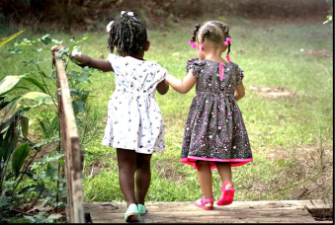  THINK about how friends are special people that we choose to connect with.  WRITE about a time you had fun with a friend.  Be sure to ―  • write about a personal experience  • organize your writing  • develop your ideas in detail  • choose your words carefully  • use correct spelling, capitalization, punctuation, grammar and sentences.   | 2. Math  Two step addition and subtraction word problems.  Read the following math story three times:  1. Read the first time and picture what the math story is about.  2. Read the second time and focus on the question and what you need to find out.  3. Read the third time and determine what important information is needed to answer the question.  Matt saved $225. He saved $264 less than his brother John. How much money did the two brothers save altogether?  Look at this strip diagram on how to model the math story.  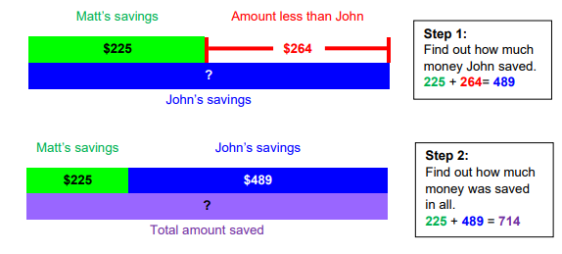  Represent the following math stories using strip diagrams and solve using your favorite math strategy.  1. Ally has 230 toys. She has 15 more toys than Becky. How many toys do Ally and Becky have altogether?  2. Cassy collected 542 seashells at the beach. Katy collected 302 fewer seashells than Cassy. On the way home, Katy lost 45 seashells. How many seashells does Katy have now?  3. On Wednesday, 657 people attended a museum. On Thursday, 38 fewer people attended the museum than Wednesday. How many people attended the museum on Wednesday and Thursday combined? | 3. Science  Observe and identify how magnets are used in everyday life.  Explore magnetism by testing objects with a refrigerator magnet.  Think About It! What are some objects around your home that can be considered magnetic? If you can, discuss this question and share your thinking with someone in your home.  What to do: • Look on your refrigerator to see if you have a magnet • If you do, use the magnet to test various objects and items around your home • Use the Non/Magnetic chart and list all the items you discovered in the correct column. • If you do not have a refrigerator magnet, use your magnetic item (paperclip) and search your home for an object the paperclip will stick to.  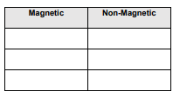  Understand It! • Magnets attract materials that are made of IRON, STEEL or NICKEL. • A magnet has two sides or ends called poles. (North Pole and South Pole) • With magnets, the opposite poles are attracted to each other • When magnets have the same side close to each other they push away, or Repel.  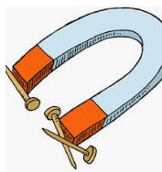  Resources: sheet of paper, Pencil, Colored pencils.
4. Reading  Feelings Change Timeline  • Use a story to create a timeline of the character’s feelings and traits throughout the text.  • As you read, ask yourself:  o How does the character feel?  o How are the character’s feelings or traits changing?  • Use the timeline below to share how the main character’s feelings change.  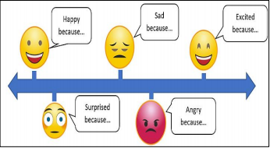 | 5. Math  Draw a polygon with five sides.  1. How many vertices does the polygon have?  2. What type of polygon did you draw?  3. How many vertices does the polygon have?  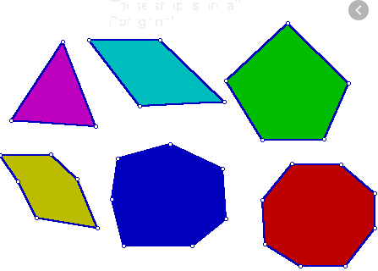 | 6. Science  Weather – Making Choices  Identify the importance of weather and seasonal information to make choices in clothing, activities, and transportation.  What to do: • Observe the pictures of each season.  • Brainstorm how you would dress and which activities you would do during each season, using the pictures as a guide. • Draw a line down the middle and across the middle of your notebook page to make four squares. Label the squares Fall, Winter, Spring and Summer.  • Draw and label pictures of clothing you would wear, activities you would do, and transportation you would take during each season.  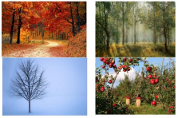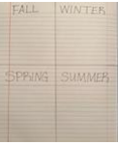
7. Reading  Rock and Roll Plot  • For this activity, you will need dice.  • If you do not have dice, you may cut apart the pictures below, place the pieces into a cup, and pull one out for every turn.  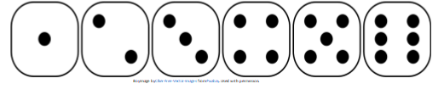  Use a book or the story When Will We Have Flying Cars  https://www.readworks.org/assignment/ZN5WCN/cbb32a83-e057-4009-b609-710642981b1e/assessmentarticle?abu=%2Fassignments%23!assignmentTab%3Aa%2FclassCode%3AZN to, select words to complete the activity.  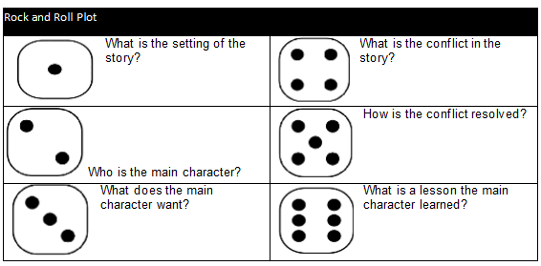  10. Reading  Log on to Imagine Reading for 60 minutes. Using the log in information sent to you.  OR  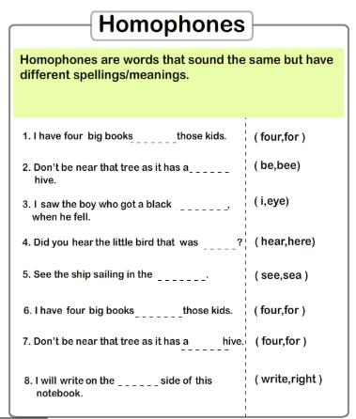 | 8. Math  Log on to Imagine Math for 60 minutes. Using the log in information sent to you.  OR  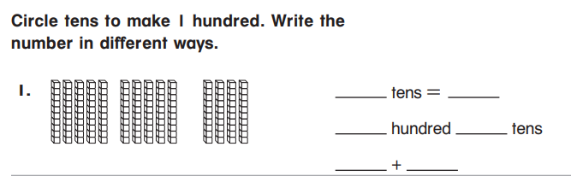  11. Math  Read the following math story three times:  1. Read the first time and picture what the math story is about.  2. Read the second time and focus on the question and what you need to find out.  3. Read the third time and determine what important information is needed to answer the question.  The school’s library has 687 books. They donated 241 books to charity. Then, they bought 325 new books. How many books does the library have now?  Look at this strip diagram on how to model the math story.  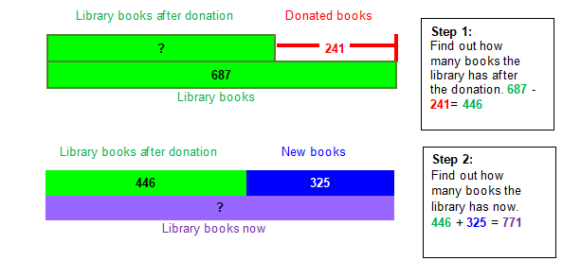  Represent the following math stories using strip diagrams and solve using your favorite math strategy.  1. A clothing store had 345 shirts on Wednesday. They received a shipment of 308 shirts on Thursday. They will receive a new order of 231 shirts on Friday. How many shirts will the store have then?  2. Ms. Campbell has 324 crayons. Her friend gave her 417 crayons. Ms. Campbell then gave 105 crayons to her students. How many crayons does Ms. Campbell have now?  3. A concert event has 600 tickets for sale. They sold 230 on Monday and 115 on Tuesday. How many tickets do they have left for sale? | 9. Social Studies  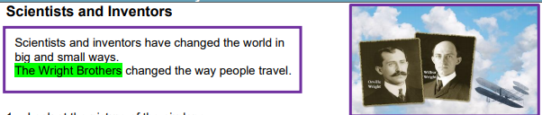  1. Look at the picture of the airplane. 2. Write/draw about how airplanes look now  12. Social Studies  Technology  See: Describe what you see in the picture.  Think: About if the picture was taken long ago or not so long ago.  Wonder: Write a sentence about the picture.  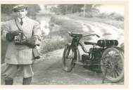  Resources notebook paper, copy paper, crayons.  .

Weekly Project: ‘Compound word foldable’

Think about some compound words you know. Create a portrait foldable. Write the compound word, draw a picture and color like the one below. Compound words are formed when two or more words are joined to create a new word that has an entirely new meaning. For example, “Sun” and “flower” are two different words, but when put together, they form another word, Sunflower.
What you need:
- Paper
- Crayon or color pencil
- Scissors
- Pencil
Steps:
- Fold the Paper such that you will have point A, B and C.
- Crease the paper along the fold.
- Open the paper and cut point A and C in the middle.
- The crease line is the bisector of the segment.
- On point B write the compound word and draw.
- For Point A and C, you will break up your compound word. Write and draw the first part of the word on point A and the other on point C.
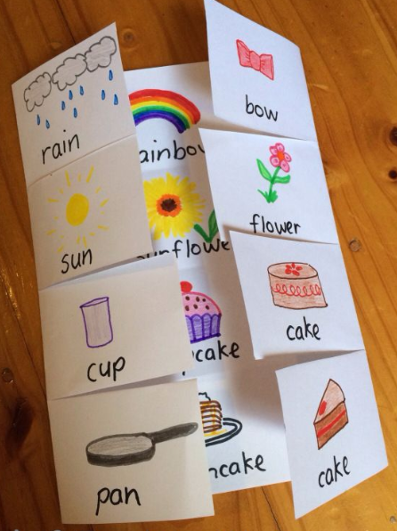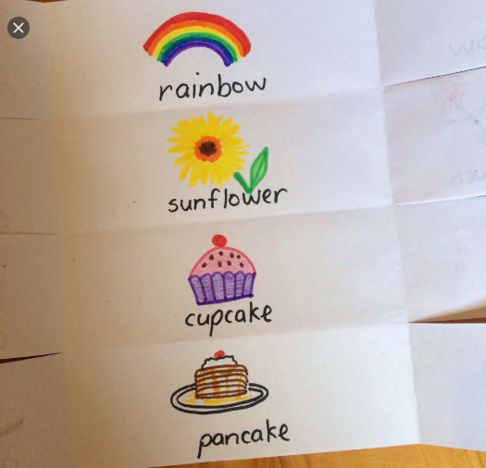
Directions: Each week students will receive a menu to be completed by the end of the week. Students will choose activities based on interest but must do: 9 squares (3Reading, 3 Math, 1 Science, 1 Social Studies, 1 extra, + Project). Of the 12 boxes, 9 must be completed. More points and reward will be given to students that will send their pictures or videos of them (parents and students) completing the work.
*The 9 boxes activity due date is May 8, 2020 while the project due date is May 15, 2020. Please submit evidence of the completion of all these activities for your child to receive the grades that are required by Texas Education Agency for this semester of learning. send completed work via our class dojo or email it to me at Esther.Onyia@houstonisd.org
If you have any questions, please feel free to call Ms. Onyia @ 281-748-6694.
Thank you for your time and patience during this time of need. Amazing Second Grade.

