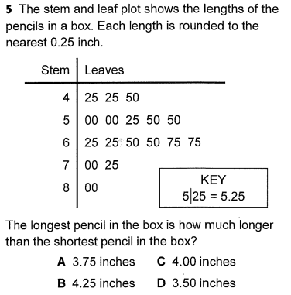  - Remember the numbers are listed from least to greatest. Pay attention to the Key that is given to you | Food Web and Food Chain  https://www.generationgenius.com/videolessons/food-webs-video-for-kids/  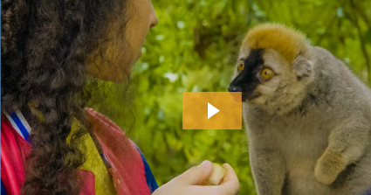  - watch the video first, once you are done answer the questions below:  - why do animals eat other animals?  - What are producers and consumers and how do they get their names?  - What role in the food web does the eagle play?  - What do zebras eat and what eat zebras? | What does it Mean?  - Food Chain  - Food Web  - Photosynthesis  - Producer  - Apex Predator  - Decomposer  - Bacteria  - Fungi  - Extinction  - Compost
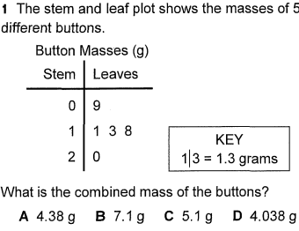 | SEL:  - If you can go anywhere in the world to visit, where would you go and why?   | READ ABOUT IT  https://www.generationgenius.com/food-webs-reading-material/  
IMAGINE MATH  - You are to spend at least 40 minutes on Imagine Math Today  • WWW.CLEVER.COM  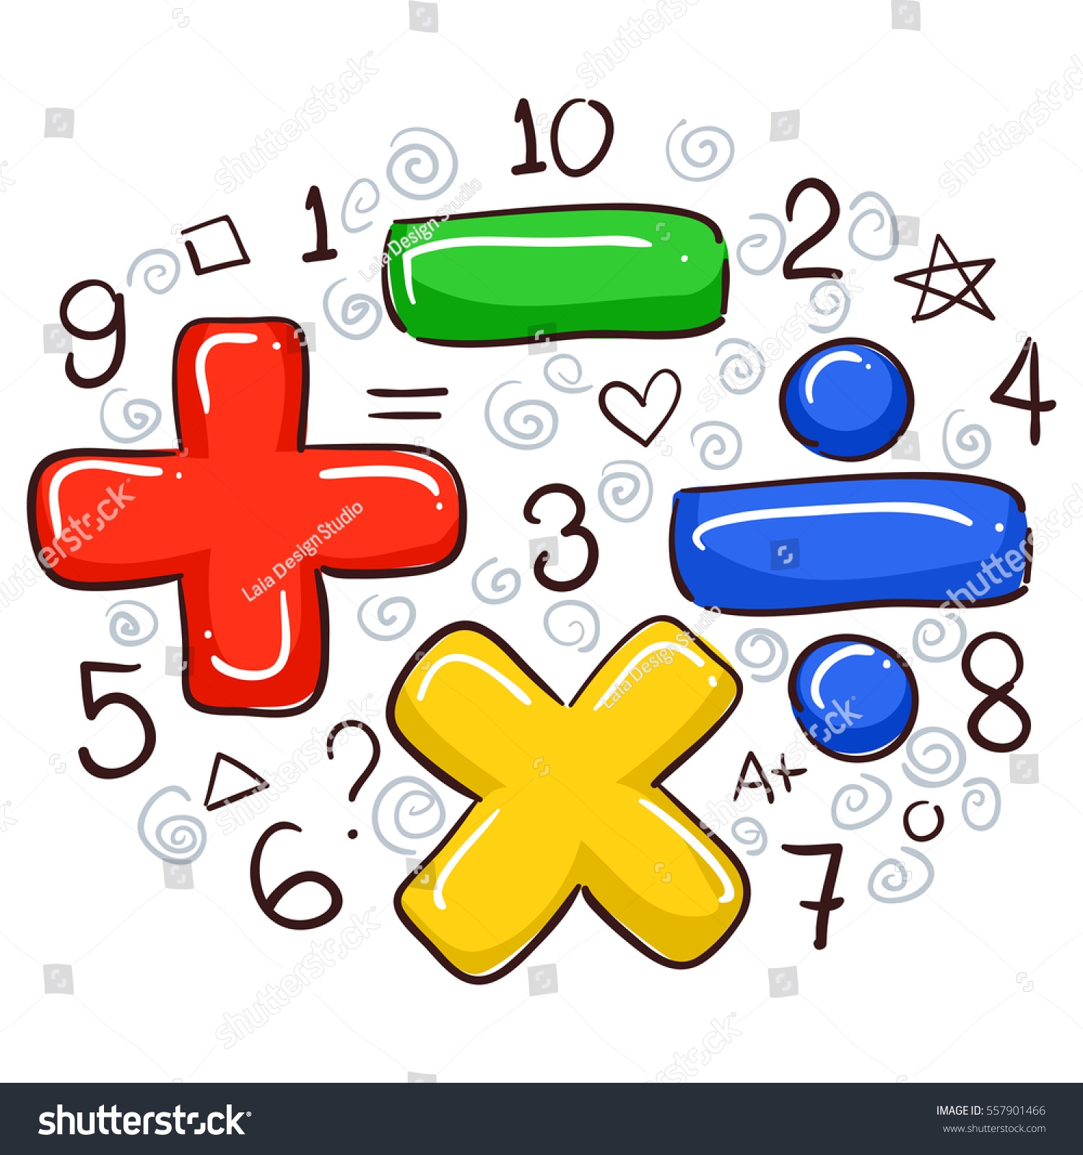 | IMAGINE MATH  - You are to spend at least 40 minutes on Imagine Math Today  • WWW.CLEVER.COM  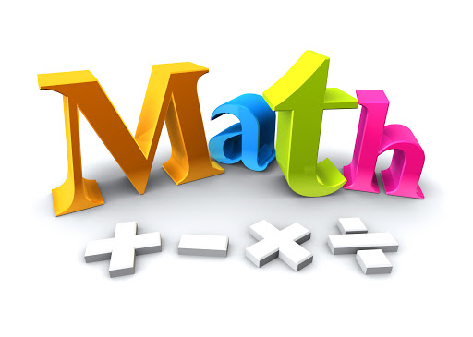 | IMAGINE MATH  - You are to spend at least 40 minutes on Imagine Math Today  • WWW.CLEVER.COM  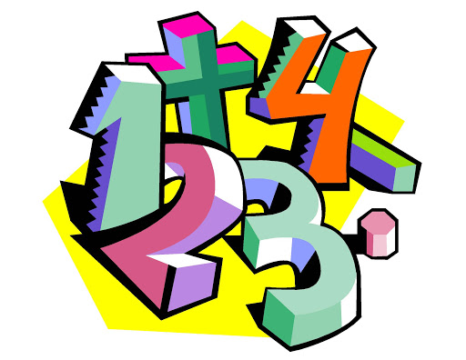
CHOICE BOARD

