2025-2026 Action Plan

Lockhart Elementary School
Cameshia Emerson

Effective Districts – Planning Diagram
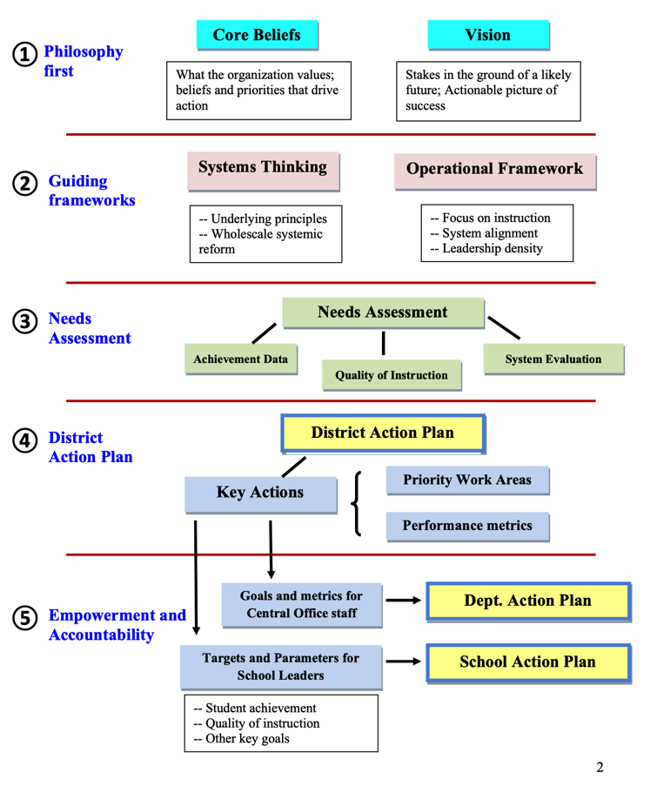

Needs related to student achievement data
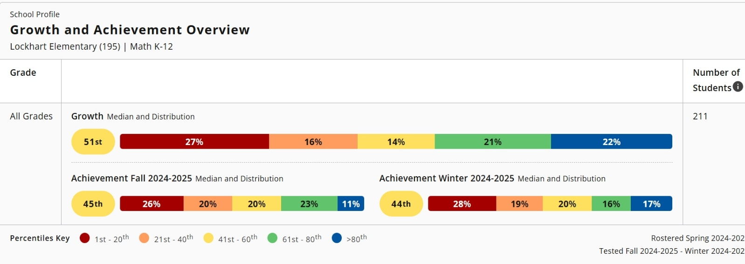
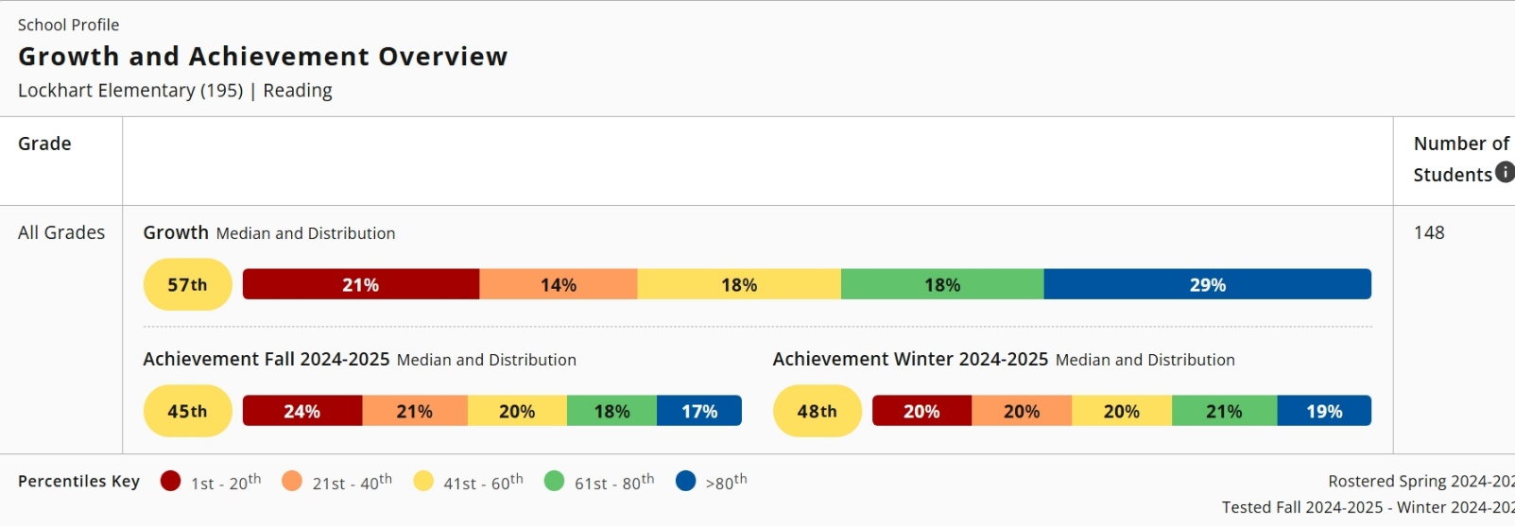

Needs related to improving the quality of instruction
Key Areas for Improvement Math:
Key Areas for Improvement Reading:
PLC Action Plan to Improve Math & Reading Instruction:
PLC Goal: Data Analysis & Instructional Planning

System evaluation (philosophy, processes, implementation, capacity)
Philosophy
Processes
To strengthen instructional quality and align with the needs assessments in reading and math, we are implementing structured processes that support teacher development and student learning:
- Leadership Coaching through the NES Model – Increasing the capacity of the leadership team to effectively guide and support teachers in implementing instructional strategies.
- Enhancing the PLC At-Bats Protocol – Ensuring PLCs are highly effective by embedding frequent opportunities for teachers to analyze student data, practice instructional strategies, and refine lesson delivery. This process fosters a cycle of continuous improvement.
- Building Teacher Capacity and Teacher-Leaders – Creating a sustainable model for professional learning by empowering teachers to lead PLC discussions, data meetings, and peer-to-peer observations. This approach not only strengthens instructional practices but also cultivates leadership skills within the teaching staff.
Implementation
To successfully implement these processes, we are establishing a bi-monthly PLC structure where teachers engage in:
- Peer-to-peer observations to provide actionable feedback on instructional practices.
- Collaborative coaching sessions supported by mentor administrators to refine teaching strategies.
- Teacher-led PLCs and data talks to foster shared ownership of student progress and instructional decision-making.
Additionally, school leaders will receive ongoing training on the NES coaching model, ensuring they have the tools necessary to support teachers effectively. By integrating these elements into our instructional framework, we will create a cohesive and sustainable approach to professional development and student success.
Capacity
By systematically building leadership within our teaching staff and strengthening the effectiveness of PLCs, we will increase our school’s overall instructional capacity. Teachers will be equipped with the skills and strategies needed to drive student achievement in math and reading, while leadership teams will play an active role in fostering a culture of continuous growth. Through ongoing coaching, collaboration, and data-driven decision-making, we are developing a system that not only meets current needs but also sustains long-term instructional excellence.

School Action Plan Template:
KEY ACTION ONE | Key Action (Briefly state the specific goal or objective.)  By the end of the academic year, our Special Education students Reading and Math will exceed the state target (Reading 59% and Math 61%) for Growth in Domain 3 - Closing the Gaps at 65% for Reading and 70% for Math.
Indicators of success (Measurable results that describe success.)
- 100% of the campus ARDs will be held on or before the deadline.
- Special Education IEPs will be implemented at 100% fidelity.
- Principal will ensure that 100% of IEPs include specific, clear, and measurable goals tailored to each student's unique needs, as verified through random quarterly reviews.
- Special Education students will complete at least three Zearn Lessons per week and four Amira lessons per week.
- Campus scores A rating on Fall and Spring State Folder Audit
Specific actions – school leaders (What specific action steps will the building leaders take to accomplish the objective?)
- Weekly SPED Meeting with Department Chair, SPED Apprentice and
- 3 SPOTs per week with on-the-spot coaching
- Bi-Monthly State folder audits completed by each Case Manager

Specific actions – staff (What specific action steps will the staff take to accomplish the objective?)
- Update State folder with data scores, observations during each PLC weekly.

Key Action One
Staff Development | Who:
 | What:
 | When:
 | Where:
Budget | Proposed Item | Description | Amount
 | Staff development
 | Materials/Resources
 | Purchased services
 | Other
 | Other
 |  | TOTAL
 | Funding Sources

KEY ACTION TWO | Key Action (Briefly state the specific goal or objective.)  At the NWEA-MAP MOY Math assessment, 60% of our students will show at least 0.6 growth or higher, and at EOY, least 80% of our students will show a growth of 1.2 or higher.
Indicators of success (Measurable results that describe success.)

- (Zearn) By the Math NWEA-MAP MOY, 90% of our K-4 students will complete at least three Zearn on-grade-level lessons per week.
- (Zearn) By the Math NWEA-MAP EOY, 90% of our K-4 students will complete at least 90 Zearn lessons.
- (Zearn) By the Math NWEA-MAP MOY, 90% of our 5th-grade students will complete at least two Zearn lessons per week.
- (Zearn) , By the Math NWEA-MAP EOY, 90% of our 5th-grade students will complete at least for 60 Zearns lessons by the end of the year.
- 100% of teachers can identify MAP RIT bands for their students and use the data to plan targeted instruction by the end of the EOY.

Specific actions – school leaders (What specific action steps will the building leaders take to accomplish the objective?)
- Pull weekly completion reports from Zearn and Amira.
- Celebrate high-usage classrooms during staff meetings or through weekly shout-outs.
- Communicate expectations for Zearn (K–4: 3 lessons/week; 5th grade: 2 lessons/week) and Amira (4 stories/week) at the start of each quarter.
- Review MAP RIT band data and Zearn/Amira progress with grade-level teams.
- Train staff on how to use Zearn reports, Amira analytics, and MAP RIT bands to differentiate instruction.

Specific actions – staff (What specific action steps will the staff take to accomplish the objective?)
- Schedule Zearn (K–4: 3 lessons/week; 5th: 2 lessons/week) and Amira (4 stories/week) into math/reading blocks or independent work time.
- Ensure students have access to technology and support to complete lessons independently.
- Maintain visible tracking charts for Zearn and Amira progress in the classroom.
- Celebrate student milestones (e.g., 30, 60, 90 lessons) with certificates, shout-outs, or rewards.
- Group students based on MAP RIT data and plan targeted mini-lessons or center activities.

KEY ACTION TWO
Staff Development | Who:
 | What:
 | When:
 | Where:
Budget | Proposed Item | Description | Amount
 | Staff development
 | Materials/Resources
 | Purchased services
 | Other
 | Other
 |  | TOTAL
 | Funding Sources

KEY ACTION THREE | Key Action (Briefly state the specific goal or objective.)  At the NWEA-MAP MOY Reading assessment, 60% of our students will show at least 0.6 growth or higher, and at EOY, at least 80% of our students will show a growth of 1.2 or higher.
Indicators of success (Measurable results that describe success.)
- Amira) By the Reading NWEA-MAP MOY, 90% of our K-4 students will complete at least 4 Amira lessons per week
- By the Reading NWEA-MAP EOY, 90% of our K-4 students will complete at least 120 Amira lessons.
- 100% of teachers can identify MAP RIT bands for their students and use the data to plan targeted instruction by the end of the EOY.

 | Specific actions – school leaders (What specific action steps will the building leaders take to accomplish the objective?)
 | Specific actions – staff (What specific action steps will the staff take to accomplish the objective?)
Key Action Three
Staff Development | Who:
 | What:
 | When:
 | Where:
Budget | Proposed Item | Description | Amount
 | Staff development
 | Materials/Resources
 | Purchased services
 | Other
 | Other
 |  | TOTAL
 | Funding Sources

KEY ACTION FOUR | Key Action (Briefly state the specific goal or objective.)  At the MOY, our IRT 1 and 2 average will be 9.5 or higher and at the EOY IRT, our average will be 10 or higher.
Indicators of success (Measurable results that describe success.)
- All admins will not only conduct their minimum of 3/3 SPOTS for their own teachers per week that they appraised and will also complete an additional 1/1 SPOTS per week for teachers not assigned to them to help calibrate the data.
- Weekly PLCs will concentrate on lesson internalization based on the Great 8.
- By IRT 2 date, our core teachers weekly SPOT observations average will be at least 10 or higher.
- By IRT 4 date, our core teachers weekly SPOT observations average will be at least 11 or higher.

Specific actions – school leaders (What specific action steps will the building leaders take to accomplish the objective?)
- Conduct regular weekly coaching cycles with targeted, actionable feedback after each IRT to support teacher development by providing Real-Time Feedback/Coaching and follow up every SPOT with specific, bite-sized feedback within 24–48 hours. Support implementation of feedback during future walkthroughs or co-teaching moments.
- Use SPOT Observations data to drive coaching conversations, provide model lesson and professional development.
- Facilitate PLCs, Demo Days, PD sessions aligned to trends in IRT data (e.g., instructional rigor, engagement, questioning techniques). Lead lesson internalization protocols that model how to unpack objectives, checks for understanding, and expectations aligned to the Great 8 Framework .
- Conduct Weekly SPOTs (3/3 + 1/1): Schedule and complete weekly SPOT observations for all assigned teachers (minimum of 3). Complete at least 1 SPOT per week for a non-assigned teacher to support data calibration across the campus.
- Track and Celebrate Growth: Use a personal tracker to monitor SPOT scores and feedback themes. Celebrate improvements (e.g., "Moved from 9 to 10 in Discourse") with team shout-outs or self-recognition.
 | Specific actions – staff (What specific action steps will the staff take to accomplish the objective?)

Key Action Three
Staff Development | Who:
 | What:
 | When:
 | Where:
Budget | Proposed Item | Description | Amount
 | Staff development
 | Materials/Resources
 | Purchased services
 | Other
 | Other
 |  | TOTAL
 | Funding Sources

