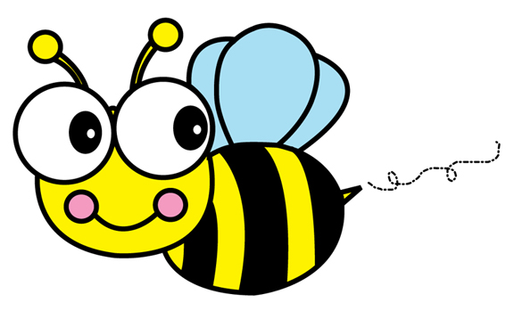 **October 2019 Bellfort Early Childhood Center**

|  |  |  |  |  |  |  |  |
| --- | --- | --- | --- | --- | --- | --- | --- |
| **Sunday** | **Monday** | **Tuesday** | | **Wednesday** | **Thursday** | **Friday** | **Saturday** |
| **October is the second Autumn month.** |  | 1 **ESL Classes begin**  **(8:00-10:00)** | | **2 October is the 10th month of the year and has 31 days.** | **3**  **ESL Class (8:00-10:00)** | **4 Please bring students to school on time!** | 5 |
| **6 Every day is a new beginning** | **7 October**  **Birthstone: Opal and pink tourmaline** | **8**  **ESL Class**  **(8:00-10:00)** | | **9**  ***Fall Holiday, No School!*** | Related image**10**  **ESL Class**  **(8:00-10:00)** | **11 Children are marked absent after 9:30** | **12 Have a fun and safe weekend!** |
| **13** | **14 Learning is good for the mind** | **15**  **ESL Class**  **(8:00-10:00)**  **Read, read, read!** | | **16 Head Start**  **Parent Meeting (8:30 am)**  **National Dictionary Day** | ***17 Hispanic Heritage Performance (8:30am.) PK/K***  ***ESL Class***  ***(8:00-10:00)*** | **18 Children’s Museum Learning Event (9:30)**  ***Early Dismissal @ 12:00 p.m.*** | **19 Have fun and carve a pumpkin!** |
| **20** | **21**  Students will wear their favorite pair of crazy or mismatched socks | **22**  **Picture Day**  Come dressed in your best attire for school picture | | **23**  **Anti-bullying Day** | **24 Fall Math and Literacy Night (5:00-6:30)**  **ESL Class**  **(8:00-10:00)** | **25**  **Report Card Day** | **26** |
|  | **ESL Class**  **(8:00-10:00)** | Students will wear ORANGE | | Students will wear their favorite hat. | Students will wear  a team jersey/shirt |
| **Red Ribbon Week October 21-25 Send A Message To Stay Drug Free**  **31 ESL Class**  **(8:00-10:00)**  **Character Day**  . | | | | | |
| **27** | **28**  **Keep a positive mindset** | **29**  **ESL Class**  **(8:00-10:00)** | | **30 Down Syndrome Awareness Wear Blue/Yellow** | | | |

**am**