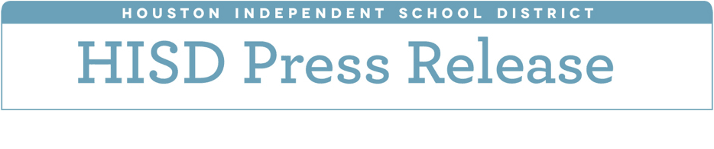

**Two HISD schools named National Blue Ribbon Schools for second time**

*Lyons Elementary and Eastwood Academy honored for high achievement*

*September 28, 2017* – A month after catastrophe crippled the city, there’s a bright spot to celebrate in HISD.  Two of our schools have been named National Blue Ribbon Schools by the U.S. Department of Education:  Eastwood Academy and Lyons Elementary.

The National Blue Ribbon Schools Program honors public and private exemplary campuses or those that are closing achievement gaps.  Eastwood and Lyons are among 26 public schools in Texas to receive the award this year, and both were named as “Exemplary High Performing Schools.”

Eastwood Academy, which is located in the East End, is a college prep high school.  Students here complete dual-credit courses, along with 80 hours of community volunteer work, before they graduate.  The principal attributes part of their success to the school’s focus on addressing the needs of individual students through social and emotional learning.

“This is tremendous,” said Eastwood principal Brandi Lira.  “This is the second time we’ve received this award in the last six years.  It reaffirms everything we’ve been doing as far as thinking outside the box.  I believe wholeheartedly that when the children are loved, they will perform.”

This is also the second Blue Ribbon award for Lyons Elementary School, which is part of the Sam Houston feeder pattern.

“This is an exceptional honor for Lyons Elementary to be recognized as a Blue Ribbon school for the second time,” said Principal Cecilia Gonzales.  “This award validates the work and effort that our entire staff, students, and parents have put forth towards academic achievement.”

To earn a nomination, schools must be deemed exemplary and high performing as measured by state assessments.  Also, each nominated school must have an economically disadvantaged population of at least 22 percent.

The schools will be honored during an awards ceremony Nov. 6-7 in Washington D.C.