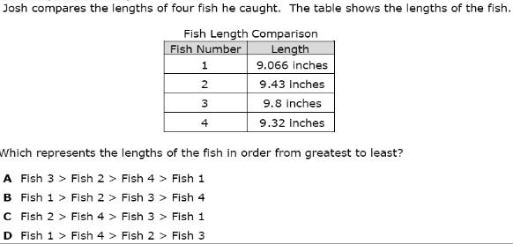  CHOICE BOARD  *be sure to rewrite the numbers shown above and place them in order from GREATEST TO LEAST* | DESIGN A POSTER  CREATE A POSTER EXPLAINING TO SOMEONE HOW TO USE PEMDAS in order to solve the problem below:  *be sure to explain each step and tell me which step comes first, second, and last * | WEATHERING, EROSION, AND DEPOSITION?  illustrate a picture like the one below showing the process of weathering, erosion, and deposition.  *make it colorful and send it to me*  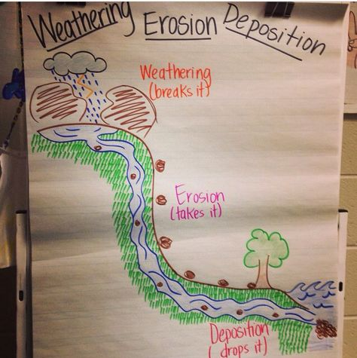
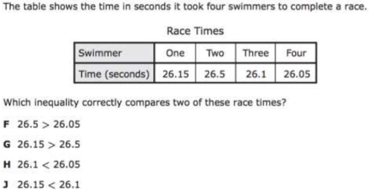  *Pay attention to the numbers shown and the correct symbols* | SEL  What is something that you do to help calm you down when someone or something has made you upset?   | Rapid or Slow?  - There are somethings that will change our Earth quickly and then there are things that will change our Earth slowly.  - Describe whether the below options are a Rapid (fast) change or will it be a Slow change?  - Volcano  - Earthquake  - Weathering  - Erosion  - Tornado  - flooding  *tell me why it will be a rapid or a slow change, Feel free to draw pictures to explain your thinking*
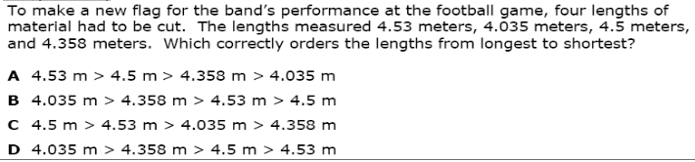  *rewrite the numbers in the problem from the longest length to the shortest length in order to help you pick the correct answer choice* | Imagine Math  - Complete at least 2 lessons  - WWW.CLEVER.COM | Take Notes:  - Watch the following video: https://www.youtube.com/watch?v=R-Iak3Wvh9c  - Watch the video until the end and write down AT LEAST 5 THINGS YOU LEARNED FROM THE VIDEO  

*WEEKLY PROJECT* Due May 1st!
Think of a Math problem and turn it into a story. Be mindful of your story because you are going to have to make sure that you can solve the problem yourself. Use correct punctuation and make sure your sentences are complete: (see the example below)
Title: A Strange School
Many years ago, in a small school, in a small town, something very strange happened, something very strange indeed. Here’s the whole story. Well, at least a fraction of it…
At this small school, which was tucked into the woods, none of the students ever smiled, and on sunny days nobody ran around and played tag or football, or even talked and laughed about their favorite TV shows. No, this school was different because the math teacher, Mr. Al Geebrah was so mean. He was actually mean squared which is to say mean times mean. In other words, on the average, he was the meanest! And with him around no one ever had any fun…
One time Mr. Al Geebrah was so mean, he made the students figure out how many 12ths were in 5 wholes! It took them all day, but they finally figured it out!
How many 12ths do you think are in 5 wholes?
Correct Answer: 60

