Reading  Let’s Make up a Story  - Make an animal puppet with a sock or paper bag  - Draw eyes, nose, mouth, ears, and part of the upper body  - Use the puppet to tell a story about the zoo animals  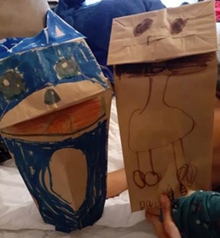  Picture of paper puppets with permission from Ms. Castruita taken with iPhone  Questions for children:  1. Where is the story taking place?  2. Are there other characters in your story?  3. How does the story end? | Math  Counting in the Jungle  •Draw a jungle on a piece of paper  •Draw 5 zoo animals that leave in the jungle (elephant, monkey, tiger, snake, and toucan) and cut them individually  •Create word problems using those animals (example: there is 1 elephant and 1 monkey in the jungle and 1 tiger comes by…how many do we have now? Total of 3)  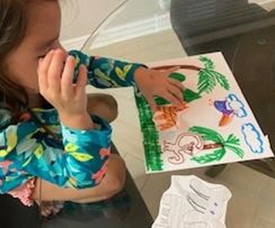  Picture of jungle with permission from Ms. Coronado taken with iPhone  Questions for children:  1. How do you know the total number of animals in the jungle?  2. What happens if we have all 5 animals in the jungle and 2 leave?  Extension: Imagine Math for 15 minutes or practice creating and extending patterns |  | Science  - Draw and color a picture of a plant (find them outside or draw them from your memory). Then label each part of the plant.  - Allow student to sound out parts of the plant and write the word out independently  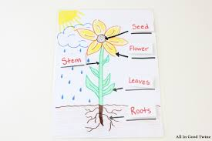  - Upload a picture of your child’s drawing to their journal on Seesaw
Reading  Vowel or Consonant Sound Cup Game  - Using 3 cups, write a letter on each cup and set them up in a line  - Take turns hiding the pom-pom under a cup and then switching the cups around like the old shell game  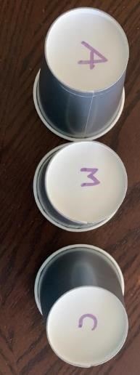  - Ask your child to guess under which cup the pom-pom could be  - Ask your child to say if this is a vowel or consonant sound  Picture of Sound Cup Game activity with permission from Ms. Azcarate with iPhone  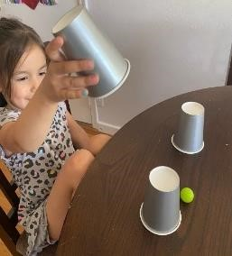  Questions for children:  1.Can you make the sound of this vowel___?  2.Can you make the sound of this consonant___? | Math  Sink or Float  - Gather 10 household objects  - Select two objects and drop them in the tub with water  - Ask your child “Which object sink and which object float?”  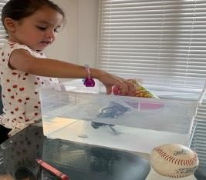  Picture of Sink or float activity with permission from Ms. Coronado with iPhone  Questions for children:  1. Which objects sink and which objects float?  2. Do you think ____ will float or sink?  Extension: Rote Counting (Please upload a video of your child practicing rote counting) |  | SEL  - Discuss feelings and emotions with student  - Explain the different emotions (happy, sad, mad, scared, etc)  - Get a sheet a paper and fold or cut the paper in half  - Have your child decide what emotion they are feeling and draw it on the half sheet of paper  - Tape or glue a pencil or popsicle stick to the back of the paper to create an emotion mask  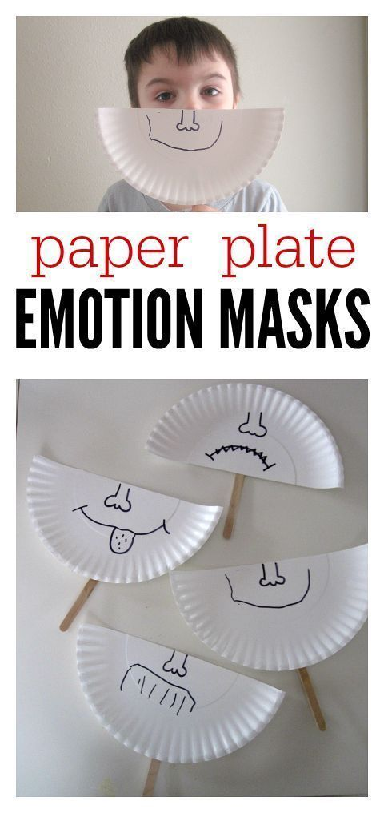
Reading  Alphabet sound hop!  - Write between 5 to 10 letters on the sidewalk with chalk  - Ask your child to jump on each letter, shouting out the sound (e.g. the child jumps on the S and shouts “Sssss”) not the letter name  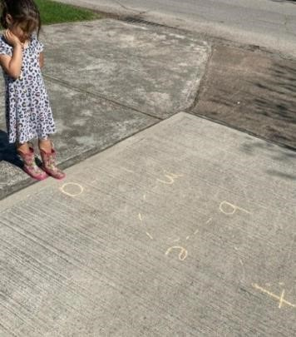  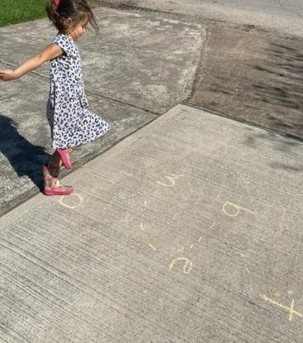  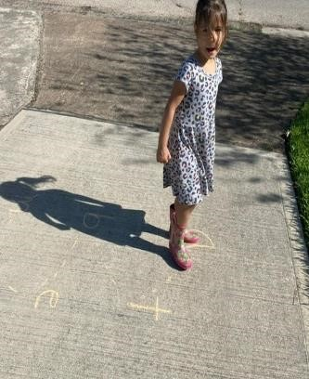  Picture of Alphabet Sounds activity with permission from Ms. Azcarate with iPhone  Questions for children:  1. Can you tell me the sound of this vowel___?  2. Can you tell the sound of this consonant___?  - Record video of your child practicing alphabet sound hopping | Math  Graphing Shapes  - Draw three columns on a piece of paper or whiteboard for the graph  - At the bottom of each column, draw a triangle, circle, and rectangle  - Show your child a picture card and count the side of each object and match it under the correct column  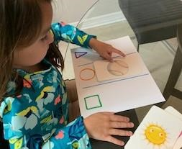  Picture of graph with permission from Ms. Coronado taken with iPhone |  | Social Studies  - Draw map of your room (bed, dresser, toys, table, chairs, tv, etc.)  - Have student practice sounding out items that they drew on their map and writing them out  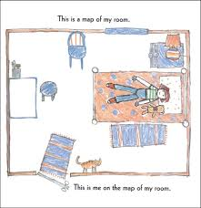  - Upload a picture of your child’s drawing to their journal on Seesaw
Weekly Project: ABC Journal |  |  |  |  | Social Studies
Monday- We will continue our ABC Journals from last week. Have your child to think of things that begin with the letter “D”, they can also find items around your home that begin with the letter. They should then write the letter at the top of the first page in their journal and draw and practice sounding out and labeling the items that they drew that begin with the Letter D.  Tuesday- Have your child to think of things that begin with the letter “E”, they can also find items around your home that begin with the letter. They should then write the letter at the top of the first page in their journal and draw and practice sounding out and labeling the items that they drew that begin with the Letter E.  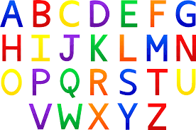  Wednesday- Have your child to think of things that begin with the letter “F”, they can also find items around your home that begin with the letter. They should then write the letter at the top of the first page in their journal and draw and practice sounding out and labeling the items that they drew that begin with the Letter F.  Thursday- Have your child to think of things that begin with the letter “G”, they can also find items around your home that begin with the letter. They should then write the letter at the top of the first page in their journal and draw and practice sounding out and labeling the items that they drew that begin with the Letter G.  Friday- Review letters D, E, F, and G in the journal. Discuss what things you were able to find that begins with the letters, review the pictures and the sounds each letter makes. |  | 