- Reading  - Using the chart made last week  - Write sentences about the characters on a paper. See the example:  - Color the adjectives.  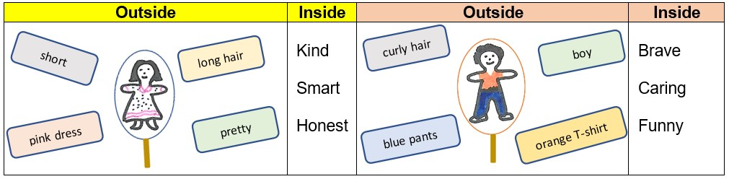  ➢  Lorena is  kind  .  ➢  Peter is a  funny  boy. | - Math  - Divide a sheet of paper into 3 sections. Write the words before and after at the top.  - Gather your number cards 1-20. Mix them up and place them in one stack faced down.  - Choose the top card from the stack and place it in the middle column. Write the number that comes before the number you chose under the word before. Write the number that comes after the number you chose under the word after.  - Repeat until you have chosen all of the cards. (You may need to create several recording sheets.)  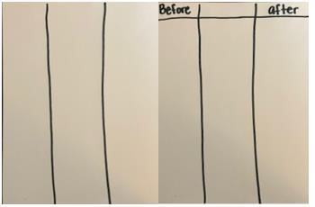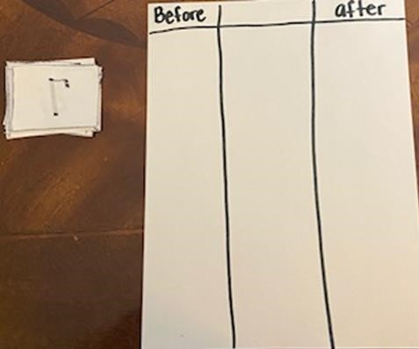  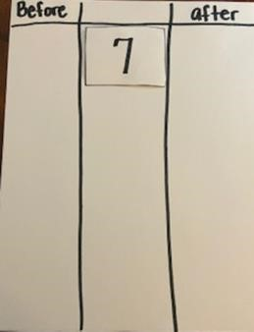  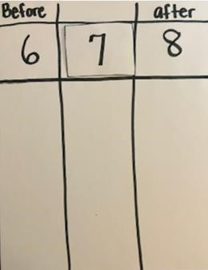  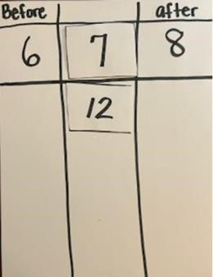  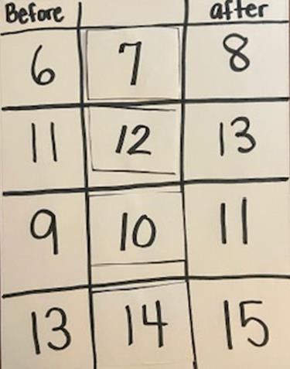 |  | - Science  Objective: I can identify the basic needs of plants. Discuss this question and share your thinking with someone in your home!  Think About It!  What do plants need to survive? Discuss this question and share your thinking with someone in your home!  Do It!  What you need:  - Adult supervision • Science notebook or paper • Pencil or crayons  - Real plant and artificial plant (indoor or outdoor)  What to do:  - Copy the bubble chart into your science notebook.  - Observe the real plant.  - Describe the needs of the real plant that will help it grow. Record each need on the bubble chart.  - Observe and compare the needs of the artificial plant.  Are the needs the same?  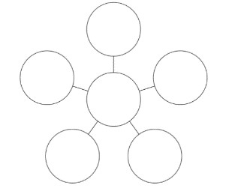  Plant  Needs
- Reading: Retell the Information  - Read or listen to an informational text.  - Select a page and read it.  - Close the book.  - Retell orally the information: What do you remember from this page? I remember …  {If you do not remember the information, read the page again.}  - Use a piece of paper to draw and write the information.  - Continue with next page.  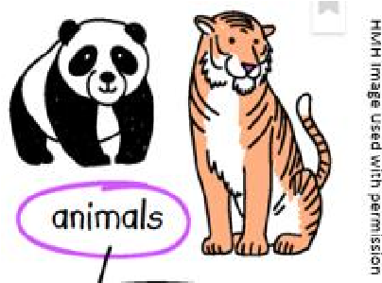  [  Page  1]  [  Page  3]  [  Page  2] | - Math  - Draw a line down the center of a sheet of paper. Then draw two lines across to create 6 boxes. Repeat the same steps on a second sheet of paper.  - Copy the domino dot patterns in the boxes as shown in the picture. Then cut them apart  - Mix the cards up and stack them in one neat stack. Flip over the card and look at it for 3 seconds and flip it back faced down.  - Use your objects to represent the dot patten you saw on the card. When you are done, check your pattern to make sure it is the same as the card. If it is not the same, you can fix it.  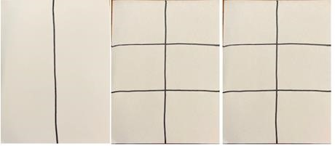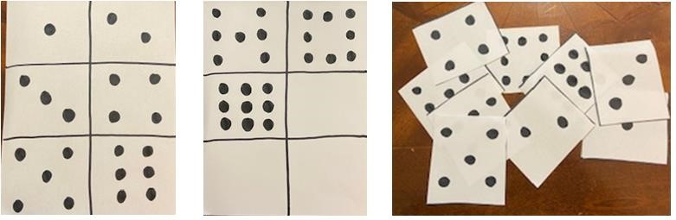  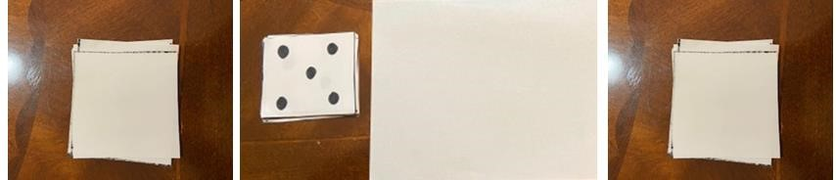  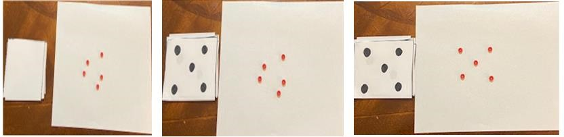 |  | - SEL: Pop that Thought Bubble  Think of a situation that made you feel happy or proud:  - What happened, what were you thinking?  - What did you do?  Think of a situation that made you feel nervous or scared:  - What happened, what were you thinking?  - What did you do?  CONNECTION: Art/English Language Arts  Create your own chart to show how your thoughts lead to feelings and actions. Post your chart nearby to remind you to be aware of your feelings.  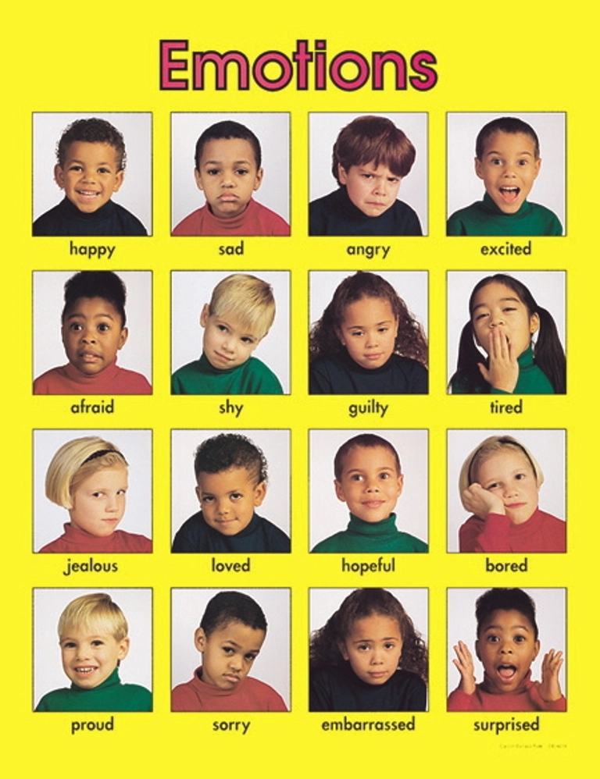
- Reading  - Use the book read or listened during the week.  - Select a page to create a picture glossary.  - What information could you illustrate from this page? The information that I can illustrate is …  - What word can you use to name the illustration? The word that names the illustration is …  - Use paper and colors to create a picture glossary.  - Use the cards to review the content.  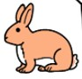  (Label)  (Picture)  Rabbit | - Math  - Divide a sheet of paper into six parts. Then draw a ten frame inside each box.  - Choose two different color crayons or markers. Copy these dot patterns inside the ten frames as shown in the picture. Then cut them apart.  - Divide another sheet of paper in to six parts. Draw a number bond in each box.  - Choose a ten frame and write the number of blue dots, the number of red dots, and the total number of blue and red dots together.  - Repeat until you have recorded all the ten frames on number bonds.  - Cut the number bonds out. Mix them up and match the ten frames with the number bond it represents.  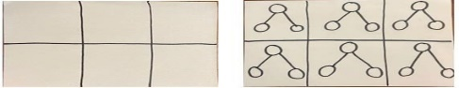  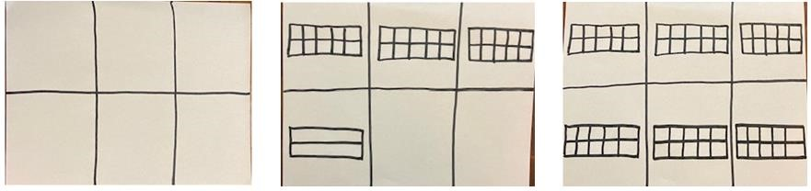  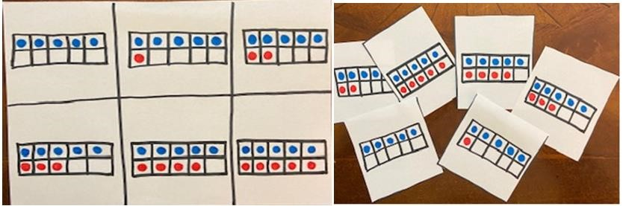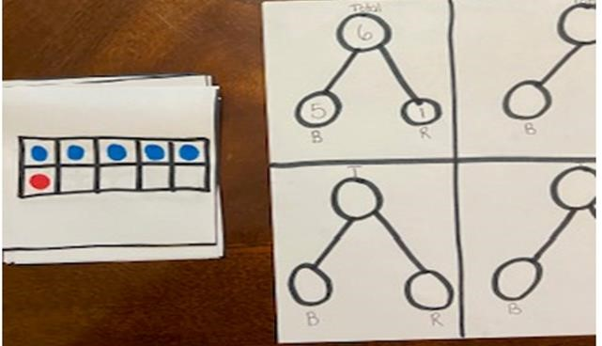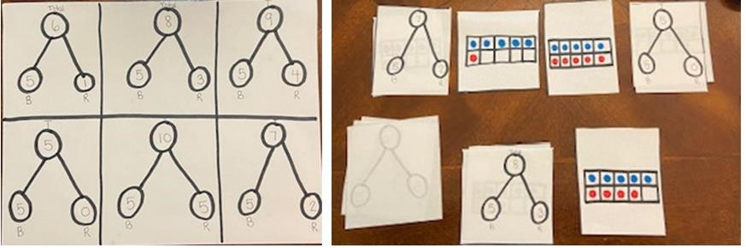 |  | - Social Studies  Think about transportation. Write a story to describe why a car goes faster than a horse drawn carriage, then read your story to a family member  
Weekly Project: Composing and Decomposing
Composing numbers to 10
- Draw a line down the center of a sandwich bag. Place 6 objects inside the bag and seal it. Grab a sheet of paper to record your work on.  - Push all the counters to the left of the line.  - Step 1: Count the counters on the left side of the line. Record that number on your paper.  - Step 2: Count the number of counters on the right side and record that number.  - Step 3: Now count all the counters on both sides and record the total number of counters.  - Now push one counter to the right side of the line. Repeat Steps 1-3. Continue until you have written all combinations of 6  - When you want to have more fun, do this process with 7 and 8 objects in the bag. |  | 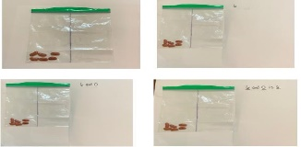  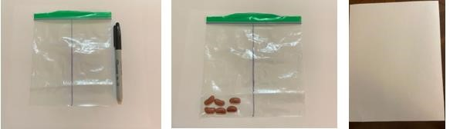  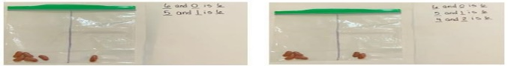  _____ and _____ is _____  7 objects 8 objects

