1. Reading  Make Inferences About Text  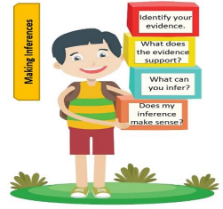  • Read the tip below to understand how to use clues from the book and what you already know to make an inference.  • Read the text below and underline the clues that support your inference.  • Ask yourself:  o What clues can I find to support my inference?  o Do my clues match my inference?  o Does my inference make sense?  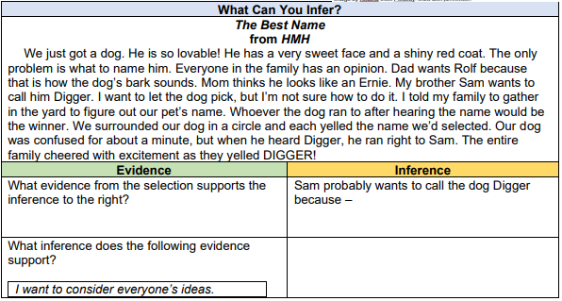 | 2. Math  3 – Dimensional shapes.  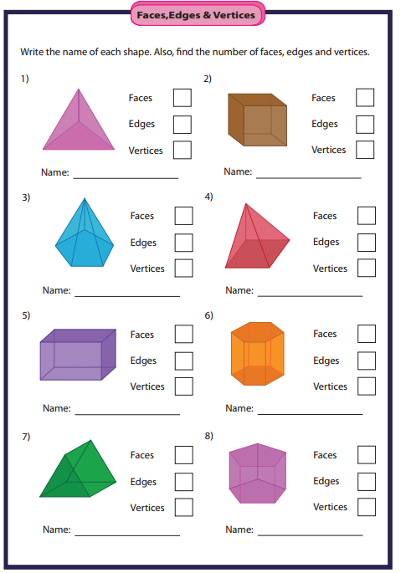 | 3. Science  Properties of Water  identify and compare the properties of freshwater and saltwater.  Think About It! How are freshwater and saltwater alike? How are they different? If you can, discuss this question and share your thinking with someone in your home.  What you need: • Cup of saltwater (1cup freshwater with 1 teaspoon salt)  • Cup of freshwater  What to do: • Compare the saltwater to the freshwater by tasting it.  • Discuss where saltwater is found naturally with someone in your home.  • After exploring the properties of saltwater and freshwater, place both water samples in the freezer.  • Check on the water samples throughout the day.  • Create a chart to record your observations. 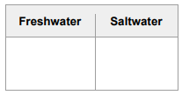 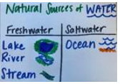  Resources: Notebook or sheet of paper, Pencil.
4. Reading  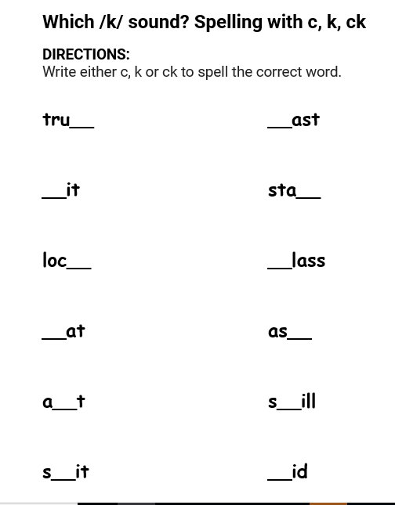 | 5. Math  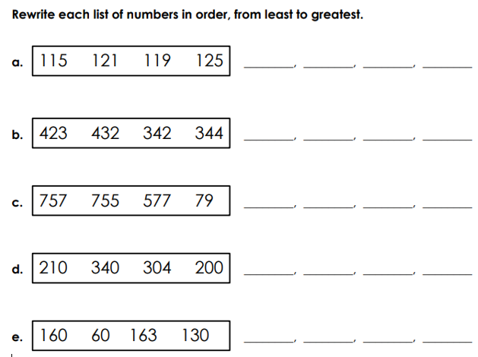 | 6. Science  Explore natural resources and identify how they are used and conserved.  Students will find 5 different objects in the house that can be either recycled or reused.  Understand It! To reuse is to use a resource again. To reduce is to use less of a resource. To recycle is to use the materials in old things to make new things. To conserve is to preserve (save) and protect resources.  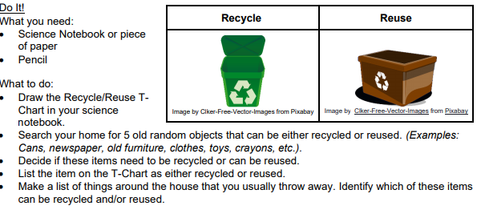
7. Reading  Log on to Imagine Reading for 60 minutes. Using the log in information sent to you.  OR  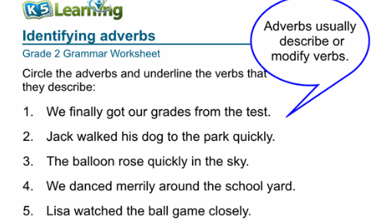  10. Reading  LOOK at the picture below.  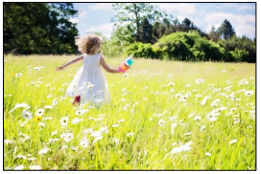  THINK about a day that something very important happened in your life. It could be a birthday, a day a relative was born, or even a day someone helped you when you were most in need.  WRITE about a very important day in your life.  Be sure to ―  • write about a personal experience  • organize your writing  • develop your ideas in detail  • choose your words carefully  • use correct spelling, capitalization, punctuation, grammar and sentences   | 8. Math  Log on to Imagine Math for 60 minutes. Using the log in information sent to you.  OR  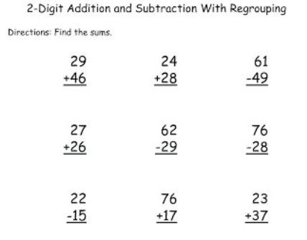  11. Math  Two-step addition and subtraction word problems.  Read the following math story three times:  1. Read the first time and picture what the math story is about.  2. Read the second time and focus on the question and what you need to find out.  3. Read the third time and determine what important information is needed to answer the question.  On Monday, 546 people attended a museum. On Friday, 27 fewer people attended the museum than Wednesday. How many people attended the museum on Monday and Friday combined?  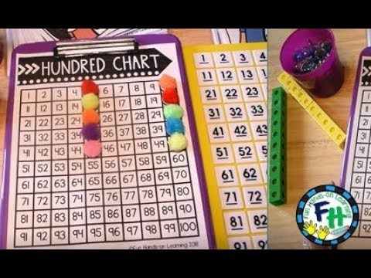 | 9. Social Studies  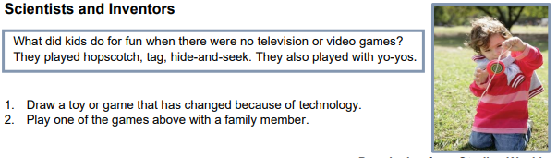  12. Social Studies  Technology    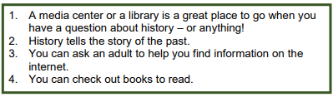  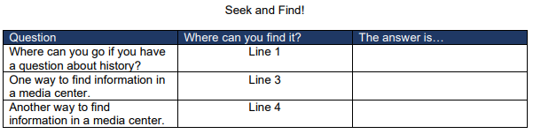Resources notebook or paper, pencil.

Weekly Project: ‘2 and 3-dimensional Shape construction’
- Use toothpicks and gumdrops to construct 2 and 3 dimensional shapes. write the name of each shape and their attributes. For your 2-dimensional shapes write how many sides and vertices it has. Write how many faces, edges and vertices your 3-dimensional shape has. take a picture and upload to your portfolio on dojo. Record or take pictures of yourself constructing your shapes.
What you need:
- Gumdrops, marshmallows, apple pieces, cheese, Styrofoam, play dough, or gummy bears etc.!
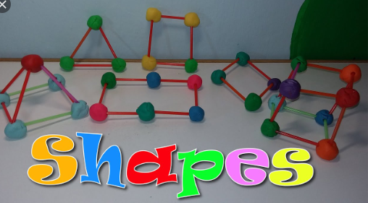
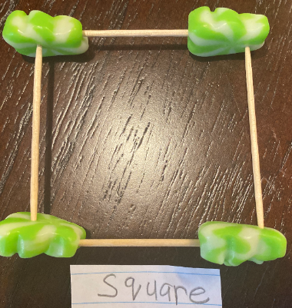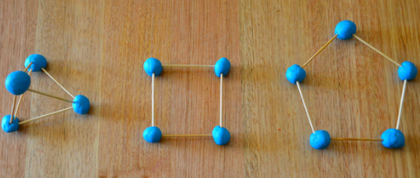
Directions: Each week students will receive a menu to be completed by the end of the week. Students will choose activities based on interest but must do: 9 squares (3Reading, 3 Math, 1 Science, 1 Social Studies, 1 extra, + Project). Of the 12 boxes, 9 must be completed. More points and reward will be given to students that will send their pictures or videos of them (parents and students) completing the work.
*The 9 boxes activity due date is May 22, 2020 while the project due date is May 29, 2020. Please submit evidence of the completion of all these activities for your child to receive the grades that are required by Texas Education Agency for this semester of learning. send completed work via our class dojo or email it to me at Esther.Onyia@houstonisd.org
If you have any questions, please feel free to call Ms. Onyia @ 281-748-6694.
Thank you for your time and patience during this time of need. Amazing Second Grade.

