Lovett Elementary SDMC
April 28, 2022
Members Present
Dawn Thompson-Principal
Amber Yother-Special Education Teacher
Mrs. Loeb-Community Member
Myra Bowyer-Parent
Ericka Williams-Teacher
Katherine Martin-Teacher

General Updates:
Updates for this meeting were focused on budget and possible vacancies for next year. Mrs. Thompson reviewed the budget allocations and explained to the committee what funds in each area were used for.
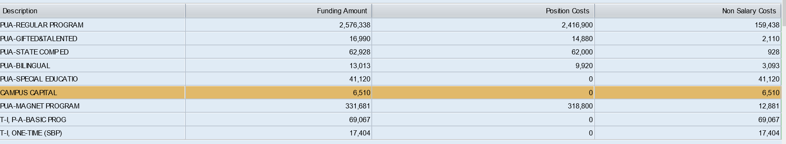
The information above was provided to the committee and each line items was discussed. Mrs. Thompson indicated that in the next SDMC meeting, we will dig deeper into the budget to look at how funds were allocated after salaries.
The committee had some questions about the ESSER dollars and Mrs. Thompson, provided clarify on how each type of ESSER fund can be used:
- ESSER funds will be allocated next year for:
  - HB4545 tutoring: 22K: these funds are to provide small group tutoring for students that were not successful on STAARR Reading or Math: Parent can opt in or opt out of tutoring.
  - Wrap Around funds 28K: These funds will be used to support implementation of programs or services to support whole student development. We want to remove barriers or provide on campus support to students through various programming.
- Current vacancies were reviewed to provide a general update.
- Mrs. Thompson shared that during May, she would be offering community talks so she could hear from the community and use this in planning for 22-23 school year.

Next meeting will be May 12th@3:15

