**[](http://www.houstonisd.org/HISDmedia)**

**HISD Board of Education to consider $212.4 million in additional bond funding**

*Additional funding would help district build schools as described in the 2012 bond election*

*Dec. 9, 2015 —* The Houston Independent School District Board of Education on Thursday will consider a funding proposal that would add up to $212.4 million to the bond program to cover significant increases in inflation and construction costs.

If approved, the additional money would help the district ensure all bond projects are completed as described to voters in the 2012 election. Voters overwhelmingly approved a $1.89 billion bond calling for the reconstruction or renovation of 40 schools across the district, including 29 high schools.

The need for additional funding was outlined in a comprehensive, project-by-project analysis completed by district staff in October.

“Our goal always has been to provide students with state-of-the-art schools that offer modern learning spaces specially designed to meet the needs of today’s global graduates,” said HISD Superintendent Terry Grier. “Once built, these schools will inspire community pride for generations to come.”

The project-by-project analysis found that some projects needed no supplemental funding, while others needed significant infusions. The cost increases are attributed in the analysis to the region’s recent construction boom, which created a huge demand for workers and materials that has affected many surrounding school districts.

Though the additional funding isn’t needed immediately, administrators are seeking authorization to spend the dollars for project planning and design purposes. The $212.4 million will only be spent if it still is needed after all other bond funds are exhausted.

The additional money would be funded through the issuance of Maintenance Tax Notes and reserves from the 2007 voter-approved bond. The new debt is not expected to impact other school district needs, nor will it impact the district’s credit rating or tax rate.

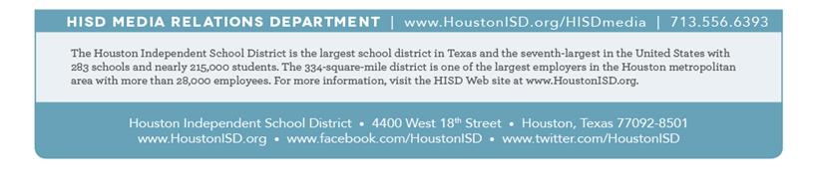**The board’s regular monthly meeting begins at 5 p.m. on Thursday, Dec. 10, 2015, in the board auditorium of the Hattie Mae White Educational Support Center, 4400 W. 18th Street. Click** [**here**](http://www.houstonisd.org/domain/7947) **to view the full agenda.** The board meeting will be broadcast live online at [www.hisdtv.org](http://www.hisdtv.org).