1. Reading  Theme  1.Read a fiction book with your child.  2.Ask your child the following comprehension questions. Your child will respond orally or in writing using the sentence stems provided below.  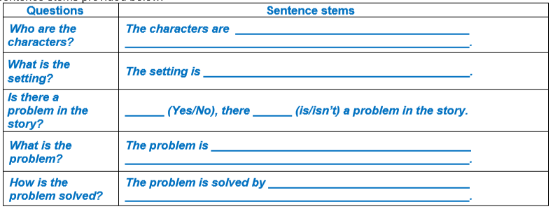 | 2. Math  Fractions  Beth and Sunny each had equal-sized pieces of paper, like the ones shown below.  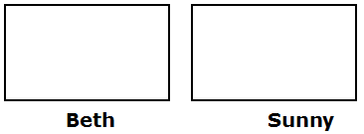  1.Beth partitioned her piece of paper into fourths. Sunny partitioned her piece of paper into eighths.  2. Whose piece of paper will have larger parts? Why?  3. Whose piece of paper will have smaller parts? Why? | 3. Science  Observe, describe, and record patterns of the Moon.  *observe, describe, and record the appearance of the moon each night to see the pattern of moon phases.  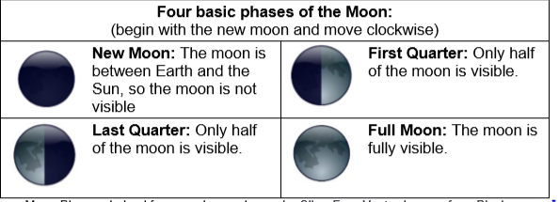  Resources: Sheet of paper, Pencil.
4. Reading  Log on to Imagine Reading for 45 minutes. Using the log in information sent to you.  OR  Choose 5 high frequency words from the box below and write one complete sentence with each word.  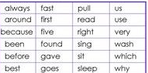  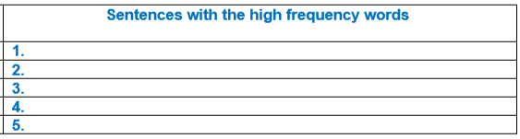 | 5. Math  Area of rectangles.  Nathan drew a model of his bedroom, as shown below.  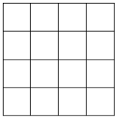  Use the squares in the figure to determine the area of Nathan’s bedroom in square units?  Area = ______ square units. | 6. Science  Observe, describe, and compare rocks.  *Collect rocks of different sizes, colors, textures, and shapes outside your home to observe, describe, and compare.  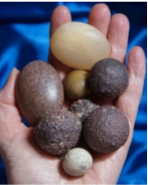  Size Color Texture  Resources: rocks, paper, pencil.
7. Reading  Informational text characteristics  Read an informational text, it could be a newspaper, textbooks, biographies, autobiographies.  *Ask your child to identify characteristics of informational text that he/she finds in the book orally and in writing.  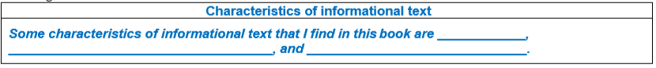 | 8. Math  Solve Two-Step Addition and Subtraction Word Problems.  Conrad had 132 marbles. Jim has 52 more marbles than Conrad. How many marbles do Conrad and Jim have altogether?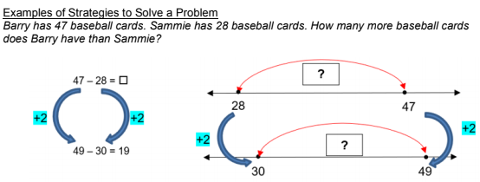  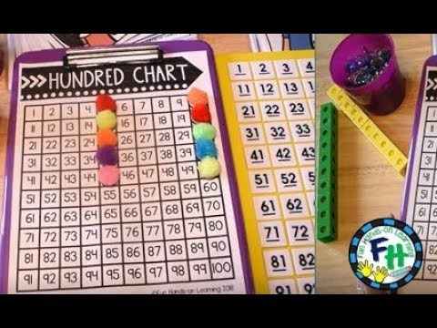 | 9. Social Studies  Find or draw a picture of your dream job, car, house, etc. Describe why you want the items to a family member.    Resources: Magazines, newspaper, pencil, paper, crayons, markers,
10. Reading  Use these sight words to complete the sentences.  down away make find  My grandma will _____________ a cake.  I will throw ___________ my launch.  I can’t _________ my pencil.  She went ____________ the slide. | 11. Math  Log on to Imagine Math for 45 minutes. Using the log in information sent to you.  OR  Solve one – step Addition and subtraction word problems.  *There are 456 students in a school. If 10 of the students move away, how many students will there be in the school? | 12. Social Studies  Read the story and write if you would buy a toy right away or wait a while.  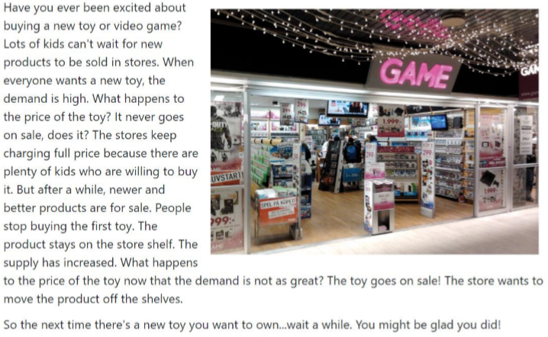  Resources: notebook paper, pencil
Weekly Project: “The Timeline of my life”

A timeline is a tool that we can use to help us understand history. It can tell us what happened at different times. It can tell us how much time there was between two events. It can give us a picture of dates in our minds. This helps us see how they all fit together. They help us keep track of important dates in our lives.
Directions:
- Complete a timeline that sequences the events in chronological order. This timeline can be created however you want. You can make a visual display or use timeline sheet provided. Please include at least 5 important events in your life. You can include more if you would like. Important events must include date, short description and picture. Picture can be illustrated, or you may use printed photographs. Your timeline should be constructed TWO ways:
- Numerical Order (Use actual dates)
- Sequential Order (most recent at top)

___ When you started second grade.
___ When you were born.
___ When you started Kindergarten.
___ When you learned to walk.
___ When you lost your first tooth.
___ Today’s date.
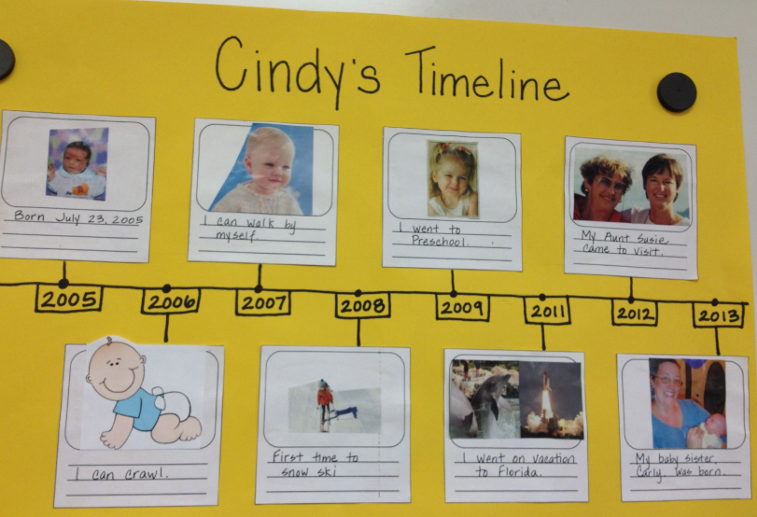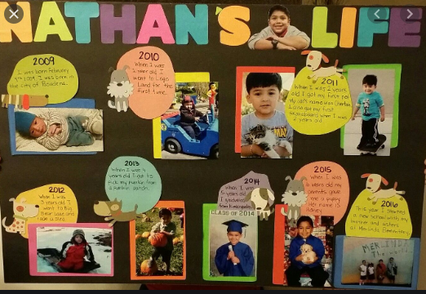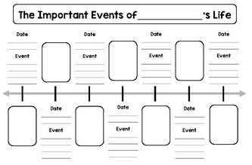
Directions: Each week students will receive a menu to be completed by the end of the week. Students will choose activities based on interest but must do: 9 squares (3Reading, 3 Math, 1 Science, 1 Social Studies, 1 extra, + Project). Of the 12 boxes, 9 must be completed. More points and reward will be given to students that will send their pictures or videos of them (parents and students) completing the work.
*The 9 boxes activity and the project due date is April 17, 2020. Please submit evidence of the completion of all these activities for your child to receive the grades that are required by Texas Education Agency for this semester of learning. send completed work via our class dojo or email it to me at Esther.Onyia@houstonisd.org
If you have any questions, please feel free to call Ms. Onyia @ 281-748-6694.
Thank you for your time and patience during this time of need. Amazing Second Grade.

