1. Click on your Start ORB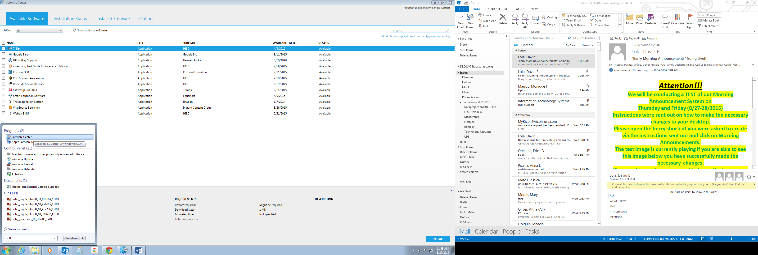 and type>> ***Soft***select Software Center listed under programs and Click it.



1. Next put a check in the box next to (***Smart Education Software***)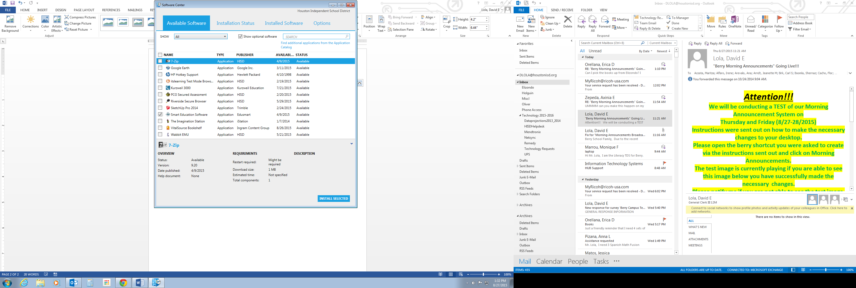

and click on  (***INSTALL SELECTED***).



1. That’s it!! Your application should begin downloading and installing. When it is done installing please ***Do Not Forget*** to restart for the changes to take effect. **Congratulations!!!**

