**[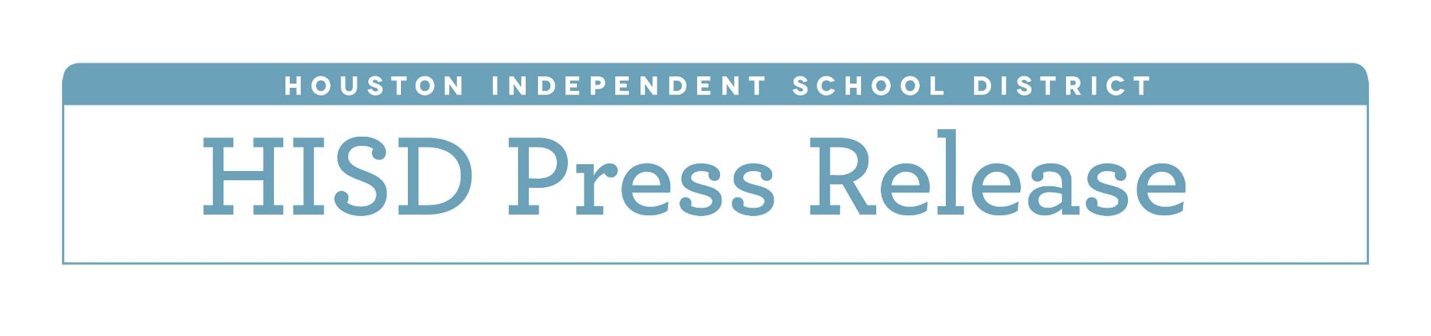](http://www.houstonisd.org/HISDmedia)**

**HISD announces partnership with Taipei Department of Education**

*Dec. 17, 2015* — The Houston Independent School District joined Thursday with the Department of Education in Taipei to celebrate the formalization of an international partnership between the two organizations.

The Partnerships in Education agreement formally solidifies the friendship between the two entities, allowing the pair to become “sister” organizations. It includes opportunities for the sharing of educational information, coursework and teaching methods between HISD and educators in Taipei, the capital of Taiwan, a world leader in information technologies.

Exposure to different languages, cultures, and economies is a key component of a global education, which is imperative for students if they are to succeed in a global marketplace.

“HISD is committed to providing students opportunities that will help them learn about and better understand the world around them,” said HISD Superintendent Terry Grier. “Opportunities and partnerships like this help ensure our students are global graduates and thoughtful, responsible, successful citizens of the world.”

Through the partnership, HISD aims to exchange best practices in education and create opportunities for exchange programs for HSID teachers and students. It also aims to promote cultural awareness by sharing information about the Taiwanese language and culture in HISD while sharing information about our culture in Taiwan.

Officials also hope the formalization of this partnership will spur additional educational, cultural and professional partnerships between the two organizations.

HISD Board of Education Trustee Greg Meyers said partnerships such as this are vital to student success.

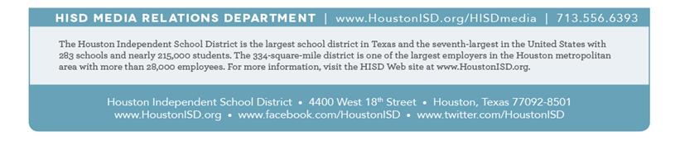"The partnership agreement we signed today solidifies our longstanding spirit of cooperation to develop educational opportunities in both Houston and Taipei,” Meyers said. “It benefits students, teachers, and administrators as we continue to learn more about each other, and improve our understanding and appreciation of our respective cultures. I am honored to partner with Taipei in this agreement, and proud to join in building a richer, more robust educational experience for the children of both our cities."