Instructions for Keyword Rebuild:

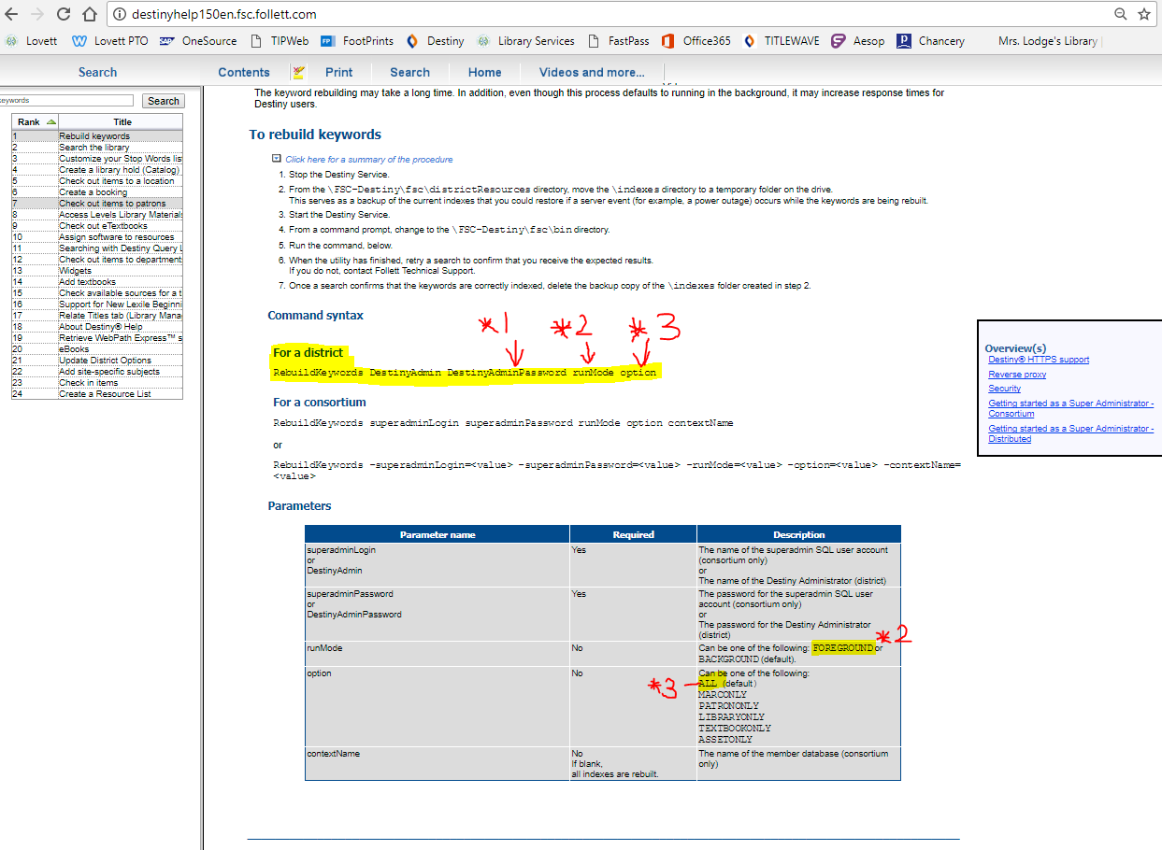

Enter the command string with the following exceptions below.

Notes:

\*1: Type the actual password not “DestinyAdminPassword”.  
\*2: Type “FOREGROUND” not runMode.  
\*3: Type “ALL” not option.