Reading  Baby Bear  • Read a book about baby animals: Baby Bear, Baby Bear, What Do You See? by Bill Martin is a suggestion https://www.youtube.com/watch?v=DPTb10tLEqk  • Make a chart of farm animals. Ask your child to tell you the names of the babies  • Explain that baby animals often have different names than their adult counterparts (Sheep/lamb, Cow/calf, Dog/puppy)  • Play a matching game with your child using the cards provided  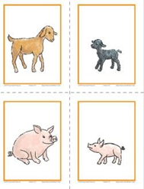  Image of Baby  Image of Baby Animal and Mother Cards from Frog Street Resources Unit, with permission from Frog Street Press  Small cards with pictures of mother animals and their babies https://bit.ly/3aDUOLo  Questions for children:  - What sound do each baby animal make?  - What is the name of this _____ baby animal?  Reading  Farm Animals Products  - Read How Animals Give Us Food? by Linda Staniford  https://www.youtube.com/watch?v=PnSCciL_K3g&t=145s  - Make a list of all the different foods that come from farm animals  - Divide the foods into groups: meat, eggs, milk  - Have your child draw small pictures to help illustrate the chart  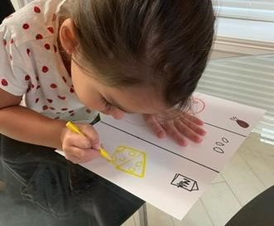  Picture of farm animals’ products activity with permission from Ms. Coronado with iPhone  Questions for children:  - Do you know what product comes from the cow?  - Do you know what other things we can make using animal products? | Math  Fun Sorting Farm Animals  - Give your child the Farm animals’ cards  - Draw a Venn diagram on a piece of paper for sorting (two large circles)  - Sort each animal card by the number of legs they have (e.g. 2 legs and 4 legs)  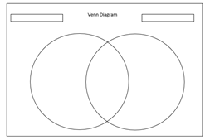  Venn diagram created by HISD Curriculum with Microsoft Word  Questions for children:  - How many legs do each animal have?  - What is the name of this_____ animal?  - Upload a video of your child practicing identifying numbers 0-20 to Seesaw (You may use flashcards or write the numbers on a sheet of paper and have your child identify them as you point  Math  Counting Five Ducks  - Sing the song “Five Little Ducks”  - Place 5 yellow pom-pom balls or cotton balls (representing the 5 little ducks) in an upside-down cup on top of blue construction paper (representing a pond)  - Take out a number of pom-pom and place them in the pond  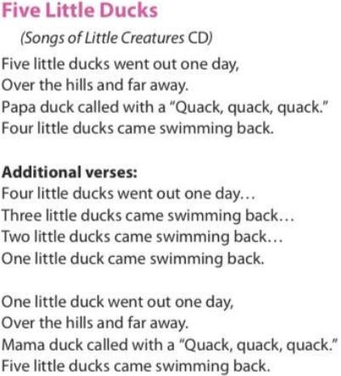  - Ask your child to determine how many ducks are missing  Imagine of Song “” The five Little Ducks” taken from Frog Street Resources Unit with permission from Frog Street Press  Questions for children:  - What strategy did you use to figure out how many ducks were hiding?  - How many more to complete five ducks?  How many ducks are left in the pond?  Complete 20 minutes of Imagine Math Learning |  | Science  Five Senses  - Discuss with your child the 5 senses and how they are used  - Review the book “Our Senses on the Frog street Portal that is free for all parents  - www.frogstreet.com  Email box: type the word parent  Password box: type the word parent  - Have your child draw the 5 senses on a paper  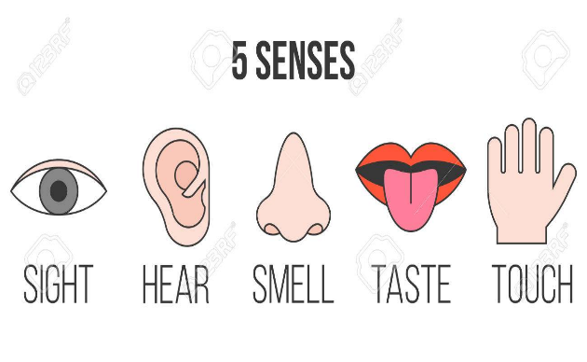  SEL  - Create a story with your family  - Each family member participates by adding one word or sentence at a time  What kind of story will your family create?  Work together to create your own drawing of the story!   - Please share your family story via Seesaw with a picture or video
Reading  Nature Walk  - Children and parents will go on a nature walk  - Collect items such as sticks, grass, flowers, leaves, etc.  - When you get back home, help your child write his name in large letters on a piece of paper  - Glue the nature items on top of the letters of his name  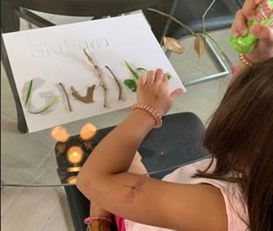  - While he works, talk about each letter in his/her name and whether it has straight lines, curved lines, or both  Picture of Nature Walk activity with permission from Ms. Coronado  Questions for children:  - Do you recognize each letter of your name? Can you name them?  - Do you see how using straight lines or curved lines you can form a letter?  - Please upload a picture/video of your child completing the Nature Walk activity to Seesaw | Math  Counting using fine motor skills  - Practice counting up to 10 items using cotton balls (or any manipulative you have available)  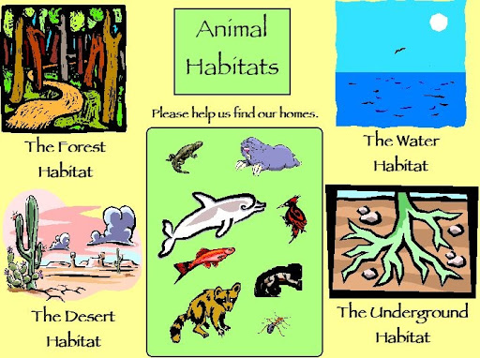  - Pick up cotton ball with the tongs/tweezers and place it to a space in the egg carton tray  - Encourage your child to repeat just the total number rather than counting from one again  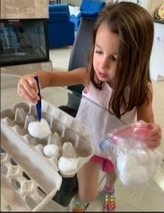  Picture of Pick Up and Count activity with permission from Ms. Coronado  Questions for children:  1. How many do we have in the egg carton now?  2. How many are missing to make 5 items?  - Complete 20 minutes of Imagine Math learning |  | Social Studies  Animal Habitats  - Discuss with your child the various animal habitats, explain to them that a habitat is a place where an animal lives  - Have your child choose 3 animals and draw the animal and their habitat

Weekly Project: ABC Journal |  |  | Social Studies
Monday- We will continue our ABC Journals from last week. Have your child to think of things that begin with the letter “H”, they can also find items around your home that begin with the letter. They should then write the letter at the top of the first page in their journal and draw and practice sounding out and labeling the items that they drew that begin with the Letter H.  Tuesday- Have your child to think of things that begin with the letter “I”, they can also find items around your home that begin with the letter. They should then write the letter at the top of the first page in their journal and draw and practice sounding out and labeling the items that they drew that begin with the Letter I.  Wednesday- Have your child to think of things that begin with the letter “J”, they can also find items around your home that begin with the letter. They should then write the letter at the top of the first page in their journal and draw and practice sounding out and labeling the items that they drew that begin with the Letter J.  Thursday- Have your child to think of things that begin with the letter “K”, they can also find items around your home that begin with the letter. They should then write the letter at the top of the first page in their journal and draw and practice sounding out and labeling the items that they drew that begin with the Letter K.  Friday- Review letters H, I, J, and K in the journal. Discuss what things you were able to find that begins with the letters, review the pictures and the sounds each letter makes. | 