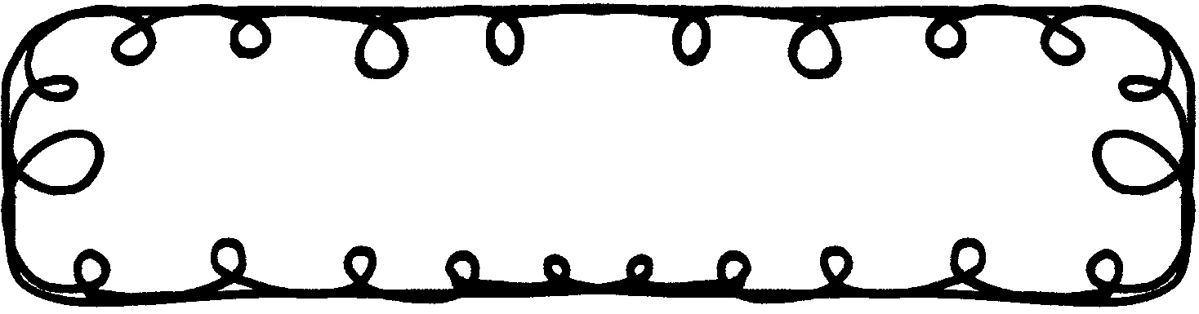

First Grade Gazette October 7, 2019

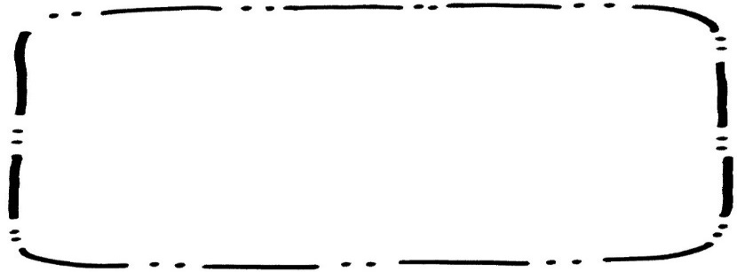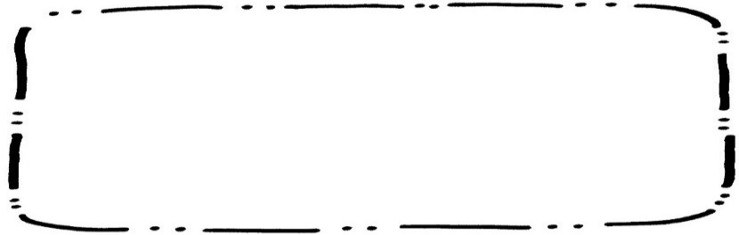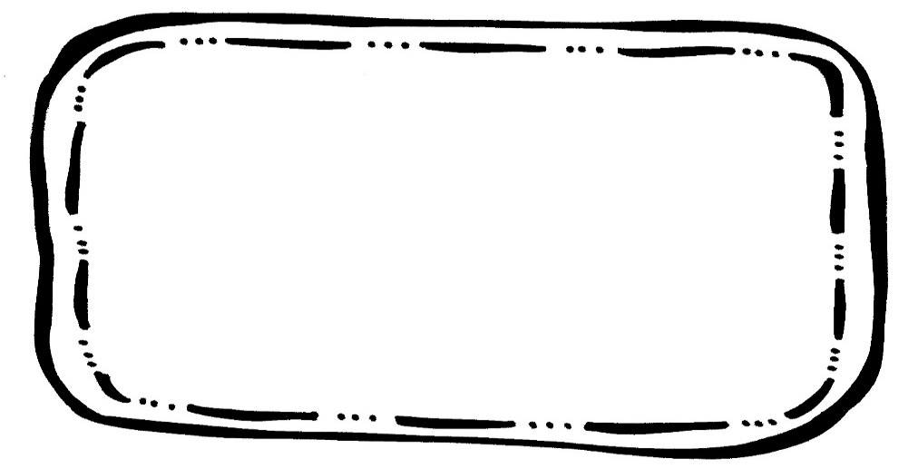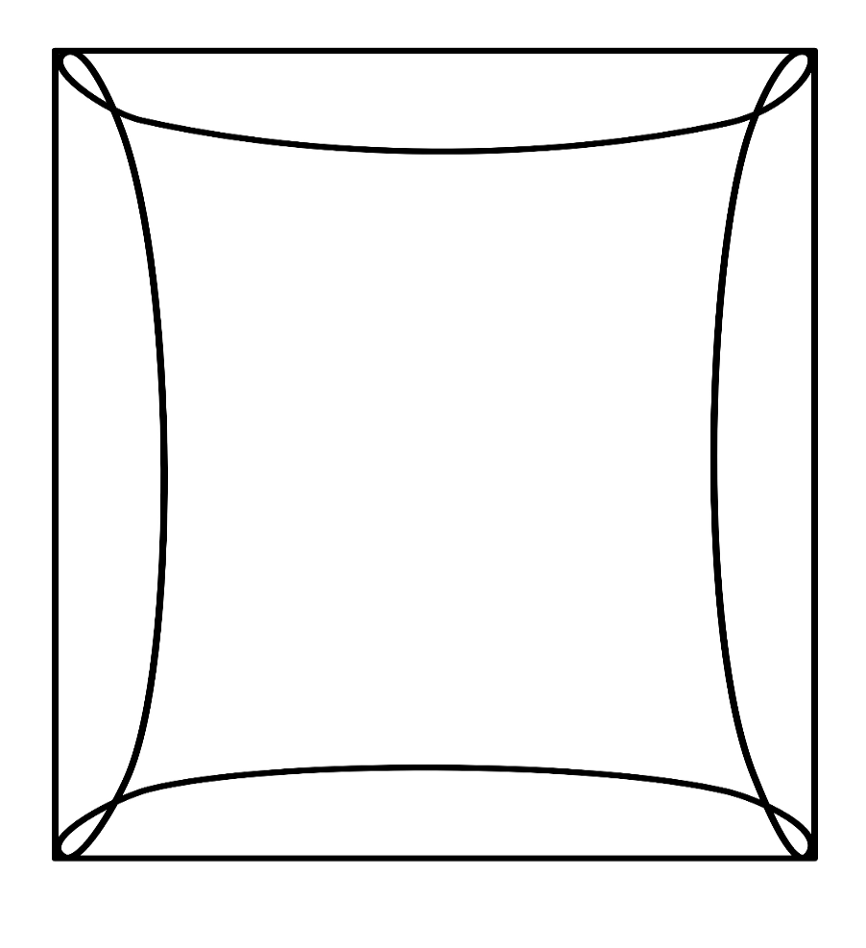

Math

We will finish up Chapter 4, Subtraction. Please continue to practice math facts.

Writing

We will learn about adjectives and how they make writing better.

Science & Social Studies

We will be learning about different bodies of water.

Spelling**Tested 9/13

Got hop lot pot top

Day did little very park

**I got a top for the pot.**

**Reading Comprehension**

***If your Monster Won’t Go to Bed***

* Retelling with key details

**Vocabulary Words**

Snarl – to growl and show the teeth

Bristly – covered with stiff, prickly hair

Massive – very large and heavy

Shiver – to shake because you are cold

Neighborhood – a group of people who live near each other

**Upcoming Events**

**October**

18 – Early Dismissal

21 – 25 – Red Ribbon Week