**5th Grade Math CHOICE BOARD**

|  |  |  |
| --- | --- | --- |
| **LEAST TO GREATEST!**   * Come up with 6 numbers (ex: 0.243, 4.5, 6.743, 8.20, 5.1, 7.890) * Place the numbers of your choice in order from least to greatest. * **Explain your thinking using sentence stems:** * ____is greater than____because____ * ______is less than____because___ * **REPEAT ONE MORE TIME!!** | Read the following math story three times:   1. Read the first time and picture what the math story is about. 2. Read the second time and focus on the question and what you need to find out. 3. Read the third time and determine what important information is needed to answer the question.   Ariel picked 5.75 pints of strawberries this past weekend. His sister, Yaneth, picked 7 pints of strawberries. How many pints of strawberries did Ariel and his sister pick this past weekend?  (represent this math story using a strip diagram or bar model.) | *Apply it: Draw a picture showing what would most likely happen if the oil, water and cork were all placed in one container. Explain your reasoning using the stem:  “________is less dense than water, and water is more dense than_____” in your explanation.  *if you can, please record yourself doing this experiment and send it to me on our Class Dojo* |
| You can use the numbers that are provided below, or you can pick 4 different numbers and copy your response on a sheet of paper. | **SEL**  Draw a picture of yourself.  Write at least 10 strengths all around the image    **\*Be sure to send me pictures of your drawings\*** | <https://docs.google.com/presentation/d/11cwFuQtADKwBx53N0i45TKt_5sHoKxKoA0zK3WfDmrU/present?slide=id.p2>    *if you can, discuss this question and share your thinking with someone in your home!  Don’t forget to write out your responses!  Feel free to draw pictures if you would like as well. |
| **What did you get?**   * Write numbers down on a piece of paper from 0-9. (you’ll need TWO sets) * Cut the numbers out and place them face down * Find 5 numbers that go to the **thousandths** place. (example: **13.423)(2.674)** * Once you have those two numbers add them together. **(13.423+2.674=16.097)** * then **SUBTRACT** the sum from the number 200. Example**(200-16.097= 183.903)** * **REPEAT THIS GAME AS MUCH AS YOU WANT!!** | **Telephone Math**  **Write your phone number**  **Round your phone number to the nearest:**   * **Hundred** * **Thousand** * **Ten Thousand** * **Hundred Thousand** * **Million** | <https://docs.google.com/presentation/d/1ZWrunGO6y4WpJ1PM6opLQQ4yLtoVZw-sTIdKjEyJJQg/present?slide=id.p2> |

**\*WEEKLY PROJECT:**

Objective: Demonstrate that the flow of electricity in closed circuits can produce light, heat, and sound.

THINK ABOUT IT: what are some of the ways you use electricity everyday in your home? How does the energy flow to make these devices work?

WHAT TO DO: create a data table. Take a walk through your home to find devices that use electricity. List the devices and how they are used. Record if they use electricity to produce light, heat, or sound.

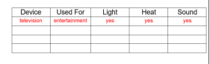 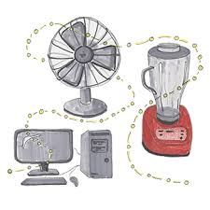

UNDERSTAND IT: we use electricity for many different devices in our homes and schools. For these devices to work, the electricity must be able to flow in a complete circuit. If the circuit is open, **the DEVICE WILL NOT WORK!**

Journal Entry: Draw a circuit with 4 bulbs and one switch. In this circuit, 3 bulbs will light when the switch is open and all 4 light up when the switch is closed. Explain why 3 bulbs remain lit when the switch is open.

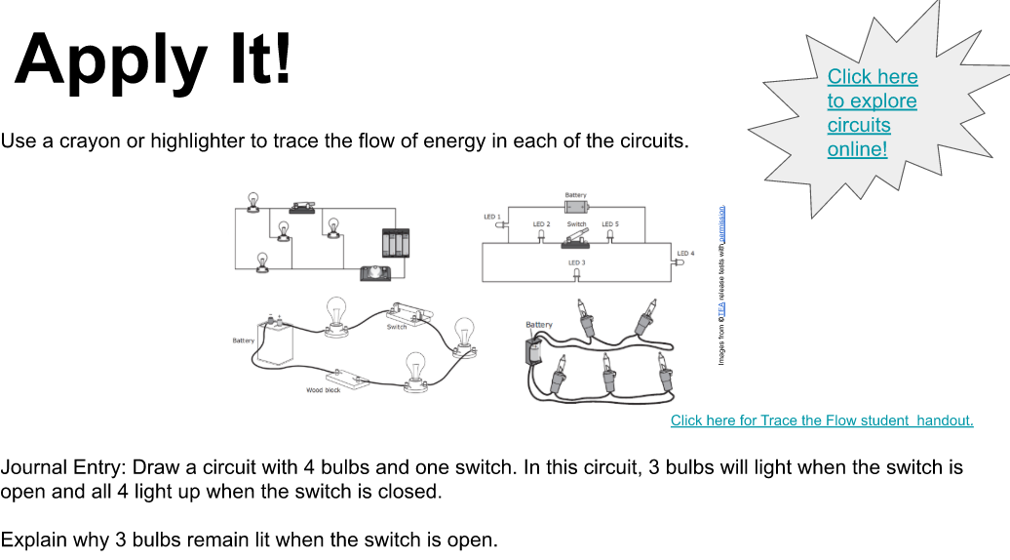

**\*please look at the link below to get a visual as to how your project is supposed to look.\***

<https://docs.google.com/presentation/d/1BNRUXETNgaCyBRZjQ6H12MPPRRBiHfww3IPUwb828L0/present?slide=id.p4>

**Resources:**

**Math:**

<https://www-k6.thinkcentral.com/content/hsp/math/hspmath/na/common/mega_math_9780547585062_/megamathcd6/cm/launch.html?strActivityName=g36_3_2_P&strAssignID=1>

<https://www-k6.thinkcentral.com/content/hsp/math/gomath/common/video/video.html#videoId=ref:En_188>

<https://www-k6.thinkcentral.com/content/hsp/math/gomath/common/video/video.html#videoId=ref:En_219>

**SCIENCE:**

<https://docs.google.com/presentation/d/1yyIRIcdBahiKfJnKYZ0_kyePdjzvllZJbKXFcAFVlcU/present?slide=id.p>