**[](http://www.houstonisd.org/HISDmedia)**

**HISD reports no issues related to threat**

*Dec. 17, 2015* — The Houston Independent School District is operating as scheduled on Thursday after receiving a threat of violence late Wednesday similar to those received this week by school districts across the nation.

HISD Police Chief Robert Mock reiterated at a media briefing on Thursday morning that the threat was not believed to be credible. No issues have been reported in the district as of Thursday afternoon.

The threat — which was not specific to HISD or any district campus — is similar to those received this week by districts in Los Angeles, New York, Miami, Dallas, Orlando, San Francisco, Long Beach and Broward County.

“The safety of our students and staff is always our main focus,” HISD Police Chief Robert Mock said. “Though we have no reason to believe this threat is credible, we’ve implemented additional security measures and brought in extra officers as a precautionary measure.”

The threat was first emailed to HISD Superintendent Terry Grier and others in the district around 8 p.m. Wednesday. It was forwarded to HISD police, and an investigation was immediately launched.

Acting out of an abundance of caution, law enforcement officers and maintenance crews conducted sweeps of district buildings. Surrounding law enforcement agencies were notified, and additional officers — from HISD Police and agencies throughout the greater Houston area — were patrolling the district on Thursday as a precautionary measure.

The increased police presence will continue through Friday.

The text from the email is below.

*Hello there. There is something you should know about, taking place   
tomorrow of 12/17/15, Thursday.  
My story starts here. I have been bullied every day here, in one of the   
district high schools. Just because, I am 'different'. I turned to   
religion, to solve my problems, and found faith and comfort in Allah. He   
has helped me through a lot. So now, I must help him. He has called upon   
me and my fellow comrades to take action against you blasphemers and   
non-believers. You have denied Allah for too long. My 46 Jihad   
affiliates and I are going to unleash an massacre of epic proportion,   
targeting every single school and student in the district. We have an   
assorted collection of Kalashnikov rifles, MG240 Light machine guns, RPG   
Launchers, .50 Cal Sniper rifles, hand grenades, and to top it off:   
suicide vests. We have already planted napalm, propane, and pressure   
cooker explosives in multiple schools. They are set to go off in places   
that will cause maximum structural damage to each building: for maximum   
casualty. First responders will be in for quite the surprise, as we have   
highly trained sniper forces straight from Ar Raqqa. We will fight for   
our cause tomorrow, and all students in every school in the entire   
district will be slaughtered for their blasphemy and unbelief in the one   
true God, Allah. You will no longer get away with your dishonesty to our   
prophet.  
Allah has called upon us:  
Quran (3:56) - "As to those who reject faith, I will punish them with   
terrible agony in this world and in the Hereafter, nor will they have   
anyone to help."  
  
You will no longer deny the wrath of Allah. He has sent us to serve his   
holy army.  
My name is (name redacted). You may not know this name now,   
but my name will be known to everyone. I will be known as the one man   
who truly saved this earth. For Allah.  
And if you think you will stop us, by canceling schools, or perhaps,   
adding security, it will not help.  
If school is canceled, then there will be bombings regardless of whether   
students are there or not, and mass shootings will be taken to the   
streets. If security is stepped up, for tomorrow's fatwa, it will not   
help. We will take out any police and other security by any means   
necessary, even if we go down with them.*  
الله أكبر

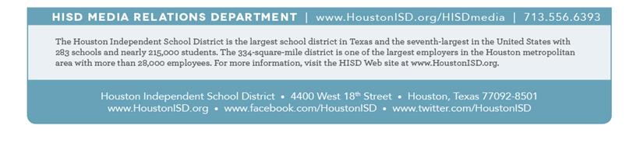‏محمد رسول الله