- Reading (fiction example)  Read/listen to a story of your choice and summarize it by telling what happened at the beginning, middle, and end. Draw a picture of each part and write one sentence below.  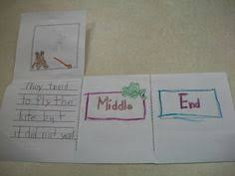 | - Math  Imagine Math complete 5 lessons.  Read the following math story three times aloud to students:  1. Read aloud the first time and picture what the math story is about.  2. Read aloud the second time and focus on the question and what you need to find out.  3. Read aloud the third time and determine what important information is needed.  There are 10 bees buzzing around in the garden. 3 of the bees flew back to the beehive. How many bees are still buzzing around in the garden?  Use objects to show your work  Use pictures, numbers and words to show your work |  | - Science  Draw and color a picture of a plant (find them outside or draw them from your memory). Then label each part of the plant.  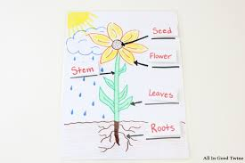
- Reading  Read or listen to a story. (Use the same book during this week). Think about the characters and the setting in the story.  Who were the characters in the story? The characters were…  What was the setting in the story? The story took place …  Draw the characters and add details to describe the setting. Label your picture  Title:____________________ | - Math  Write 10-100 across the top or side of the page. Use small objects (beans, pasta, crackers, Legos) to count out the correct number of objects. Counting bt 10’s |  | - SEL  Gratitude Walk  Take a walk outside your home with a parent or guardian. As you are walking, say 10 things you are grateful for. You can take turns saying what you are grateful for with your parent/guardian. (Use your 10 fingers to count to 10!)  Sentence Stem: I am grateful for ___________.
- Reading Describe the Main Character  1. Reread or listen to the previous story.  2. Think about the characters  Who was the main character in the story?  How can we describe the character? (Outside: How the character looks like? Inside: How the character behaves? )  The main character was…  Draw the main character and label the pictures. | - Math  Read the following math story three times aloud to students:  1. Read aloud the first time and picture what the math story is about.  2. Read aloud the second time and focus on the question and what you need to find out.  3. Read aloud the third time and determine what important information is needed.  Eigth bunnies sat on the grass. two more bunnies hopped over to join them. How many bunnies are on the grass now?  Use objects to show your work  Use pictures, numbers and words to show your work |  | - Social Studies  Draw and label a map of your room.  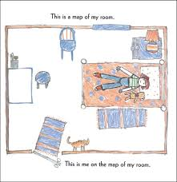
Weekly Project: “My Moment in History”  A journal of your experience during COVID-19 |  |  |  |  | Social Studies
You are living during a historic time. Create a journal where you can write and draw about your experiences every day. To set up your journal, you can staple together several pieces of paper (or fold them in half together) or use a notebook/journal you have at home. Then decorate the outside with the title, your name, and pictures. You will create 4 entries for this week and a few more entries in the weeks to come. Every entry should have the date, a picture, and at least one sentence of what you did that day.  Day 1: Make your journal and color the cover page.  Days 2-5: Make an entry for the day, by drawing a picture and writing a sentence about it.  Options:  - Your favorite activity you did that day (inside game, outside play, school work, TV you watched)  - How you felt that day  - What you ate that day  - Anything else that was important for you that day.  ** Try to make each day’s entry different** |  | 