1. Reading  Draw, Write, Retell  • Choose your own book and retell the ideas in the text. • As you read, STOP and think about what you see in your head. • Focus on drawing pictures of the main character, setting, conflict, and resolution. • Then write a few words about your picture. • Use those pictures and words to retell the book. • Read the tip below to help you understand how to retell.  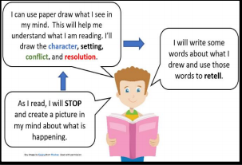  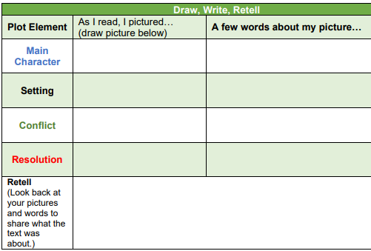 | 2. Math  Vocabulary Match  Draw a line to match each word with the corresponding image.  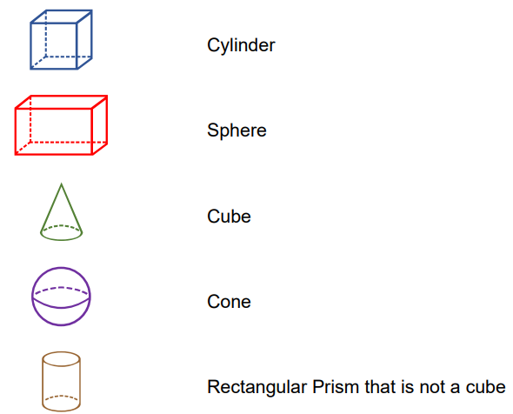 | 3. Science  Physical Characteristics of Animals  Investigate how the physical characteristics and behaviors of animals help them meet their basic needs.  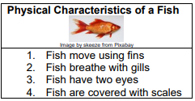  Create a “Physical Characteristics chart in your notebook. • Think about your favorite animal. • Draw a picture of the animal you chose. • Write a sentence about how it moves. • Write a sentence about how it breathes. • Write a sentence about the animal’s body covering. • Write a sentence that describes your animal. • Record your sentences and picture in the chart.
4. Reading  Conflict and Resolution  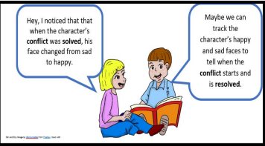  Select a fiction picture book to read. • The faces a character makes can tell us much more than how they are feeling. •Find the conflict and resolution by looking closely at how the character’s faces look. • Read the tip on the right to understand how to find the conflict and resolution by looking at the main character’s face. • Use the following questions to help you think about the conflict or resolution as you read: 1. What kind of face is the character making? 2. Does the character’s face give me a clue to the conflict or resolution?  • Use the chart below to write about conflict or resolution you found as you read.  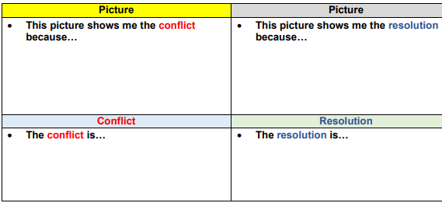 | 5. Math  Length  Choose an object from your home that you can measure using a yard stick or a meter stick. Estimate and then measure the object you chose. Draw the picture in the space below.  My estimate:  My measurement using a ___________: | 6. Science  Factors in the Environment  Understand how changes in the environment affect the growth and behaviors of organisms.  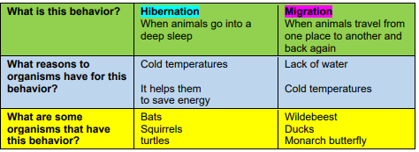  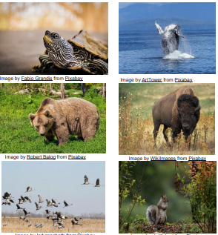  Analyze the pictures of the different animals • In your science notebook or sheet of paper, write two columns: one side labeled “Hibernation” the other column labeled “Migration”.  - Write the name of each animal picture in the correct column.  - Draw each animal in the correct column.
7. Reading  Log on to Imagine Reading for 45 minutes. Using the log in information sent to you.  OR  LOOK at the picture below.  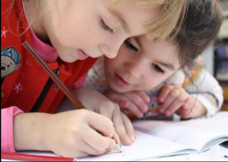  THINK about how important it is to help others.  WRITE about a time when you helped a friend in need.  Be sure to — • write about a personal experience • organize your writing • develop your ideas in detail • choose your words carefully • use correct spelling, capitalization, punctuation, grammar, and sentences.   | 8. Math  Log on to Imagine Math for 45 minutes. Using the log in information sent to you.  OR  Solve One – Step Addition and Subtraction  Read the following math story three times:  1. Read the first time and picture what the math story is about.  2. Read the second time and focus on the question and what you need to find out.  3. Read the third time and determine what important information is needed to answer the question.  Ernesto has 83 worms in a pail for fishing. If he uses 48 of the worms,  how many will still be in the pail?  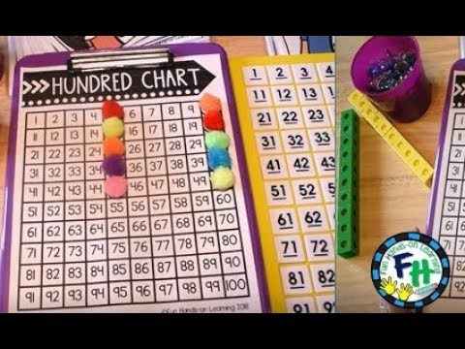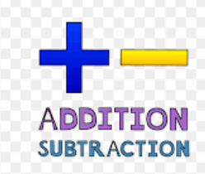 | 9. Social Studies  Producers and Consumers  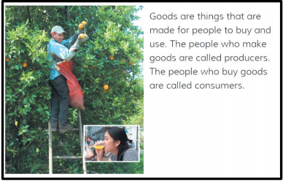  Read the tip above and complete the Frayer Model on a sheet of notebook paper.  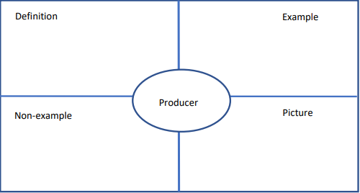  Resources: Notebook paper, crayons, pencil.
10. Reading  Place these words in alphabetical order:  Nothing someone everything without maybe sometimes outside  - 2.  - 4.  - 6.  7. | 11. Math  Length  Look at this number line.  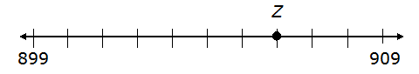  a. What number does point Z best represent? ______________  b. What distance is point Z from 899? ____________  c. What distance is point Z from 909? ______________ | 12. Social Studies  Money and Markets  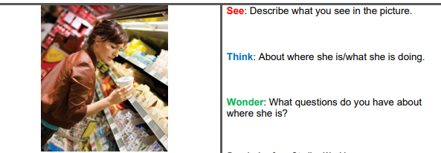  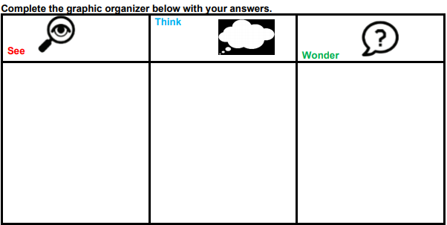  Resources: • Notebook paper, pencil.

Weekly Project: ‘Gumdrop bridge building activity’
- Use toothpicks and gumdrops to construct a bridge. Test it to see if it will bear weight. make sure you are flexible too with how the activity goes. Record or take pictures of yourself building the bridge.
What you need:
- Gumdrops, marshmallows, apple pieces, cheese, Styrofoam, play dough, or gummy bears etc!
- toothpicks
- lego men {optional for crossing bridge).
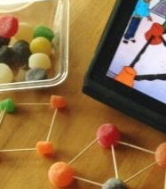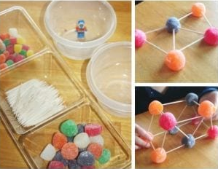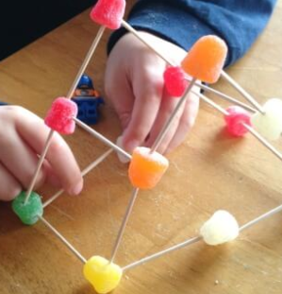
Directions: Each week students will receive a menu to be completed by the end of the week. Students will choose activities based on interest but must do: 9 squares (3Reading, 3 Math, 1 Science, 1 Social Studies, 1 extra, + Project). Of the 12 boxes, 9 must be completed. More points and reward will be given to students that will send their pictures or videos of them (parents and students) completing the work.
*The 9 boxes activity and the project due date is May 1, 2020. Please submit evidence of the completion of all these activities for your child to receive the grades that are required by Texas Education Agency for this semester of learning. send completed work via our class dojo or email it to me at Esther.Onyia@houstonisd.org
If you have any questions, please feel free to call Ms. Onyia @ 281-748-6694.
Thank you for your time and patience during this time of need. Amazing Second Grade.

