Isaacs Elementary
Pre-K Lewis Choice Board May 26-29
Reading  Bubble Map  - Read a book to introduce ocean life from myON before this lesson  - Create a bubble map about the ocean  - Introduce new vocabulary using pictures or cards  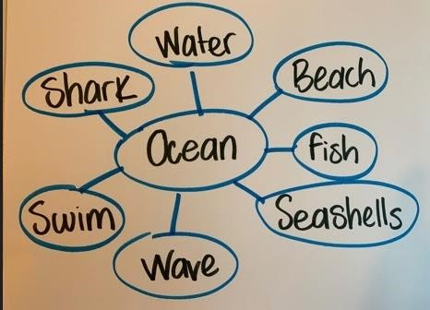  Bubble map chart created by Curriculum Department HISD by hand with markers and paper  Upload to Seesaw | Math  Sea Animals Poems and Chants  - Introduce poems and chants about sea animals  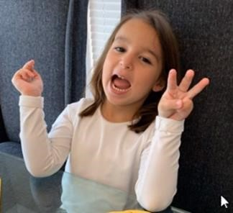  - Ask your child to use manipulatives or fingers to count to 5  Counting numbers activity picture created by Ms. Coronado with her permission, taken with iPhone  Questions for children:  - How many fingers am I holding up?  If I hide one finger, how many do I have left?  Imagine Math for 20 minutes  Math  Octopus Counting  - Draw 5 pictures of an octopus with different number of arms from 1 to 5  - Play a game matching the number of arms on an octopus with the number card  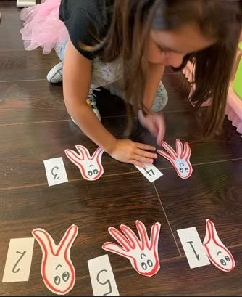  Octopus counting game picture created by Ms. Coronado with her permission, taken with iPhone  Imagine Math for 20 minutes  Upload to Seesaw | Science  Build a Ramp  - Show your child how to build a ramp and ask him/her to make predictions using the suggested questions below  - Stack blocks or books  - Add a piece of wood or cardboard to the top of the stack to create an incline or ramp to the floor  - Encourage your child to put a toy or car at the top of the ramp and let it roll down  - Ask your child to describe what happened and compare it to his/her predictions  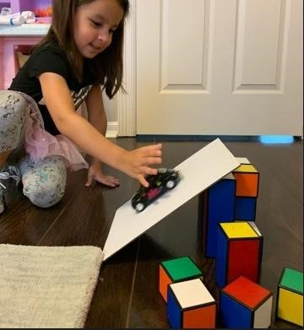  Build a Ramp activity picture created by Ms. Coronado with her permission  Question for children:  - What do you think will happen when we put the car on the ramp?  - What could we do to make the car go faster?  - What would happen if we stacked the ramp up too high?  Upload to Seesaw
Reading  Sea Animals Vocabulary  - Read a book to introduce sea animals  - Ask your child to identify animals who live in the sea  - Create a sentence stem such as: “The _____ lives in the ocean”  - Have your child write the names of the sea animals to fill in the blanks  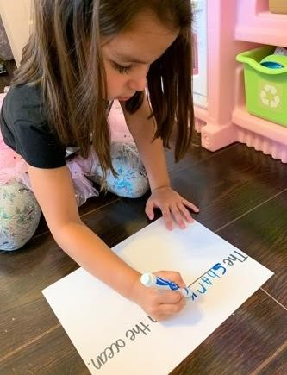  Writing sea animals activity picture created by Ms. Coronado with her permission, taken with iPhone  Reading  Sea Animals  • Use a KWL chart to record what you know about sea animals and what you want to know about them. At the end of the unit revisit the chart to add what you learned  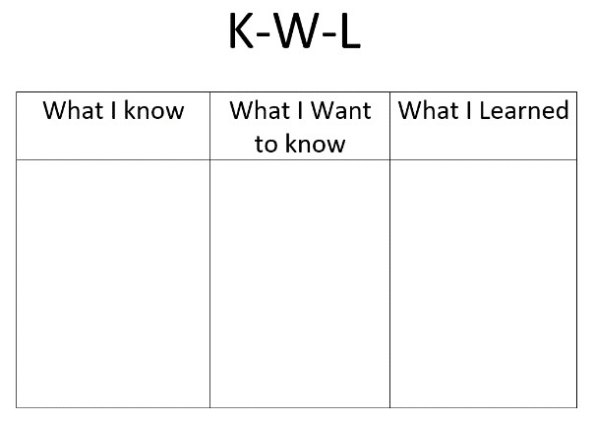  There are  sharks in  the ocean  KWL Chart created by Curriculum Department HISD with Microsoft Word | Math  Fishbowl Counting  - Draw a fishbowl with water on a piece of paper  - Gather a fair amount of Goldfish crackers  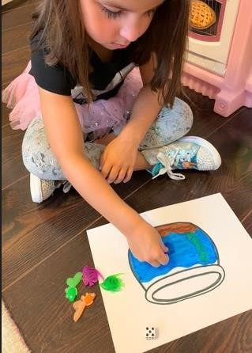  - Roll a dot die to count and put the same number of Goldfish crackers on the fishbowl drawing  Fishbowl counting activity picture created by Ms. Coronado with her  permission, taken with iPhone  Imagine Math for 20 minutes  Upload to Seesaw | S. Studies  Land and Water  • Use a Venn diagram to compare animals that live on land, animals that live in the water and animals that can live in both  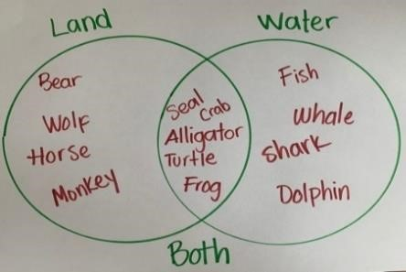  Venn Diagram created by Curriculum Department HISD by hand with markers and paper  Questions for children:  - Why do you think some animals can only live in the water?  - What do animals that live in water have in common?  SEL  Self Portrait  - Explain to your child that a self portrait is a picture that they draw of themselves  - Have your child draw a self portrait of themselves  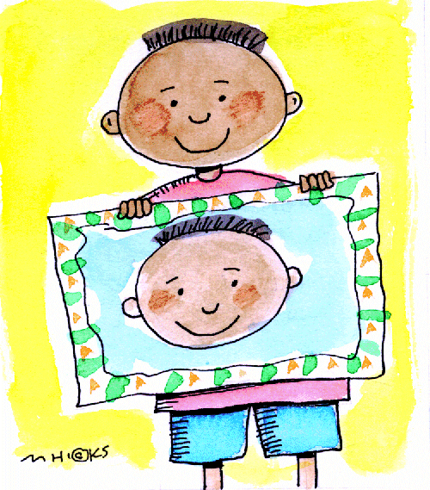  Upload to Seesaw
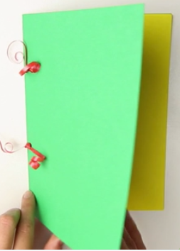
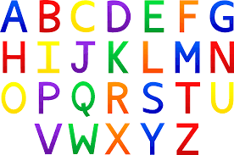
Weekly Project (ABC Journal)

Monday- We will continue our ABC Journals from last week. Have your child to think of things that begin with the letter “T”, they can also find items around your home that begin with the letter. They should then write the letter at the top of the first page in their journal and draw and practice sounding out and labeling the items that they drew that begin with the Letter T.

Tuesday- Have your child to think of things that begin with the letter “U”, they can also find items around your home that begin with the letter. They should then write the letter at the top of the first page in their journal and draw and practice sounding out and labeling the items that they drew that begin with the Letter U.

Wednesday- Have your child to think of things that begin with the letter “V”, they can also find items around your home that begin with the letter. They should then write the letter at the top of the first page in their journal and draw and practice sounding out and labeling the items that they drew that begin with the Letter V.

Thursday- Have your child to think of things that begin with the letter “W”, they can also find items around your home that begin with the letter. They should then write the letter at the top of the first page in their journal and draw and practice sounding out and labeling the items that they drew that begin with the Letter W.

Friday- Review letters T, U, V, and W in the journal. Discuss what things you were able to find that begins with the letters, review the pictures and the sounds each letter makes.

You should be uploading the letters of the week to Seesaw when complete.

