1. Reading  What’s the Central Idea? find the central idea of a text. 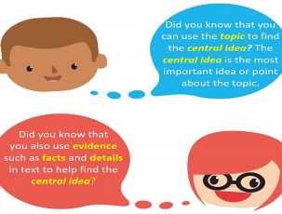  1.Read the tip above to understand how to use the topic and evidence to find the central idea.  2.Read the text below and underline details and facts that support the topic and central idea.  3. Be sure to write the topic and central idea in the box below.  Follow Safety Tips  On sunny days, wearing sunscreen and sunglasses will help protect your skin and eyes. Sunny days can be hot or cold. Drinking lots of water on a hot, sunny day is important. Your body loses water when it’s hot. Keeping all parts of your body covered in very cold weather will help protect your skin. Knowing the weather forecast helps keep you safe, too. Don’t go outside when there is a thunderstorm on the way. Be sure to take breaks from being outside when it is very hot or very cold, too. Enjoy the outdoors safely!  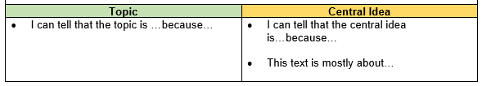  http://go.imaginelearning.com | 2. Math  Solve One-Step Addition and Subtraction Word Problems.  Read the following math story three times:  1. Read the first time and picture what the math story is about.  2. Read the second time and focus on the question and what you need to find out.  3. Read the third time and determine what important information is needed to answer the question.  Barry has 56 baseball cards. Sammy gives Barry 48 more baseball cards. How many baseball cards does Barry have now?  *Represent the math story using pictures.  *Solve the math story.  *Explain your strategy.  *Solve the math story a different way. 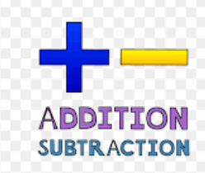 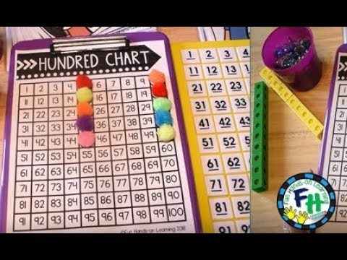 | 3. Science  Classify objects based on whether they are solid or  liquid.  Explore liquids by pouring them into different containers and solids by placing them in different  containers.  *Draw what you observed.  *Describe differences between solids  and liquids.  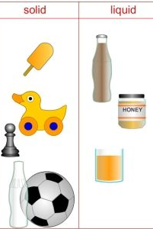
4. Reading  Log on to Imagine Reading for 45 minutes. Using the log in information sent to you.  OR  Vocabulary  • Select a text to read.  • use clues to figure out words you do not know.  • Read the tip below to know how to use clues to help you think about what to do when you find a word that you do not know.  •use the chart below to show your understanding of the word. 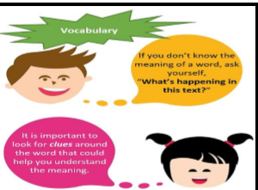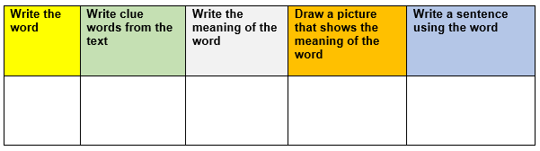 | 5. Math  Choose 5 numbers (up to 1,000) and create a place value foldable with the standard form, word form, base-10 form, expanded form.  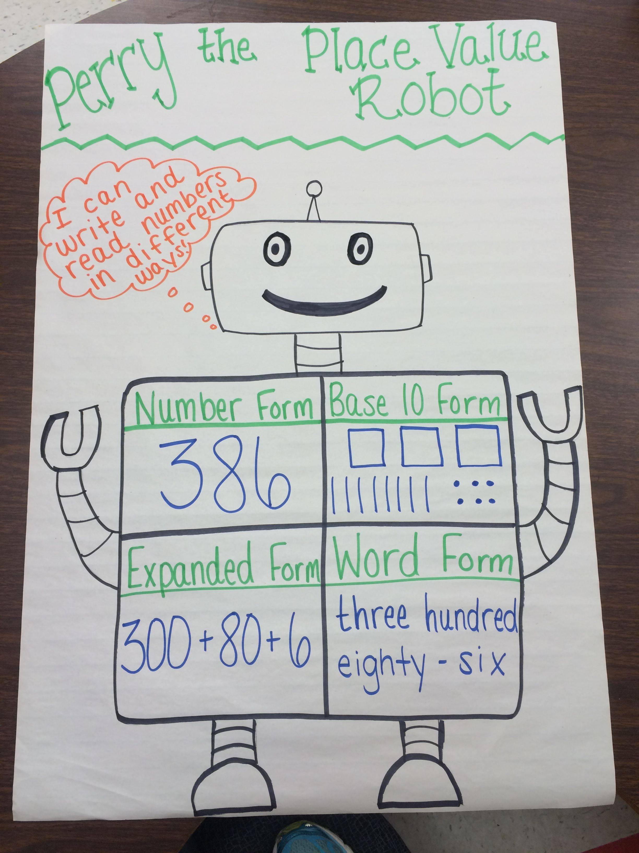 | 6. Science  Identify and explore forms of energy.  Explore your home to find items that are a  source of heat, light, or sound energy.  *Write what the item is, what source of energy it provides, and how it is used in our everyday lives.  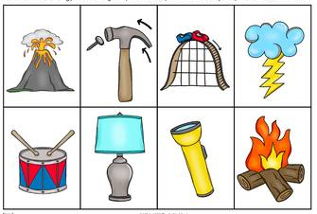
7. Reading  THINK about something that you love to do.  It could be reading, drawing, dancing, or collecting things.  WRITE about your favorite thing to do. Explain why you like to do it.  My favorite thing to do is _________________________.  Because ____________________.  * organize your writing.  *choose your words carefully.  * use correct spelling, capitalization, punctuation, grammar and sentences.   | 8. Math  Solve One-Step Addition and Subtraction Word Problems.  Larry has 76 pencils. Sam has 38 pencils. How many more pencils does Larry have than Sam?  *Represent the math story using pictures.  *Solve the math story.  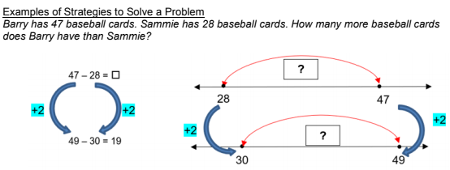 | 9. Social Studies  Write about what you want to be when you grow up.  *How will you spend the money you earn? *Draw a picture to go with your writing.  When I grow I want to be a  _________________________________  _________________________________  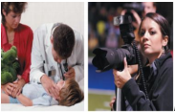  Resources: notebook paper, pencil, crayons
10. Reading  *Add a prefix (pre-, re-, un-, dis-) to the base word to create a new word.  *Write a complete sentence with the new word.  ___Play ____heat  ____agree ____use  ____obey ____honest  ____do ____known | 11. Math  Log on to Imagine Math for 45 minutes. Using the log in information sent to you.  OR  *My friends ate 213 chocolate chips. If I eat 178 chocolate chips, how many will we have eaten in all? | 12. Social Studies  Use notebook paper to match the work with the tools they use to provide services.  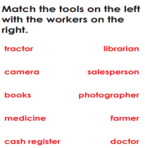  Resources: notebook paper, pencil
Weekly Project: “The Timeline of my life”

A timeline is a tool that we can use to help us understand history. It can tell us what happened at different times. It can tell us how much time there was between two events. It can give us a picture of dates in our minds. This helps us see how they all fit together. They help us keep track of important dates in our lives.
Directions:
- Complete a timeline that sequences the events in chronological order. This timeline can be created however you want. You can make a visual display or use timeline sheet provided. Please include at least 5 important events in your life. You can include more if you would like. Important events must include date, short description and picture. Picture can be illustrated, or you may use printed photographs. Your timeline should be constructed TWO ways:
- Numerical Order (Use actual dates)
- Sequential Order (most recent at top)

___ When you started second grade.
___ When you were born.
___ When you started Kindergarten.
___ When you learned to walk.
___ When you lost your first tooth.
___ Today’s date.
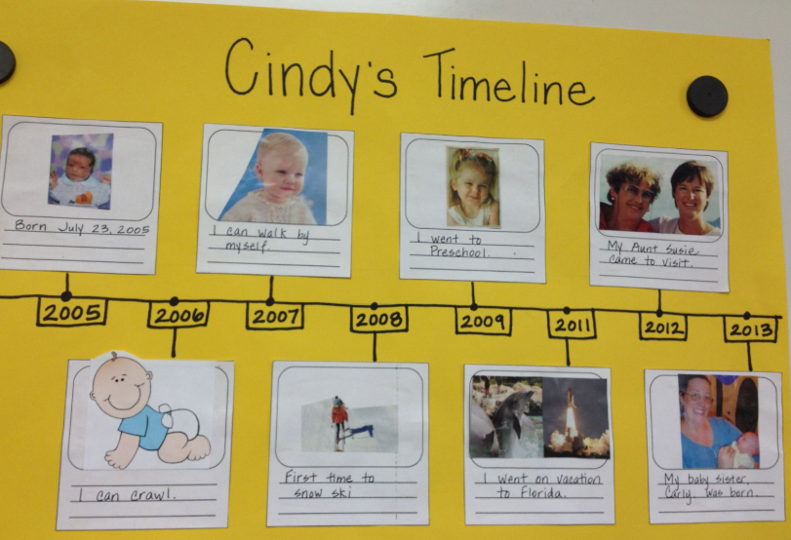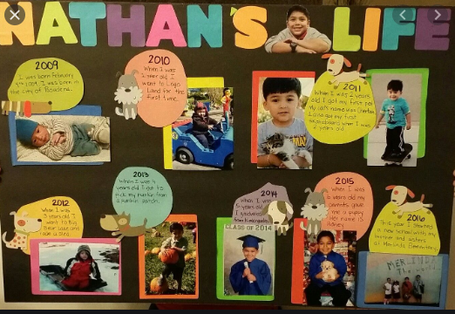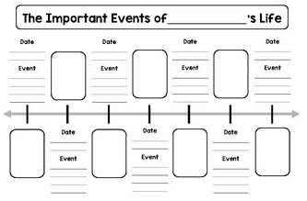
Directions: Each week students will receive a menu to be completed by the end of the week. Students will choose activities based on interest but must do: 9 squares (3Reading, 3 Math, 1 Science, 1 Social Studies, 1 extra, + Project). Of the 12 boxes, 9 must be completed. More points and reward will be given to students that will send their pictures or videos of them (parents and students) completing the work.
*The 9 boxes activity due date is April 10, 2020 while the project due date is April 17, 2020. Please submit evidence of the completion of all these activities for your child to receive the grades that are required by Texas Education Agency for this semester of learning. send completed work via our class dojo or email it to me at Esther.Onyia@houstonisd.org
If you have any questions, please feel free to call Ms. Onyia @ 281-748-6694.
Thank you for your time and patience during this time of need. Amazing Second Grade.

