Mrs. Price/Ms. Lara Week of April 13 – April 17, 2020 Grade 1
Instructions: Choose the activities you want to complete. Out of the 12 boxes, 9 must be completed (3 Reading, 3 Math, 1 Science, 1 Social Studies, + 1 extra choice or Project). Please send evidence of completion of all these activities so that your child can receive credit. You can send pictures of your completed assignments through ClassDojo.
Reading | Math | Science
Choice 1 – Predictions  1) Select a fictional book of your choice.  2) Ask your child to make predictions about the book orally and in writing using the following questions and sentence stems.  Questions Sentence Stems  What does the title tell you? The title tells me __________ ________________________  What do the pictures tell you? The pictures show me ______ ________________________  What do you think the story will be about? I think this story will be about ________________________ ________________________  3) Ask your child the following questions once the book has been read:  Where your predictions correct? My predictions were __________ because _________________ *  Why?  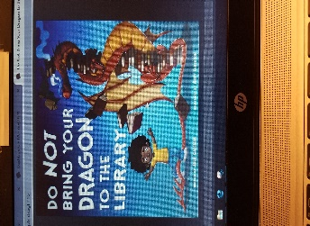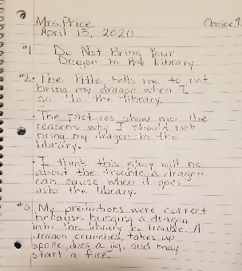 | Choice 2  1) Create number cards. Get a paper and write the numbers 1 through 9. Have two stacks of cards with the numbers 1 through 9.  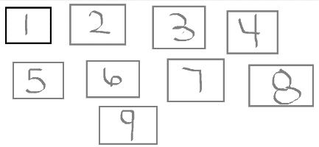  2) Without looking choose two numbers from one stack. Create two numbers. The first number that you got from your stack is going to be your tens and the second number your ones.  3) The choose two more numbers from the second stack of cards. The same as before, your first number is going to be your tens and the second number your ones.  4) Write the numbers in a piece of paper. Compare both numbers. Ask yourself, “Which number is bigger? Which number is smallest?”  5) Do 5 rounds. Repeat steps 2 -5.  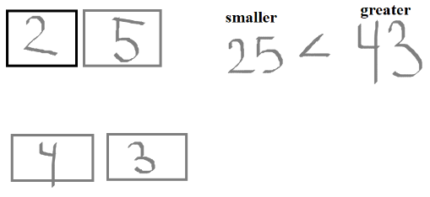 | Choice 3 – Science  *Sort objects based on their length. Objects can be sorted in different ways. We can sort objects by their shape, texture, size, color or length.  What you need:  • A set of 4 or 5 objects (toys, crayons, or any other objects)  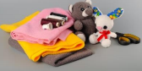  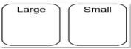  What to do:  - Draw and label a graphic organizer like the one above.  - Describe the objects as either large or small.  - Sort and place each object in a pile based on its length.  - Write and complete the following sentences.  The ______ is larger than the ___________.  The ______ is smaller than the __________.
Choice 4 – Character Profile  1) Select a fictional book of your choice. It could be the same book you read for choice 1.  2) Ask your child to create a picture of the main character of the story and write a short description in complete sentences.  Picture of Main Character Description of Main Character  3) Questions to ask yourself when describing the main character.  --What does the character look like?  --What did they say or do?  --How do they think or feel?  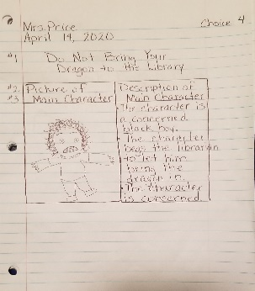 | Choice 5  1) Create number cards. Get a paper and write the numbers 1 through 9. Have two stacks of cards with the numbers 1 through 9.  2) Without looking choose two numbers.  3) Your first number is your tens and your second number are your ones.  4) Write the number you created. Now that you have your number you are going to write the number in expanded and standard form.  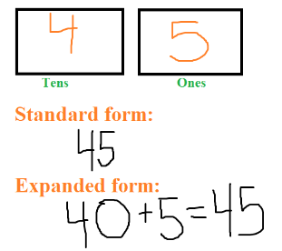  5) Repeat the activity 5 times. Repeat steps 2-4. | Choice 6 – Science  *Sort objects by its properties (heavy or light).  What you need:  A set of 4 or 5 objects (toys, crayons, or any other objects)  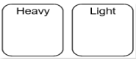  What to do:  - Draw and label a graphic organizer like the one above.  - Predict which toy is heavy or light.  - Describe the objects as either heavy or light by placing one object in each hand (hefting) to  - compare the mass of the objects.  - Place each object in a pile based on whether it is heavy or light.  - Write and complete the following sentences.  The _____ is heavier than the ___________.  The ______ is lighter than the __________.
Choice 7 – HFW Practice  *Write a word from the box to complete each sentence.  bring eyes family girl  move soon together warm  1) Eve and I play __________ in the park.  2) Did you __________ the ball, Eve?  3) It is very __________ out!  4) My family __________ went into some shade.  *Write a word from the box for each picture. | Choice 8  *Read the following math story three times:  - Read aloud the first time and picture what the math story is about.  - Read aloud the second time and focus on the question and what you need to find out.  - Read aloud the third time and determine what important information is needed.  Sam has 30 baseball cards. Jim gave him 9 more. How many baseball cards does Sam have now?  *Represent the math story by using objects. Then use pictures, numbers, and words to show your work.  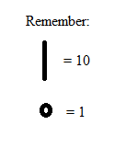  Just as we have done in class you can use you tens and one to represet the numbers. | Choice 9 – Social Studies (Tools)  *We need tools to make life easier. Tools include pencils, computers, washing machines, and cars.  *Sorting Activity:  1) Sort the many different tools found in and around your home.  2) Draw a picture or write the name of each item.  Example:  Tools to Work Tools to Build  stapler hammer  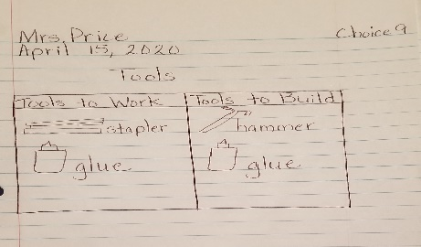
Choice 10  Words About Actions and Directions  *Action words, or verbs, tell what someone or something is doing.  *Direction words tell where a person or thing is going.  *Write one action and one direction word to finish each sentence about the picture.  Action Words Direction Words  run swim dig fly up through down across  1) Birds __________ __________ the sky.  2) Squirrels __________ __________ a tree.  3) Rabbits _________ _________ into the ground.  4) Turtles __________ __________ the water. | Choice 11  * Interview your family. Ask your family, “What is your favorite ice cream flavor?” Before asking your family, choose 3 ice cream flavors that you want your family to choose from. Such as chocolate, vanilla, strawberry.  Create a graph to represent your results.  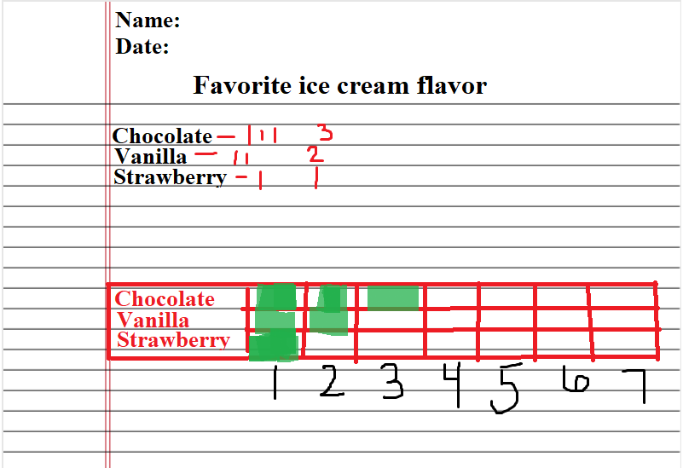  Answer the following questions:  What category has the most?  What category has the least? | Choice 12 – Social Studies  (Entertainment)  *Make a collage of the different items that you have at your home that are used for  recreation/entertainment.  *A collage is a combination or collection of various things.  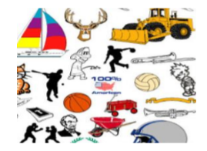
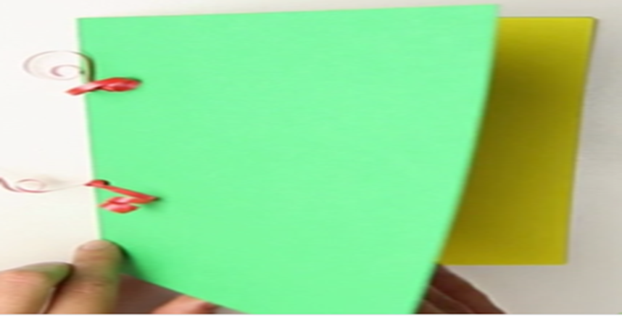
Weekly Project
With the journal you set up last week, you are to continue adding entries for each day this week. Every entry should have the date, a picture, and writing.

Day 1 – (today’s date): Check-in – How are you feeling today? What did you do over the weekend?

Day 2 – Next entry (date): What makes you special?

Day 3 – Next entry (date): Name three (3) things you love about yourself.

Day 4: Next entry (date): How do you feel when you earn good grades?

Day 5: Next entry (date): What is the bravest thing you have ever done?

