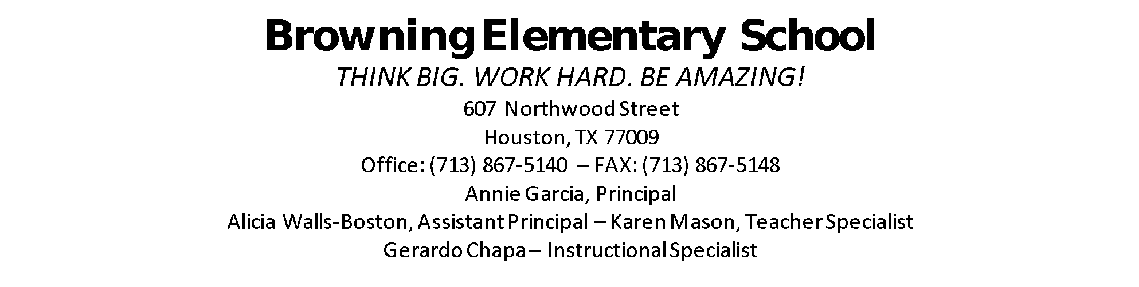
SDMC Mins
2021-2022
Community of Builders and Learners!

- ESSR Funds:
- Wraparound supplies
- Counselor or Social Worker – voted for counselor/will post position
- Interventionist – HB4545 to support with accelerated learning
- Submit SAF:
- Food (pantry)
- Clothing (donations appreciated)
- Housing Assistance (see Ms. Cortina)
- Supplies (school)
- SIP:
- Board Goals
- School Goals (Measurable Objectives/Activities/Responsible/Timeline)
- Budget for Afterschool:
- HB4545 – ESSER Funds available, certified teachers to support, schedule
- After-School clubs such as drumline, sewing, gardening, coding – budget?

In Attendance:
Marissa Lopez Amaya Santo Toma
Jocelyn Moten Gerardo Chapa
Lauren Flegle Keitha McQueen
Karen Mason John Quinn
Annie Garcia Yvonne Cortina

