Choose the activities you want to complete. Of the 9 boxes, 6 must be completed.
* Please send evidence of completion of all these activities so that your child receives the grades required by the Texas Education Agency for this semester of learning.
  Mindy blew up 124 red balloons and 64 white ballooons, 42 balloons popped. How many balloons did Mindy have left? | 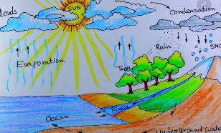  Create a drawing that explains the water cycle. Send me a photo of your drawing. | 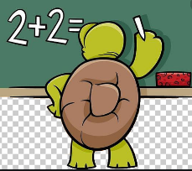  Write a math problem that includes addition and subtraction. Use the following set of numbers in your problem: 60, 28 &13  Send me a picture of your problem.
  Create a comic book explaining how to take care of our environment. Send me a picture of your comic book. |   Create a song that expresses why learning math is important. Record yourself singing the song or write the song on paper. | You're a scientist!    Go out and collect ten different rocks. Sort the rocks into different rows. Sort them by size, shape, color, and texture. Record yourself explaining how you classified the rocks.
Create a menu with prices for a pizza restaurant. Include at least 10 items to include in your menu; name each item and list toppings.  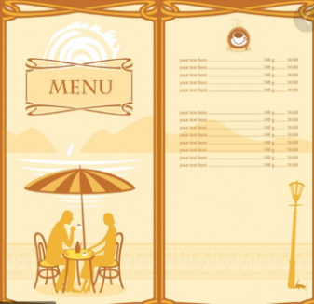 |   write a poem describing today's weather. | Do Imagine math for at least 45 minutes.  

