School Vision: We envision a world-class learning institution developing a community of holistic leaders who will demand-and-then-realize- endless opportunities for themselves and their community.

Mission: It is our mission to deliver the highest quality educational experience by maintaining a college culture within a diverse, supportive, public high school.
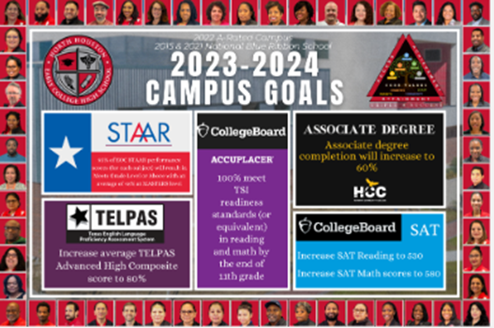

School Action Plan GOALS
- Develop leadership capacity through instructional coaching and feedback.
Indicators of success: On-The-Spot Observations, Highly effective instructional leadership
- Increase teacher capacity to demonstrate highly effective Tier I instruction.
Indicators of success: STAAR, AP, NWEA, Dual Credit, TSI, Industry Based Certifications, Teacher Domain II – Average score of 6
- Ensure 100% of students receiving special education services succeed academically at the high school and dual credit college level in order to meet TEA Outcomes Based Measures and prepare for post-secondary success.
Indicators of success: CCMR by December, SPED Compliance, TSI readiness by 11th grade

Format of Meeting: Virtual on Microsoft Teams
Format of Meeting: Hybrid-- In-person and on Microsoft Teams present = ☒
Members:

☐ Dr. Samantha Brooks, Principal
☒ Alondra Robinson, parent
☐ Molly Tavira, parent
☒ Matthew Weaver, Other School-Based
☒ Marcie Colemon, Dean of Instruction
☒ Janice Omoge, Teacher
☒ Dustin Langley, Teacher
☒ Kenneth Dorsey, Teacher – replacement as of 11.2023
☐ Jasmine Harris, Non-instructional
☒ Jeffrey Stear – Community, HCC STEM
☒ Reginald Peters—Community, HCC P-16
☐ Victoria Gray – THRIVE, Inc., Bus. Rep
☒ Carmen Garcia, Dean of Instruction
☐ SPED Chair: Dr. Charlesa Easter

- Welcome & Introductions
- Core Values
  - Dr. Brooks reviewed the campus vision, mission, values, and school action plans to maintain focus on our NHECHS work.
- Purpose of Meeting
  - Brooks emphasized the purpose was to provide updates to the SDMC on NHECHS progress data, to invite members to share opportunities for our students and community engagement. Brooks also reviewed the District Core beliefs and NHECHS alignment to those core beliefs.
- School Overview
  - Brooks shared several achievements of the campus to-date, including achievement of students in CTE- Entrepreneurship classes who have participated in Junior Achievement competitions and won.
  - Demographic information on the campus was shared. Current enrollment is at 475. Ethnicity percentages are 92.7% Latino students, 5.9% African American, and 1% other . We have a high percentage (48%) of GT students; however, many struggle with their academic habits, and their test scores may reflect better than their actual report card grades. We are consistently working to support students’ improvement of their academic habits (study skills, time management, etc.).
  - Uniquely, NHECHS has observed steady increases in both our emergent bilingual population (28%), at-risk (70%), and economically disadvantaged (89%). Also, we have more Accelerated Testers, students who earned Algebra I credit in middle school. The implications are that ATs must now earn at least 540 on their math SAT to earn MEETS level accountability for our campus achievement.
  - Community: We are located on the HCC Northline campus, in a community that also has a large working class community of small business owners. The surrounding are is filled with small and franchise businesses. Considering our Entrepreneurship endorsement area, Brooks mentioned she is expanding our campus interactions and networking with area businesses through our CTE classes. On the academic side, NHECHS prides itself with a family culture. We have high parental engagement, programs of study (Entrepreneurship and Government & Public Administration) and several advanced curriculum programming such as UT On Ramps – College Algebra and Physics, PreAP, AP, Dual Credit. We celebrate the steady increases in Industry Based Certifications for our scholars, also.
- Attendance
  - Student monthly attendance has typically been better that last school year. Staff attendance this year shows some declines due to members on leave and lingering illnesses. The goal is 98.5% attendance for all.
- CCMR – College, Career, Military Readiness
  - We are currently at 100% CCMR for our campus seniors.
- Accountability – STAAR, STAAR Interim
  - Brooks displayed a slide of the 2-year progress in the passing, meets, and masters levels of STAAR performance. Our biggest celebrations include the fact that NHECHS STAAR scores in math last year surpassed those of 3 out of 4 or our HISD partnering ECHSs. Our MEETS and MASTERS levels of achievement are indicators that more students are able to enroll in college level classes, particularly English 1301 and College Algebra, which also increase our college, career readiness indicators and TEA early college benchmarks.
  - STAAR interim: We also are predicted to do significantly well on this year’s STAAR exams according to the STAAR interim data, which was also shared by Dr. Brooks. US History is the only exam we have not completed a STAAR interim for, since APUSH and Dual Credit History curricula do not address STAAR – tested content until 2nd semester.
- AP Scores
  - Over the last 2 years, NHECHS AP scores have been on the incline in all but 2 classes, AP Human Geo, AP Comp Sci Principles. The teachers have implemented different plans to ensure growth this year.
- SAT School Day average score
  - Last year, our Math scores in SAT took a drastic decline. Average reading-writing score was 519 and math, 482. We are using College Spring this year to support improvement in those areas.
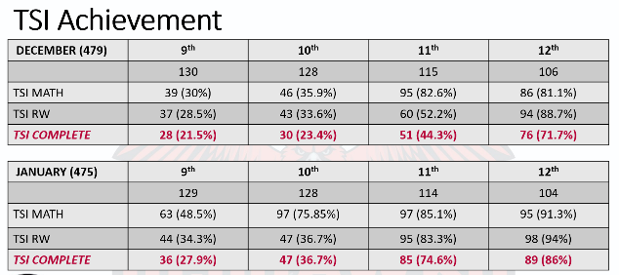
- TSI Achievement tracking
  - Brooks emphasized the significant growth in TSI achievement within a one-month span. From December to January, all grade levels in all areas of TSI testing showed growth. Refer to the chart below which was noted on the PPT:

- TELPAS
  - We predict that 80% of our EB students will be exited from LEP status. Many are already achieving at the college level.

- DATA Glows & Grows on Instruction
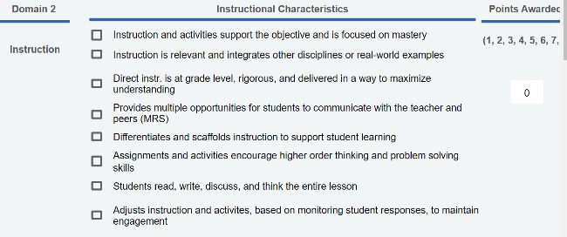
  - Recently, NHECHS was visited by a district independent review team to evaluate our academic performance. The team shared glows and grows with our campus leadership. The areas of strength were aligned TEKS or standards to DOLs and the overall learning environment. We received feedback to work on our instructional practice to ensure that students are doing the academic heavy lifting 90% of the time. Our growth areas include indicators 4, 5, 7 and 8 in Domain 2 – Instructional Practice. These indicators refer to implementation of MRS strategies, Differentiation and Scaffolds, 90% student reading, writing, discussing, thinking, and teacher monitoring and adjusting instruction. Our PLCs will focus on these growth areas.
- Staffing Updates
  - Our Spanish teacher, Mr. Ugalde, has retired from the district. We are in search of a strong candidate. We have a candidate in place for the nurse position for 24-25 school year.
- Concerns, Questions, Opportunities
  - Mr. Stear (HCC community partner) shared that he leads exposure opportunities for those interested in the field of engineering. He will share those opportunities.
  - Dean of Instruction, Marcie Colemon, concurred that we anticipate a high EB exit rate of 85%. The TELPAS testing dates are Feb 28th and 29th.
  - Dean of Students, Carmen Garcia, shared that we are in compliance on our safety drills and meetings, and she is looking forward to our course selection meetings coming soon in March. Dates are TBD and will be shared with parents and students soon.
- Next meetings
  - Wed, Apr 17, 2023 Fourth Quarter
  - Wed, May 15, 2023 Final Meeting/Voting on Waivers/Summer Updates

- Next Step/Closure- Meeting is adjourned at 4:34 p.m.

