High School Ahead Academy
BELL SCHEDULE
2022-2023

6th GRADE
1st Period | 2nd Period | 3rd Period | LUNCH | 4th Period | 5th Period | 6th Period | 7th Period
7:30 AM  –  8:00 AM | 8:00 AM  –  9:00 AM | 9:05 AM  –  10:05 AM | 10:10 AM  –  10:40 AM | 10:45 AM  –  11:45 AM | 11:50 AM  –  12:50 PM | 12:55 PM  –  1:55 PM | 2:00 PM  –  3:00 PM

7th/8th GRADE
1st Period | 2nd Period | 3rd Period | 4th Period | LUNCH | 5th Period | 6th Period | 7th Period
7:30 AM  –  8:00 AM | 8:00 AM  –  9:00 AM | 9:05 AM  –  10:05 AM | 10:10 AM  –  11:10 AM | 11:15 AM  –  11:45 AM | 11:50 AM  –  12:50 PM | 12:55 PM  –  1:55 PM | 2:00 PM  –  3:00 PM

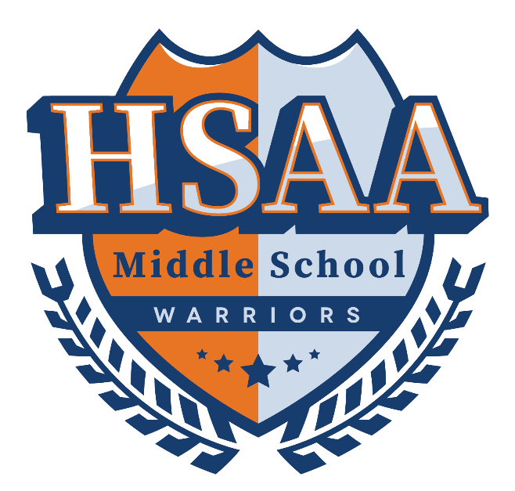
High School Ahead Academy
WARRIOR FRIDAY -BELL SCHEDULE
2022-2023

6th GRADE
1st Period | 2nd Period | 3rd Period | 4th Period | LUNCH | 5th Period | 6th Period
7:30 AM  –  8:15 AM | 8:20 AM  –  9:05 AM | 9:10 AM  –  9:55 AM | 10:00 AM  –  10:45 AM | 10:50 AM  –  11:20 AM | 11:25 AM  –  12:10 PM | 12:15 PM  –  1:00 PM

7th/8th GRADE
1st Period | 2nd Period | 3rd Period | 4th Period | 5th Period | LUNCH | 6th Period
7:30 AM  –  8:15 AM | 8:20 AM  –  9:05 AM | 9:10 AM  –  9:55 AM | 10:00 AM  –  10:45 AM | 10:50 AM  –  11:35 PM | 11:40 AM  –  12:10 AM | 12:15 PM  –  1:00 PM

