- Reading  - Read or listen to a story. (Use the same book during this week)  - Identify the characters and the setting. Then, think about the character’s motivations.  - Where did the story take place? The story took place …  - What can you say about the character …? I think the character …  - Yes, but why …? How do you know?  Maybe because …  - Reread the story or Read on to support your answers.  - Draw and label the pictures to explain. You may use the following chart.  The character _____. (Tell what the character did) The character ____ because _____. I know this because I I had to _____ to find evidence on page ___. | - Math  - Draw a line down the center of a sheet of paper. Then draw two lines across to create 6 boxes. Repeat the same steps on a second sheet of paper.  - Copy the domino dot patterns in the boxes as shown in the picture. Then cut them apart and flip it back faced down.  - Mix the cards up and stack them in one neat stack. Flip over the card and look at it for 3 seconds  - How many dots did you see?  - How did you see 7?  - Turn the card over again and check to see if you are correct.  - Point and make the pattern on the card in the air.  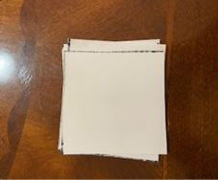  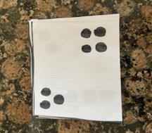  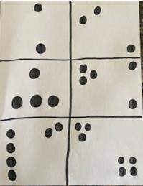  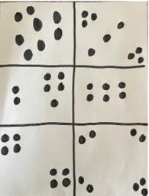  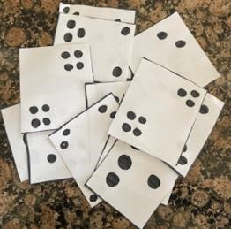  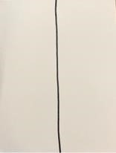  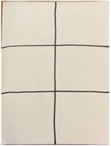  - Place the card at the bottom of the stack and repeat until you have made all the dot patterns.  LOOK  image by HISD Curriculum using iPhone  image by HISD Curriculum using iPhone  image by HISD Curriculum using iPhone |  | - Science  Objective: I can use my senses as a tool of observation to identify properties and patterns of objects.  Think About It!  What properties of objects and patterns are observed through our senses? Discuss this question and share your thinking with someone in your home!  Do It!  What you need:  - 6 different objects in a paper bag/sack  - Science notebook or paper  - Magazine or newspaper  - Pencil or crayons  - Scissors  - Adult Supervision  What to do:  - Discuss with someone what body parts are used for your five senses. (Sight, Hearing, Taste, Smell, Touch)  - Ask an adult to find 6 different objects and place in a paper bag or sack.  - Observe the objects in the bag without using your sense of touch, sight and taste.  - Describe what you hear or smell.  I think it is a __________. I used my sense of ________.  - Describe the objects using the sense of touch. I think it is a _________  Understand It!  We can explore and observe properties. To observe means to use our five senses to help us learn.  Apply It!  - Copy this table into your science notebook.  - Cut out pictures from magazines or newspaper.  - Sort the pictures into groups on the table.  - Glue the pictures onto the table.  Taste Sight Smell Hear Touch
- Reading Identify the Problem and Resolution  - Reread or listen to the previous story.  - Identify the problem in the story.  - What happened at the beginning of the story? In the beginning …  - What happened next? Then…  - What happened at the end? In the end…  - Draw and label the pictures to retell the story.  - Then select the events that show the problem and the resolution.  You may use the following organizer to record your answers.  EVENTS  In the beginning… The problem was … In the end … | - Math  - Divide a sheet of paper into six parts. Then draw a ten frame inside each box.  - Choose two different color crayons or markers. Copy these dot patterns inside the ten frames as shown in the picture. Then cut them apart.  - Divide another sheet of paper in to six parts. Draw a number bond in each box.  - Choose a ten frame and write the number of red dots, the number of yellow dots, and the total number of red and yellow dots together. Repeat until you have recorded all the ten frames on number bonds.  - Cut the number bonds out. Mix them up and match the ten frames with the number bond it represents.  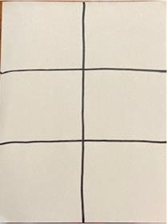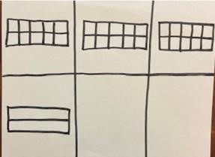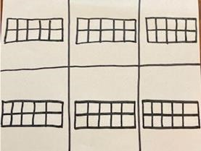  image by HISD Curriculum using iPhone  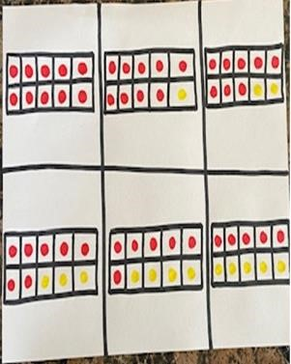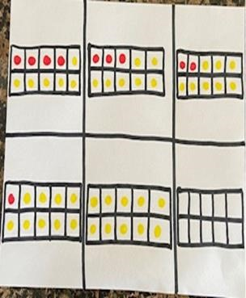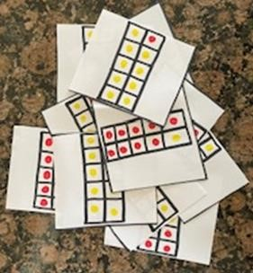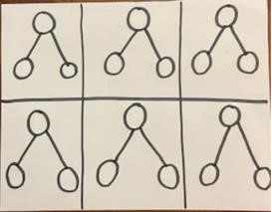  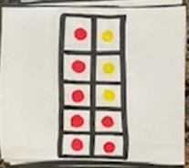  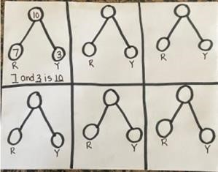  image by HISD Curriculum using iPhone  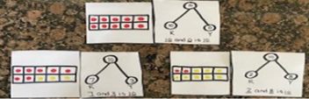 |  | - SEL  Watch a favorite movie, YouTube or TV show: -  - Watch for the different feelings throughout the show.  - Pause the show occasionally to discuss the characters’ feelings.  - Use the feelings chart to see how many feelings you can find.  CONNECTION: Social Studies Discuss:  - Feelings Clues  - What clues tell you how someone is feeling? –  - Label sheets at the top with big feelings, such as happy, sad, angry, scared.  - Fold sheets of paper in half, label each side:  - What does it look like?  - What does it sound like? Draw or glue photos or pictures of the clues you see and hear for the feelings.
- Reading Theme  - Reread or listen to the previous story.  - Use the chart made the day before to retell the events.  - Find the theme of the story by answering the following questions:  - What did the main character learn? The main character learned …  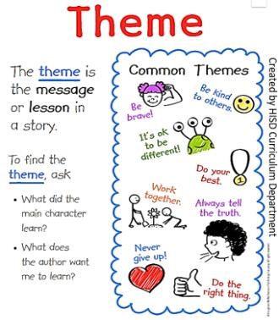  EVENTS  In the beginning… The problem was … In the end … | - Math  - Read the following math story aloud and picture what the math story is about.  - Trinity baked 7 oatmeal cookies. She ate 2 of the cookies. How many cookies does Trinity have left?  - Read the math story aloud a second time. This time focus on the question and what you need to find out.  - Read the math story a third time. This focus on the important information.  - Now model the story.    - How many cookies did Trinity start with? Use your counters to model that amount.  What strategy will you use?  - Counting back  - Counting on    What answer did you get? How did you get that answer?  Possible Answer:  - Counted back: “I started at 7 and said, 6,5.”  - Counting on: “I started at 2 and used my fingers to track as I said, 3,4,5,6,7. Then I knew the answer was 5.  Now follow the steps above to solve this math story on your own. Act it out using counters and explain your thinking.  Mercedes has 9 crayons. She broke 6 of them. How many crayons are not broken? |  | - Social Studies  What are Rights and Responsibilities?  Americans believe that everyone has rights.  Name one responsibility you have at school.  Americans believe that everyone has responsibilities.  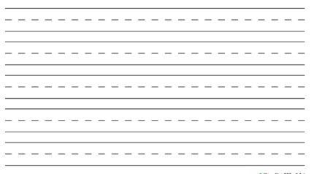  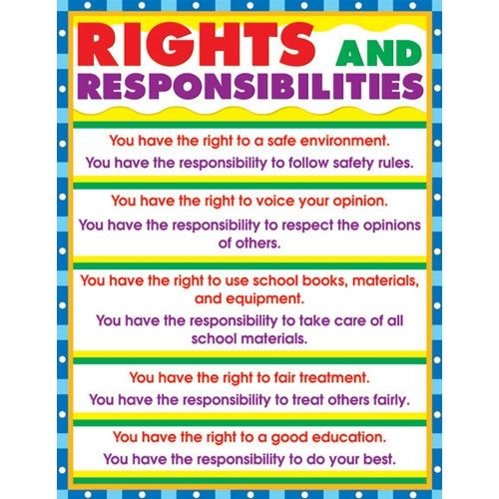
Weekly Project: Vocabulary: Characters’ Actions

- Reread or listen to the previous story.  - Draw the characters of the story.  - Write a word to explain the characters’ actions.  - Explain the characters’ actions by saying complete sentences.  - Ex) Tony runs in the park. |  | 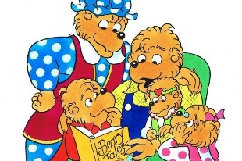  ex. The Bearstein bears read a book  Character Action: _________ Character Action: _________ Character Action: _________ Character Action: _________

