Mrs. Price/Ms. Lara Week of May 25 – 29, 2020 Grade 1
Instructions: Choose the activities you want to complete. Out of the 12 boxes, 9 must be completed (3 Reading, 3 Math, 1 Science, 1 Social Studies, + 1 extra choice or Project). Please send evidence of completion of all these activities so that your child can receive credit. You can send pictures of your completed assignments through ClassDojo.
Reading | Math |  | Science
Choice 1  Use the Pictures to Read the Words  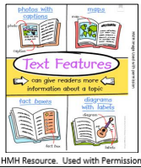  1. Pick an informational text to read for the week. (book, magazine, newspaper)  2. Use the pictures in your book to help you read and understand the author’s words.  3. Retell someone what you learned from the book. “I learned…”  Draw a picture of what you learned from the book.  4. Spend at least 30 minutes on Imagine Language & Literacy | Choice 2  Income  *Look at the vocabulary below:  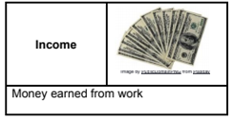  *Income is money someone earns from working. Work is another word to describe a job that someone does to earn income.  Write 3 different jobs people can do to earn an income.  - _________________  - _________________  - _________________  *Billy is a first-grade student who is looking for ways to earn money. Look at the examples below to see how Billy earns money for doing chores at home.  Ways to earn Money  Chore - Clean my room - Take out the trash - Sweep the floors Income - 10 cents - 25 cents - 50 cents  Fill in the table below to show how you could earn money at home.  Ways to Earn Money  Activity or Chore 1. 2. 3. 4. Income 1. 2. 3. 4. |  | Choice 3 – Science  Objective: Observe and record data about daily weather conditions using pictures and numbers. What you need:  • Paper • Pencil and crayons  What to do:  • Observe the weather calendar.  • Draw the Sun. Count the number of sunny days.  • Draw the clouds. Count the number of cloudy days.  • Draw the rain. Count the number of rainy days.  • Write the numbers you counted for each kind of weather.  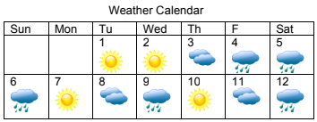  Apply It!  Look at the pictures and numbers you wrote from the weather calendar. Create a picture graph to record the data you collected. Use the table below to help you.  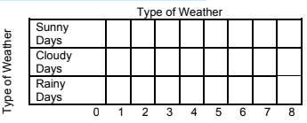
Choice 4  Using Text Features to Understand the Book!  1. Read your non-fiction book from the day before or pick a new one.  2. Look for one of the text features from the anchor chart in your book.  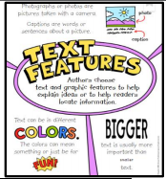  Draw a picture of the text feature you picked from your book. How does this kind of text feature help you to understand the ideas in the book? This text feature helps me to understand… ____________________ ____________________ ____________________ ____________________ *  3. Spend at least 30 minutes on Imagine Language & Literacy | Choice 5  Services and Goods  Look at the picture below:    Describe what you see happening in the picture. Use the following sentence stem:  In the picture I see ________________________  _________________________________________  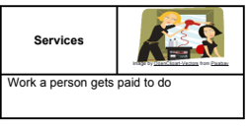  Look at the vocabulary below:  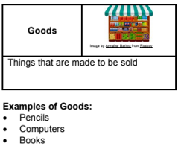  Examples of Goods and Services:  Goods Services  Pencils Visit to the doctor  Computers Hair Cut  Books Lawn Service  Your turn:  List 4 goods and services on the table below:  Goods Services |  | Choice 6 – Science  Objective: Organize weather data using numbers and words.  What you need:  • Paper • Pencil • Type of Weather picture graph, completed  What to do:  • Observe the data from the Type of Weather picture graph.  • Think: How many sunny days are on the graph?  • Think: How many cloudy days are on the graph?  • Think: How many rainy days are on the graph?  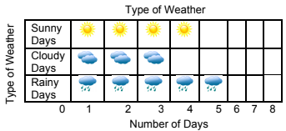  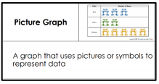  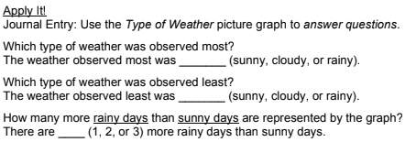
Choice 7  Responding to Text  1. Reread the informational text from Tuesday.  2. Pick one of the ways to respond to the text from the anchor chart.  3. Share your response with someone at home.  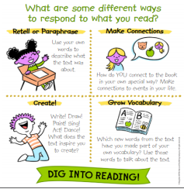  4. Spend at least 30 minutes on Imagine Language & Literacy | Choice 8  Save or Spend  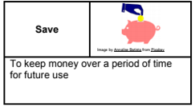  Look at the vocabulary below:  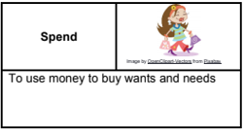  Read the following scenarios. Write down if it falls under Spend Money or Save Money category.  - Gracie is going to the mall to buy 3 pars of jeans.  - Jared’s grandma gave him $20 for his birthday. Jared is going to put the $20 in his bank account.  - Colby wants to buy a new toy from the store.  Read the following scenario and complete the sentence stem.  It’s your birthday! Your grandmother gave you $10 as a gift. You are trying to get enough money to buy your favorite video game. Should you spend the money to go to the movies or save the money to buy your favorite video game?  I should ______ because ____________________  _________________________________________  _________________________________________ |  | Choice 9 – Social Studies  Time  SEE: What do you see in this picture?  THINK: What does this picture make you think about?  WONDER: What questions do you have about this picture?  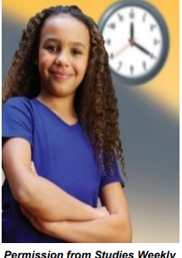  Name all the places you can find the time.  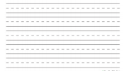  *
Choice 10  High Frequency Words  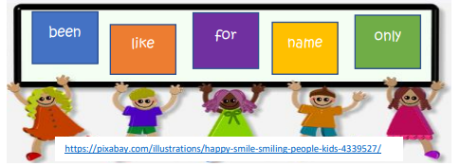  1. Read each word to someone at home or to a stuffed animal.  2. Fill in the missing letters of each word below.  f o __ o__ __ y  __ e e __ n __ m __  l __ k __ Check your work with someone at home.  3. Spend at least 30 minutes on Imagine Language & Literacy | Choice 11  Solve the Problem  Read the following math story three times:  - Read aloud the first time and picture what the math story is about.  - Read aloud the second time and focus on the question and what you need to find out.  - Read aloud the third time and determine what important information is needed.  15 baby bears brush their teeth before going to bed. 8 baby bears still need to brush their teeth. How many baby bears have already brushed their teeth?  *Represent the math story by using objects. Then use pictures, numbers, and words to show your work.  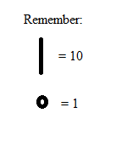  Just as we have done in class you can use you tens and one to represet the numbers. Remember this time you are subtracting, so you are taking out, you can use x to take out. |  | Choice 12 – Social Studies  The Past  The past is everything that happened before now. Yesterday happened in the past.  Discuss with parents how you know this picture happened in the past.  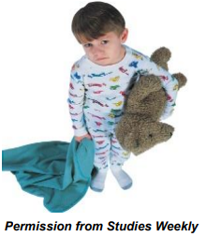  Draw something that you did before now (in the past).  *
Choice 13  Ms. Johnson’s Class Only – Reading  * Directions: Read each set of words. Are they synonyms or antonyms? Circle the correct answer.  1. absent present S A 2. dull sharp S A 3. lift drop S A 4. feeble weak S A 5. walk stroll S A 6. watch observe S A 7. long short S A 8. friend buddy S A 9. kind sweet S A 10. think wonder S A 11. lead guide S A 12. bright smart S A 13. sad depressed S A 14. push shove S A 15. fix mend S A 16. agree argue S A 17. stop cease S A 18. wrong incorrect S A 19. bright sunny S A 20. sit lounge S A  * |  | Choice 14  Ms. Johnson’s Class Only – Math  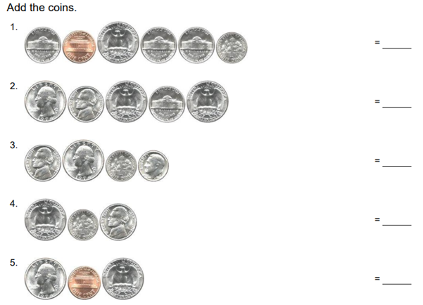  *
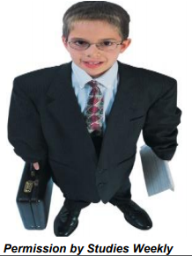
Weekly Writing Activity
The Future

The future is everything that will happen after right now. Tomorrow will happen in the future.

Discuss with your parents how the picture to the left represents the future.

Draw what your future career will be.

*

