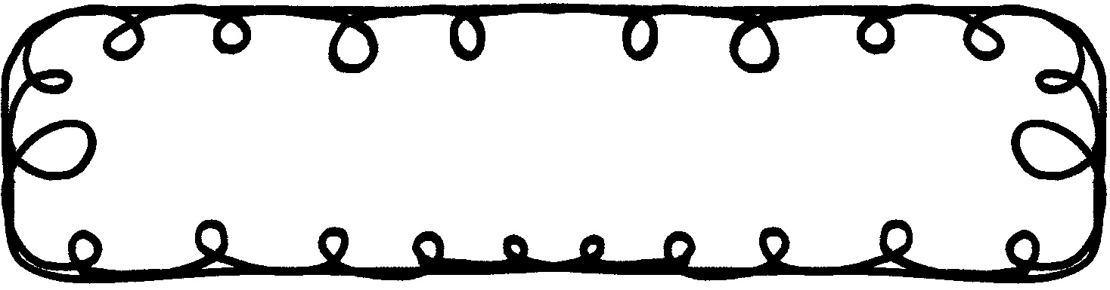

First Grade Gazette September 29, 2019

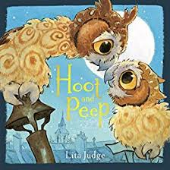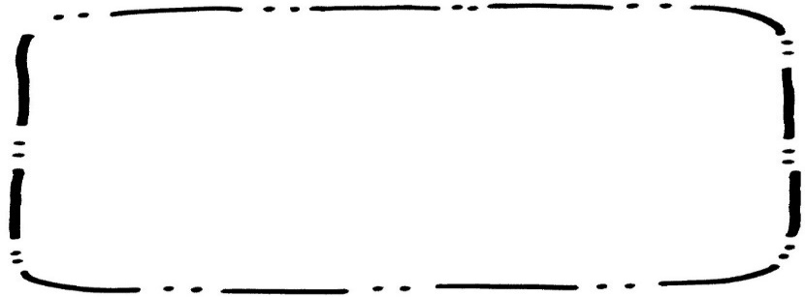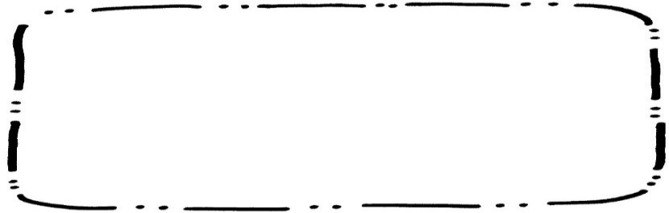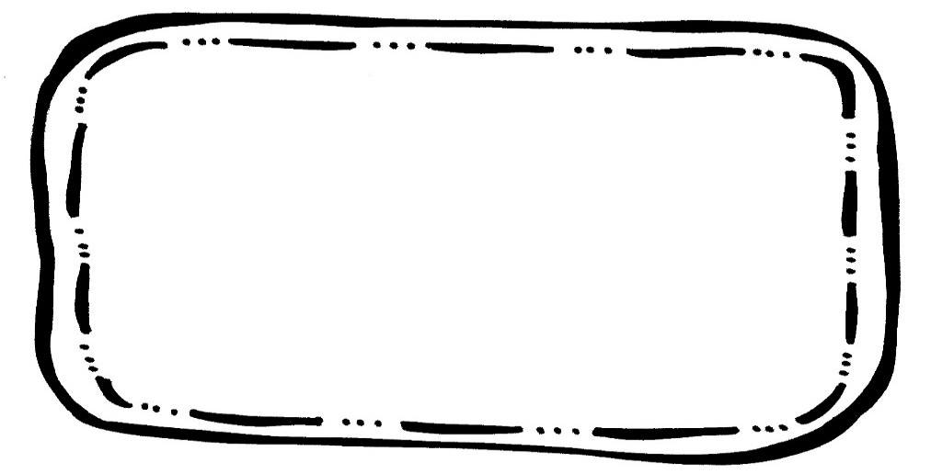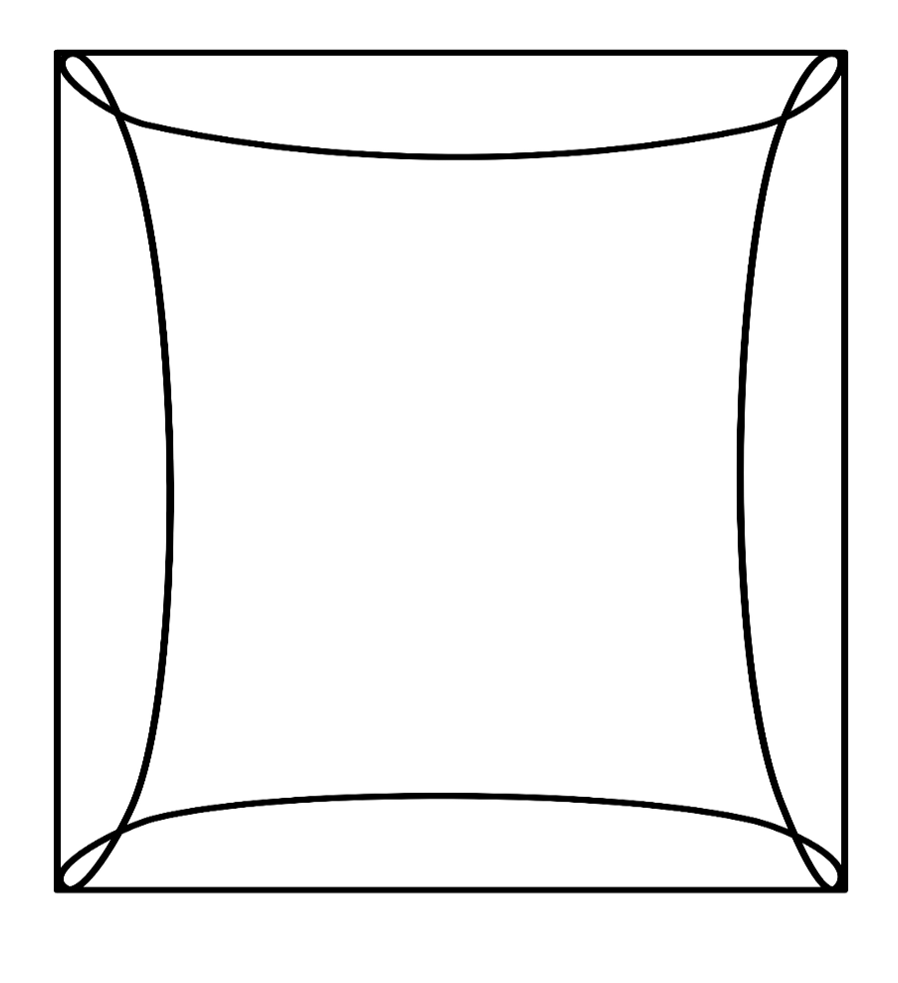

Math

We will begin Chapter 4, Subtraction. Please continue to practice math facts.

Writing

We will learn about onomatopoeia and how it makes writing better.

Science

We will be learning about magnets and how they are used.

Spelling**Tested 9/13

dot fox job nod pop

teacher has no grow now

**Fox can hop on the log.**

**Reading Comprehension**

* Making connections

**Vocabulary Words**

Moonbeam – a ray of light from the moon

Peep – a weak, sharp sound of a young bird

Mistake – a thought or action that is not correct

Joy – a great feeling of happiness

Drift – to be carried along by the wind

**Upcoming Events**

**October**

9 – No School for students

18 – Early Dismissal

21 – 25 – Red Ribbon Week