

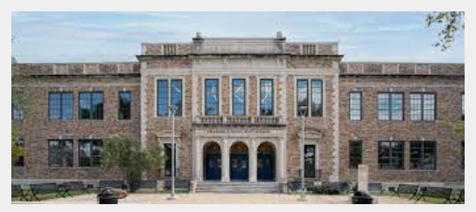
Charles H. Milby High School
1601 Broadway St.
Houston, TX 77012
(713) 928-7401

SCHOOL-PARENT COMPACT

The Charles H. Milby High School and the parents of the students participating in activities, services, and programs funded by Title I, Part A of the Elementary and Secondary Education Act (ESEA) (participating children), agree that this compact outlines how the parents, the entire school staff, and the students will share the responsibility for improved student academic achievement and the means by which the school and parents will build and develop a partnership that will help children achieve the State 's high standards.

This school-parent compact is in effect during school year 2023 – 2024.

School Responsibilities:
Charles H. Milby High School will:

Provide high-quality curriculum and instruction in a supportive and effective learning environment that enables the participating children to meet the State's student academic achievement standards as follows:

- Implementing HISD 's curriculum
- Providing modified instruction to special education students as specified by their Individual Education Plan
- Hiring highly qualified teachers and staff to serve our students.
- Providing appropriate use of technology in technical classes as well as integrated in the content area.

Hold parent-teacher and parent-principal conferences during which this compact will be discussed as it relates to the individual child's achievement.

- These conferences will be held within three weeks of the beginning of each semester.

Provide parents with frequent reports on their children's progress. Specifically, the school will provide reports as follows:

- Progress Report Cards
- Report Cards every 6 weeks

Provide parents reasonable access to staff. Specifically, staff will be available for consultation with parents as follows:

- Via the phone
- In person
- Email

Provide parents opportunities to volunteer and participate in their child's class, and to observe classroom activities, as follows:

- After parents have completed the VIPS background process, parents are able to volunteer and observe classroom activities.

Parent Responsibilities:

We, as parents, will support our children's learning in the following ways:

- Monitoring attendance.
- Stay aware of my child's academic progress and participate in the decisions relating to his/her education.
- Get my child to school, on time every day, and pick him/her up on time.
- Provide a place where my child can study at home.
- Making sure that homework is completed.
- Monitoring amount of television and electronic use.
- Provide current emergency telephone numbers in case of an accident or illness.
- Participating, as appropriate, in decisions relating to my children 's education.
- Promote positive use of my child's extracurricular time.
- Stay informed about my child's education and communicate with the school by promptly reading all notices from the school or the school district either received by my child or by mail and responding, as appropriate.

Student Responsibilities:

We, as students, will share the responsibility to improve our academic achievement and achieve the state's high standards. Specifically, we will:

- Actively participate in all classes by completing assignments, homework, and projects.
- Do my homework every day and ask for help when needed.
- Attend tutorials if we have been assigned any.
- Read at least 30 minutes every day outside of school time.
- Give my parents or guardian all notices and information received from my school.
- Take all tests and benchmarks seriously and do our best at all times.

