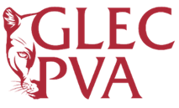


Gregory-Lincoln Education Center for the Performing & Visual Arts
SDMC Meeting Minutes – QUARTER 3
Thursday, February 8, 2024 | 4:15 pm
Dr. LaTreia Woodard, Principal

Attendance

Dr. LaTreia Woodard, Principal
Toni Outlaw, Dean of Instruction
Valarie Moore, Assistant Principal
Sharron Breedlove, Assistant Principal
Thomas Porter, Magnet Coordinator
Sharon Ford, Parent Engagement Representative
Melissa Robinson, Administrative Assistant
Angela McNeil, General Clerk
Pastor Elmo Johnson, Community Member
Keidrick Perry, Community Member
Pastor Lou McElroy, Community Member

Minutes

The SDMC meeting was held in person in the school library at 4:15 pm. Dr. LaTreia Woodard, Principal, facilitated the meeting.

Dr. LaTreia Woodard presented updates.

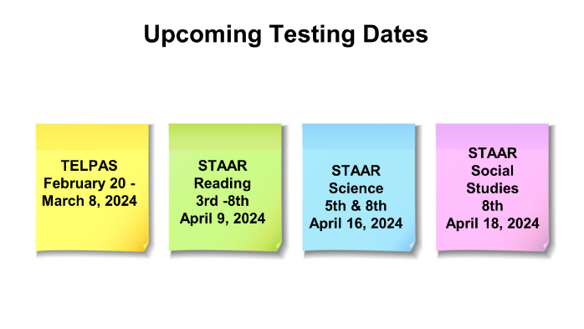


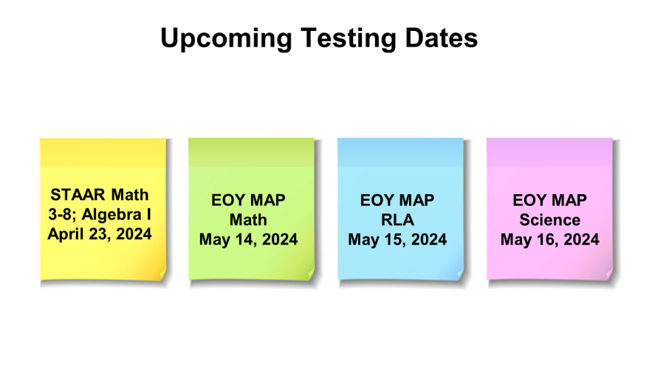

Thomas Porter, Magnet Coordinator, presented Celebrations.
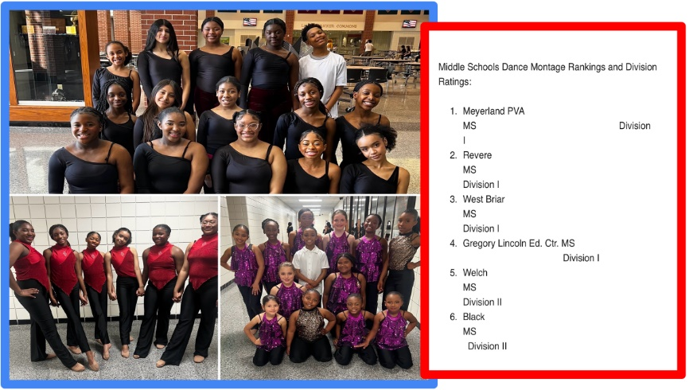





Valarie Moore, Assistant Principal, presented Announcements.



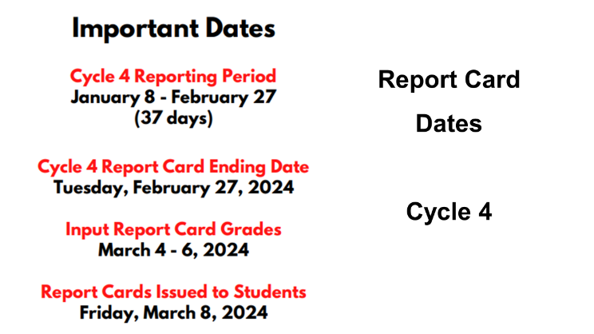

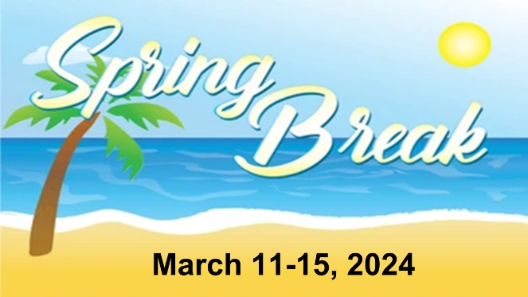

Dr. LaTreia Woodard, Thomas Porter and Valarie Moore presented the SDMC Focus – NES Community Overview.

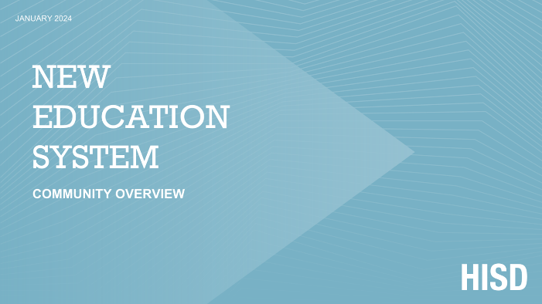

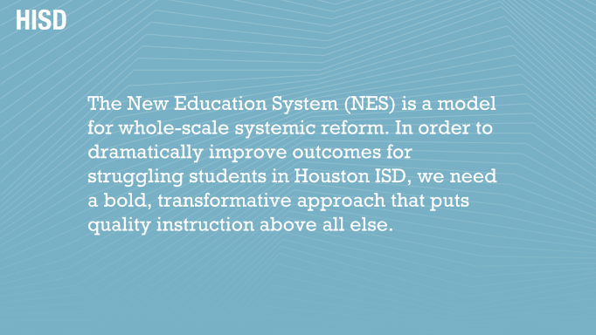
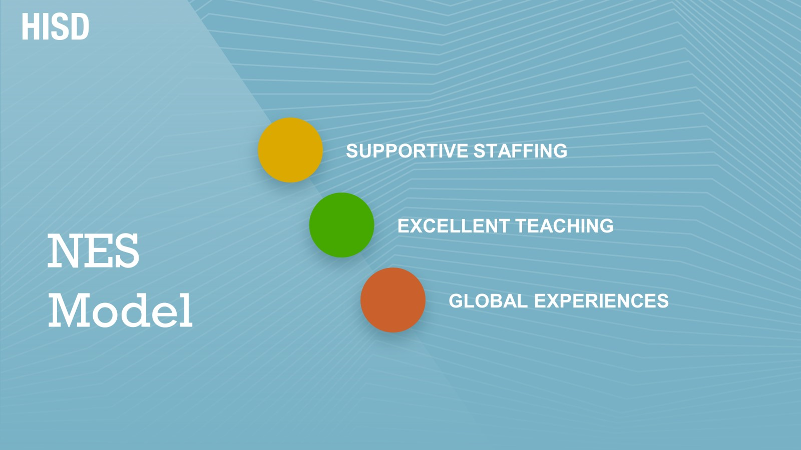

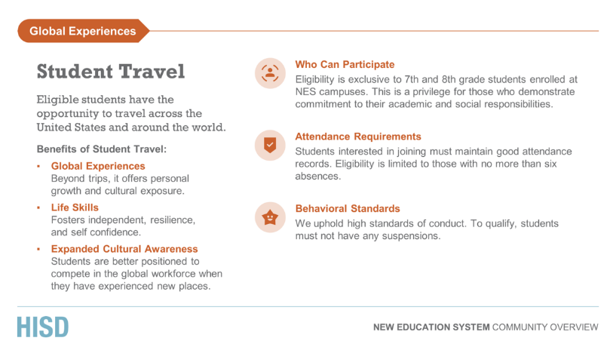
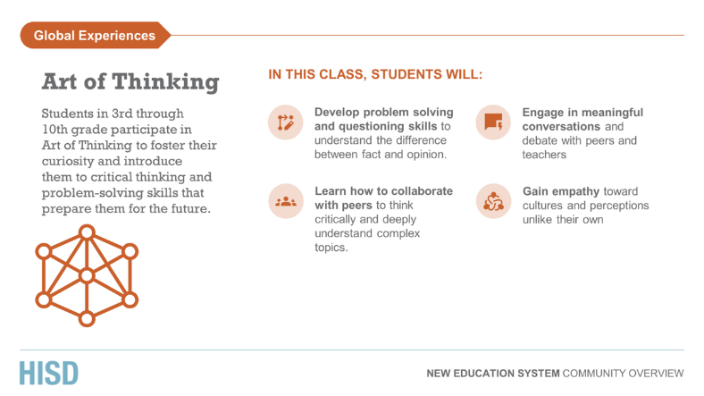
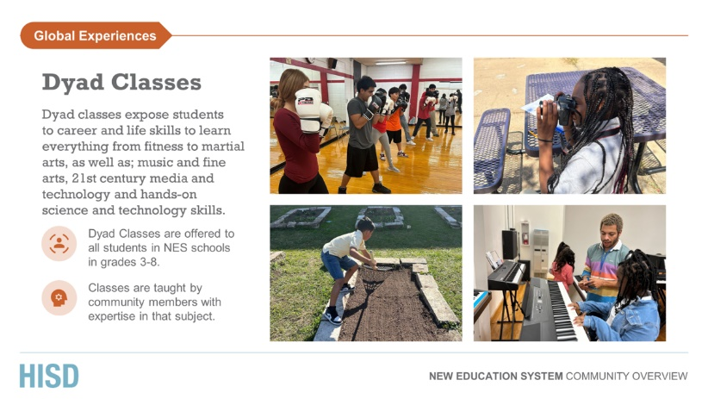
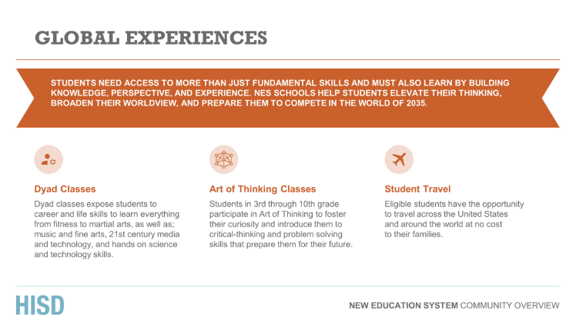
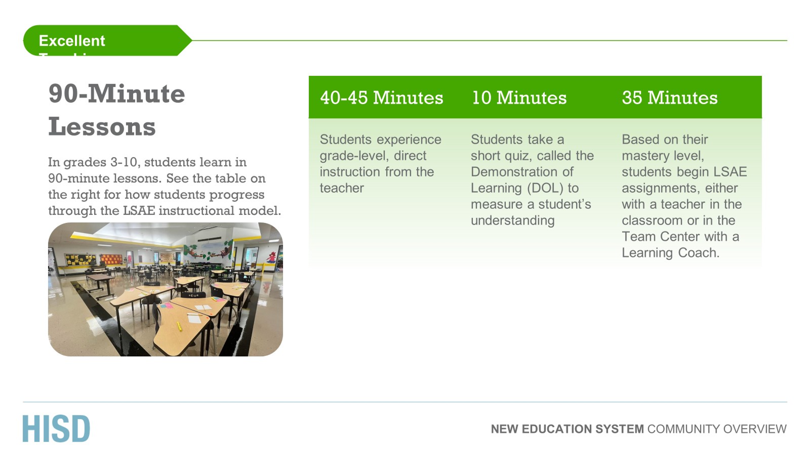
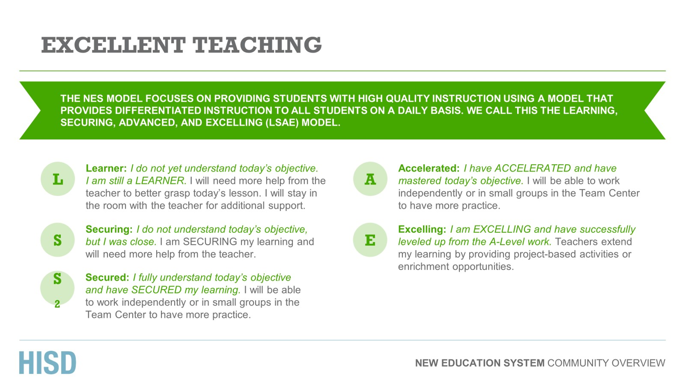
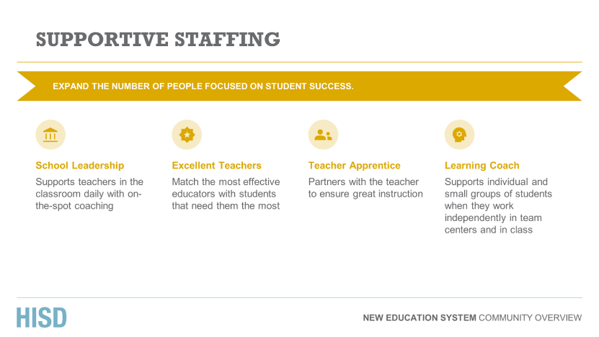

Dr. LaTreia Woodard ended the meeting with questions from the community members and then provided the QR Code for any further questions regarding the NES model. The community members shared they are in full support of the NES model and will continue to support Gregory-Lincoln.



