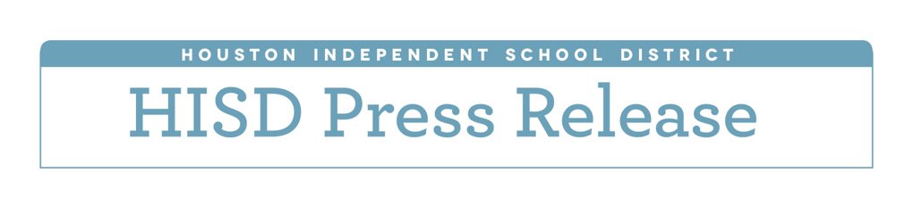**Carnegie Vanguard ranked 10th best high school in nation**

*U.S. News & World Report also puts DeBakey HS, Eastwood Academy, Challenge Early College HS in top 100*

*April 19, 2016* — Carnegie Vanguard High School has been ranked as the 10th best high school in the country, according to the U.S. News & World Report’s 2016 Best High Schools rankings.

Three additional Houston Independent School District schools were ranked in the top 100 — DeBakey High School for Health Professions, which was ranked 29th, Eastwood Academy, which came in at the 50th spot, and Challenge Early College High School, which was ranked 78th.

The U.S. News & World Report rankings are designed to identify great high schools that serve all students — no matter their socioeconomic status. The list is determined by looking at results from state assessments results, as well as the degree to which students at each school are prepared for college-level work. Graduation rates were also included as a factor in the rankings for the first time.

“Our teachers and administrators take their job of educating our students very seriously and are committed to making sure all students are prepared for college and the workforce,” said HISD Board of Education President Manuel Rodríguez Jr. “We are proud of their work and our students'. To be recognized nationally reaffirms our district's path to excellence.”

A total of 19 HISD schools were included on the 2016 list, which recognized more than 6,000 top public high schools from across the country. Five received Gold Medal Designations, ten received Silver Medal Designations, and four received Bronze Medal Designations.

“It is rewarding to see the efforts of our educators and students recognized for their commitment to academic excellence,” HISD Interim Superintendent Ken Huewitt said. “This is just one measure that highlights our achievements as we continue to look for ways to enhance all our schools and meet the needs of all our students.”

Fifteen of these schools also were included on the U.S. News & World Report lists for Best Magnet, Charter, and STEM (Science, Technology, Engineering and Math) Schools. Carnegie Vanguard secured a fourth-place spot on the Best Magnet Schools list. DeBakey earned a seventh-place spot on the Best Magnet Schools list and an 11th-place spot on the list of Best STEM Schools. Eastwood Academy took home 14th place on the Best Charter School list.

The complete list of rankings is available at <http://www.usnews.com/education/best-high-schools/national-rankings>. HISD high schools included in rankings are listed below.

**2016 Best High Schools List – HISD high schools**

Gold Medal Designations

Carnegie Vanguard High School (U.S. rank: 10; Texas rank: 3; Magnet: 4; STEM: 232)

DeBakey High School for Health Professions (U.S. rank: 29; Texas: 5; Magnet: 7; STEM: 11)

Eastwood Academy (U.S. rank: 50; Texas: 8; Charter: 14)

Challenge Early College High School (U.S. rank: 78; Texas: 14; Charter: 26)

The High School for the Performing and Visual Arts (U.S. rank: 128; Texas: 24; Magnet: 32; STEM: 198)

Silver Medal Designations

North Houston Early College High School (U.S. rank: 502; Texas: 62; Charter: 110)

Sharpstown International School (U.S. rank: 509; Texas: 63; Magnet: 77)

East Early College High School (U.S. rank: 537; Texas: 66; Charter: 115)

High School for Law Enforcement and Criminal Justice (U.S. rank: 595; Texas: 69; Magnet: 88)

Bellaire High School (U.S. rank: 662; Texas: 73; Magnet: 97)

Westside High School (U.S. rank: 707; Texas: 81; Magnet: 102)

Houston Academy for International Studies (U.S. rank: 850; Texas: 94; Charter: 142)

Energized for STEM Academy West High School (U.S. rank: 973; Texas: 109; Charter: 155)

Lamar High School (U.S. rank: 1,615; Texas: 154; Magnet: 203)

Reagan High School (U.S. rank: 1,854; Texas: 166; Magnet: 230)

Bronze Medal Designations

Energized for STEM Academy Central High School (no ranking)

Energy Institute High School (no ranking)

Barbara Jordan High School for Careers (no ranking)

South Early College High School (no ranking)

