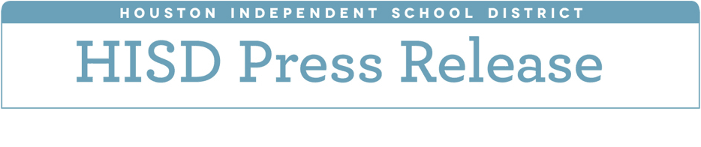

**HISD Board of Education approves inclusive**

**practices for special education students**

*November 9, 2017* – The Houston Independent School District Board of Education on Thursday approved a resolution to strengthen current services provided to HISD students with special needs to succeed in the general education classroom.

This resolution lays out a set of best practices for increasing the time that special education students spend in the general education classroom, while providing additional services and the support needed.  The district recognizes the need to raise expectations for students with disabilities and educate them in the least restrictive environment.

“As the district focuses on equity in every classroom, we understand our special needs students deserve every resource we can offer to ensure they succeed,” Superintendent Richard Carranza said.  “This resolution is a necessary next step to delivering the services they need.”

Trustees also approved a resolution to pay employees for the workday missed as a result of the district closing due to the Houston Astros parade on Nov. 3.

The closure, in addition to supporting the efforts of city officials to uplift the community, anticipated significant street and highway traffic problems, which would affect buses throughout the district, and reflected concerns about staffing and student absenteeism.

By approving this resolution, the Board ensured district employees, including hourly workers, were paid for the lost day.

The Board also approved the academic calendar for the 2018-2019 school year. The calendar was drafted with input from a committee made up of principals, union representatives and departments across the district, as well as the District Advisory Committee.

The first day of school for students will be Aug. 27, and the final day of classes will be May 31.  The academic calendar gives students and staff a full week off during Thanksgiving.  Meanwhile, the Fall Holiday is set for Monday Sept. 10, a date that coincides with the first day of the Jewish holiday Rosh Hashana.