

**HISD** **students to perform speeches at annual Martin Luther King Jr. Oratory Competition**

|  |  |
| --- | --- |
| **WHAT:** | Twelve Houston Independent School District elementary students will spread the work and teachings of Dr. Martin Luther King Jr. by reciting self-written speeches inspired by the civil rights leader as part of the 23rd Annual MLK Oratory Competition.    Sponsored by Foley Gardere LLP, the competition invites fourth- and fifth-grade students to write and deliver an original speech that envisions King’s message in today’s world. This year’s theme is “What would Dr. King say to the children of today’s world?”    Students are judged based on stage presence and decorum, content interpretation, and memorization. The winner will be awarded a $1,000 prize. The second place contestant receives $500 while the third place contestant receives $300. Other finalists will each receive $100.    More than 180 students representing 24 HISD schools participated in the qualifying rounds in October. One student from each school was selected to advance to the semifinals on January 11. Of the 24 semifinalists, 12 have advanced to the final competition.  The 12 students who will present their speeches are:   * Nyla Johnson, Lockhart Elementary School * Asia Jefferson, Blackshear Elementary School * Chrisette Wigfall, Askew Elementary School * Corine Ellis, Law Elementary School * Annoria McDuffie, Pleasantville Elementary School * Raheem Khokhar, Sutton Elementary School * Leik Mire, Windsor Village Elementary School * Emmanuel Akukoro, Valley West Elementary School * Irmani Garcia, Bastian Elementary School * Mya Parnell, Foster Elementary School * Beverly Antia, Bell Elementary School * Alexa Zelaya, Cornelius Elementary School     The competition will be streamed live on [Facebook.com/HoustonISD](https://www.facebook.com/HoustonISD). |
|  |  |
| **WHO:** | HISD Interim Superintendent **Grenita Lathan**, HISD Board of Education trustees, and HISD students and their families |
|  |  |
| **WHEN:** | Friday, Jan. 18  10 a.m. – 12:30 p.m. |
|  |  |
| **WHERE:** | Antioch Missionary Baptist Church of Christ, 500 Clay St., 77002 |

[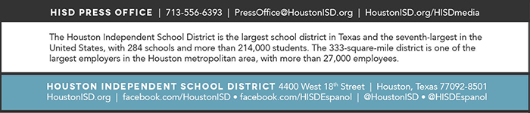](http://houstonisd.org/HISDmedia)